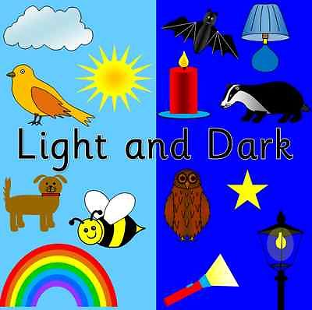
Reception – Autumn 2 - Theme: Light & Dark
Literacy  We will be exploring a range a texts including: Chapatti Moon, Owl Babies and the mixed up chameleon. We will be using our phonics to write labels and letters to Father Christmas. We will also be exploring rhyming words. We will continue to learn our phonic sounds following scheme of learning. |  | Mathematics  We will continue to focus on counting and the numbers to 5. We will be comparing two groups using five frames; the children will be encouraged to count each group, which helps them to link names of numbers, their value and their position in their counting order. We will be using our counting and comparing skills to find one more and one less than numbers up to 5. They will recognise that 1 more is the next number when counting and one less is the number before. We will be using five frames to compare numbers to 5. We will also be looking at time, ordering times in their day and using positional language to describe when evens happen. |  |  |  | Physical Development  We will be learning to travel in different ways using different apparatus. We will develop our fine motor skills through a range of activities including: threading, playdough and cutting. We will be practising our letter formation to help with our writing.
Communication and Language  We will be listening and responding to the stories we are reading. We will talk about our own experiences including different celebrations such as Bonfire Night. |  | 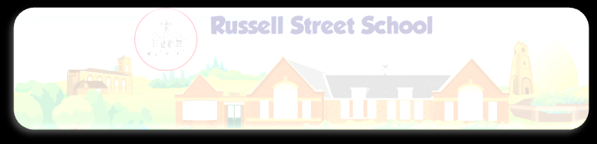  Light and dark |  |  |  | Personal, Social and Emotional Development  We will look closely at our value of thoughtfulness. We will look at the importance of being a kind friend and also learn about how to deal with bullying
Expressive Arts and Design  Exploring media and materials: During music lessons we will be looking at rhythm and pulse and using bodies to follow the rhythm. We will be using clay to create Diva lamps. Throughout the term we will have access to both construction and creative materials.  Being imaginative: We will be exploring different pieces of art including ‘A Starry Night’ by Vincent Van Gogh to inspire our own paintings. We will be looking at colour mixing and using this to create Kandinsky circles. |  |  |  | Understanding the World  The world: We will be learning about Nocturnal and Diurnal animals. We will be exploring shadows and how shadows are made.  People and Communities: We will be looking at different festivals and celebrations (Divali, Christmas, Bonfire Night) looking at similarities and differences.  Technology: We will have regular access to tablets and the Interactive whiteboard to access age appropriate software.

Phonics | Read Write Inc  Set 1 & 2 | Read Write Inc  Set 1 & 2 | Read Write Inc  Set 1 & 2 | Read Write Inc  Set 1 & 2 | Read Write Inc  Set 1 & 2 | Read Write Inc  Assessment Week
English | Week 1 | Week 2 | Week 3 | Week 4 | Week 5 | Week 6
 | Writing Focus | Reading Focus | Reading Focus | Reading Focus | Writing Focus | Writing Focus
Contexts | Chapatti Moon by  Pippa Goodheart and Lizzie Finlay | Owl Babies | The Mixed Up Chameleon | Night Monkey, Day Monkey | Dear Santa | The Jolly Postman
Learning Intention and Success Criteria | WALT: Use descriptive language  To use senses to describe smell, taste, texture. | WALT:Know book language  Know what an author, illustrator etc is. | WALT: Compose a sentence orally.  Using observations and feelings to generate descriptive language. | WALT:Rhyme  Know rhyming words have the same ending. | WALT: Write a list  Know the features of a list.  Writing each word underneath | WALT: Write an insert for Christmas card  Using phonic knowledge to write simple words.
New Vocabulary (Grandma Fantastic)  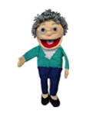 | Chapatti  Aubergines  Ghee  Pakoras  Samosas  Luminous  Slumber  Delicious  Action words from the text | Author  Illustrator  Blurb  Title  Front cover  Back Cover | Emotion words  Describe  Notice  Features | Clambered  Chorus  Creepy  Slithered  (from the text) | List  Under  Page  Word  Line | Insert  Greeting  Celebration  Festival
Starters | Body percussion/ Hickety Tickety Bumble Bee | Feelings – How do the owl babies feel? | Feely bag with animals – what am I desribing? | Pause and predict the rhyme. | Circle:Have you been to a post office, what did you send? | Circle: Who would you like to send a Christmas card to.
Main Lesson | Modelling language to describe vegetables and food from the story. | Model book language.  Talk about the author etc and beginning, middle and end. | Teacher to wear wig and wings-can the children think of ‘wow’ words for ‘funny’ etc. | Model rhyming strings using a phoneme frame. | Model writing a letter to Santa. | Model how to write a card insert.
Task | Writing a bank of descrivbing words (in a group) | Using the story box puppets to re-enact the story. | Design a mixed up chameleon and teacher to scribe the children’s sentence to describe their chameleon. | Write a rhyming caption. | Writing a Christmas list. | Writing a card insert.

Phonics:
Set 1
m - a - s - d - t - i - n - p - g - o - c - k - u - b - f - e - l - h - sh - r - j - v - y - w - th - z - ch - qu - x - ng – nk

Set 2
ay – ee – igh – ow – oo – oo – ar – or – air – ir – ou – oy

Set 3
a-e – ea – i-e – o-e – u-e – aw – are – ur – er – ow – ai – oa – ew – ire – ear – ure – tious – tion

Week | Expressive Art & Design (Art) | Learning Intention/  Success Criteria | Key Vocabulary | Key Skills  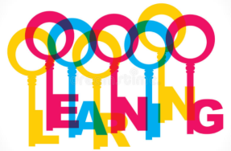 | Key Knowledge  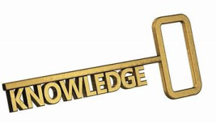
1 | They safely use and explore a variety of materials, tools and techniques, experimenting with texture, form and function.  Diva Lamps (Diwali) – moulding dough/clay. | Manipulate materials  Roll my dough/clay  Mould a shapewith my hands | Diwali  Diva  Roll  Pinch  Mould | Rolling, squeezing, pushing, pulling and pinching malleable materials | Techniques for moulding malleable materials to create different forms.
2 | They safely use and explore a variety of materials, tools and techniques, experimenting with texture, form and function.  Diva Lamps (Diwali) – decorating. | Design  Think of my design  Select the colours  Select the materials | Decorate  Colour  Adorn | Desiging  Painting  Sticking | Know vocabulary of colour names and different materials.
3 | They safely use and explore a variety of materials, tools and techniques, experimenting with colour.  Colour mixing | Describe change  Look carefully  Think about the colour at the beginning  Think about what causes the change  Think about what is different at the end. | Colour  Primary  Secondary | Observing, predicting and describing change. | Know which primary colours combine to create which secondary colours.
4 | They safely use and explore a variety of materials, tools and techniques, experimenting with colour.  Van Gogh’s Starry Night | Identify features  Look carefully  Draw/paint what you see | Artist | Brush and paint skills | Know what an artist does  Know who Van Gogh is  Know how to paint from observation
5 | They safely use and explore a variety of materials, tools and techniques, experimenting with design, colour, texture, form and function.  Making Christmas Cards | Design  Think of my design  Select the colours  Select the materials | Design  Colour | Desiging  Painting/drawing  Cutting/sticking | Know how cards are designed and made  Understand that card designs need to relate to the occasion.
6 | They safely use and explore a variety of materials, tools and techniques, experimenting with design, colour, texture, form and function.  Decorating Christmas Trees | Design  Think of my design  Select the colours  Select the materials | Design  Colour | Desiging  Painting/drawing  Cutting/sticking | Understand what a decoration is and how to join materials.
 | They safely use and explore a variety of materials, tools and techniques, experimenting with design, colour, texture, form and function.  Making Christmas Decorations | Design  Think of my design  Select the colours  Select the materials |  | Desiging  Painting/drawing  Cutting/sticking | Understand what a decoration is and how to join materials.

.
Week | Understanding the world: The World and People and Communities  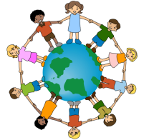 | Learning Intention/  Success Criteria | Key Vocabulary | Key Skills | Key Knowledge
1 | Make observations and talk about changes.  Know about similarities and differences in relation to places, objects, materials and living things.  Colour mixing | Observe  Look carefully  Say what has changed | Colour  Mix  Primary  Seconday | Observing changes | How colours change when mixed.
2 | Make observations and talk about changes.  Adding white/black | Observe  Look carefully  Say what has changed | Colour  Mix  Primary  Seconday  Light  Dark | Observing changes | How colours change when mixed with white or black.
3 | Make observations and explain why some things occur.  Know about similarities and differences in relation to places, objects, materials and living things.  Shadows/shadow puppets | Observe  Look carefully  Explain what is happening | Shadow  Dark  Light | Observing | What a shadow is?  How a shadow is created?
4 | They make observations of animal or plants  Nocturnal animals | Identify  Look closely  Use the correct vocabulary | Nocturnal  Night  Day  Names of nocturnal animals | identify | What nocturnal and diurnal means.  Animals that are nocturnal.
5
6
7

Week | Physical Development  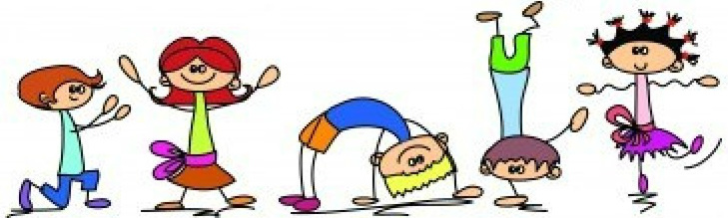 | Learning Intention/ Success Criteria | Key Vocabulary | Key Skills | Key Knowledge
1 | Safely negotiating space  Moving with control | Play games  Listen to instructions  Take turns  Move in different ways | Communicate  Collaborate  Teamwork | Communicating, collaborating and competing | Understand the rules of different games and know associated vocabulary.
2 | Safely negotiating space  Moving with control | Play games  Listen to instructions  Take turns  Move in different ways | Communicate  Collaborate  Teamwork | Communicating, collaborating and competing | Understand the rules of different games and know associated vocabulary.
3 | Safely negotiating space  Moving with control | Play games  Listen to instructions  Take turns  Move in different ways | Communicate  Collaborate  Teamwork | Communicating, collaborating and competing | Understand the rules of different games and know associated vocabulary.
4 | Children show good control and coordination in large and small movements.  Using large apparatus | Travel on apparatus  Listen to instructions  Take turns  Move in different ways  Bend my knees when I land | Travel  Over  Under  Movement  Balance | Agility, balance and coordination | Vocabulary of the names of P.E. equipment and ways of moving.
5 | Children show good control and coordination in large and small movements.  Using large apparatus | Travel on apparatus  Listen to instructions  Take turns  Move in different ways  Bend my knees when I land | Travel  Over  Under  Movement  Balance | Agility, balance and coordination | Vocabulary of the names of P.E. equipment and ways of moving.
6 | Children show good control and coordination in large and small movements.  Using large apparatus | Travel on apparatus  Listen to instructions  Take turns  Move in different ways  Bend my knees when I land | Travel  Over  Under  Movement  Balance | Agility, balance and coordination | Vocabulary of the names of P.E. equipment and ways of moving.
7 | Children show good control and coordination in large and small movements.  Using large apparatus | Travel on apparatus  Listen to instructions  Take turns  Move in different ways  Bend my knees when I land | Travel  Over  Under  Movement  Balance | Agility, balance and coordination | Vocabulary of the names of P.E. equipment and ways of moving.

NB. In addition, fine motor skills are taught and practised in EAD, English, Handwriting and specific activities available in continuous provision (inside & outside). Gross motor skills also developed daily, through use of the large outdoor equipment .
Health and Self-care taught and supported daily through circle times, meal times and books. Parents encouraged to help children to develop self-care skills at home, as communicated through weekly parent updates.

Week | PSED  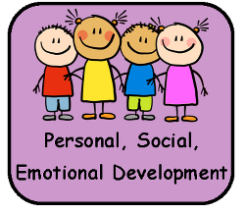 |  |  | Learning Intention/Success Criteria | Key Vocabulary |  | Key Skills |  | Key Knowledge
1 | Can describe self in positive terms and talk about abilities.  Identify something I am good at and understand everyone is good at different things. |  |  | Understand everyone is good at different things/  Sing the song  Listen to the chime  Reflect | Abilities  Individual  Achievements |  | Listening  Reflecting  Sharing ideas |  | Can I describe my positive attributes?
2 | Can describe self in positive terms and talk about abilities.  Understanding how differences make us special. |  |  | Understanding that difference makes us all special /  Share your strengths  Listen to others  Compare and reflect | Differences  Interests  Opinions |  | Listening  Speaking clearly  Sharing ideas |  | Can I listen and reflect on others interests and compare them to my own?
3 | Confident to speak to others about own needs, wants, interests and opinions.  Seeing similarities and differences between themselves and their peers. |  |  | Knowing that we are all different but the same in some ways/  Look at the pictures  Recognise similarities  Notice differences | Reinforce  Similarities  Differences |  | Listening  Sharing ideas  Noticing |  | Can I recognise similarities and differences between groups sof people?
4 | Confident to speak to others about own needs, wants, interests and opinions.  Sharing how their home is special to them. |  |  | Sharing why our homes are special/  Build a house  Compare our houses  Relect | Teepee  Apartment  Mansion |  | Listening  Speaking clearly  Discussing |  | Can I share my ideas on my house and why it is special to me?
5 | Understands that own actions affect other people  Looking at how we can be a kind friend. |  |  | Tellinng eachother how to be a kind friend/ Listen to the ideas  Discuss with your partner  Reflect | Empathy  Friendships  Reflecting |  | Listening  Sharing ideas  Discussing |  | What can we do to be a kind friend?
6 | Children are confident to speak in a familiar group.  Understanding how to stand up for themselves appropriately when people are unkind. |  |  | Knowing which words to use to stand up for themselves/  Watch, Listen  Reflect | Encountering  Scenario |  | Listen  Share ideas  Reflect |  | Which words are right to use to resolve a conflict?
Week |  | Understanding the World - Technology | Learning Intention/  Success Criteria |  |  | Key Vocabulary |  | Key Skills |  | Key Knowledge
1 |  | Select and use technology for a particular purpose.  Using the ipads to click and drag an object- puzzle | Select and use a program  Think about what you want to do  What controls you have to use |  |  | Ipad  Program  Drag and drop |  | Selecting a programming  Using the programme |  | How to click and drag the object
2 |  | Recognise a range of technology is used in places such as homes and schools  Clicker 7 | Identify  Look carefully  Use the correct vocabulary |  |  | Clicker  Vocabulary |  | Using the programme |  | How to use Clicker 7  Vocabulary associated with Clicker 7  How we can use technology to contact people- email, texting, phoning
3 |  | Recognise a range of technology is used in places such as homes and schools  Clicker 7 | Identify  Look carefully  Use the correct vocabulary |  |  | Clicker  Vocabulary |  | Using the programme |  | how to use clicker 7  Vocabulary associated with clicker 7  How we can use technology to contact people- email, texting, phoning
4 |  | Select and use technology for a particular purpose. | Select and use a programme  Think about what you want to do  What controls you have to use |  |  | Program  Controls |  | Selecting a programming  Using the programme |  | How to open the camera on an IPAD.  How to Take a picture on the IPAD.
5 |  | Select and use technology for a particular purpose.  Use an IPAD to take a photo | Select and use a programme  Think about what you want to do  What controls you have to use |  |  | Program  Controls |  | Selecting a programming  Using the programme |  | How to open the camera on an IPAD.  How to Take a picture on the IPAD.
6 |  | Select and use technology for a particular purpose.  Use an IPAD to take a photo | Select and use a programme  Think about what you want to do  What controls you have to use |  |  | Program  Controls |  | Selecting a programming  Using the programme |  | How to open the camera on an IPAD.  How to Take a picture on the IPAD.
NB. Technology also planned in across all areas of learning and in continuous provision.

