Home Learning Overview – Year 2 – Week 7
Tuesday: Click on the link below to watch the introduction to the day
https://www.loom.com/share/fc7d52117aa6431586ceac51499368c1

Maths  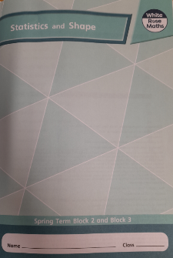  All activities are now in the accompanying workbooks in your packs or on the website. Please only follow the stated pages from each lesson. | Lesson 2  Today, we will be starting a new learning journey. This lesson is an introduction on how to recognise 2D and 3D shapes. Maybe you can spot some around your home or on a daily walk?  Click on the pictures to watch a maths song and a recorded lesson! Complete pages 26 to 29 in your booklets.  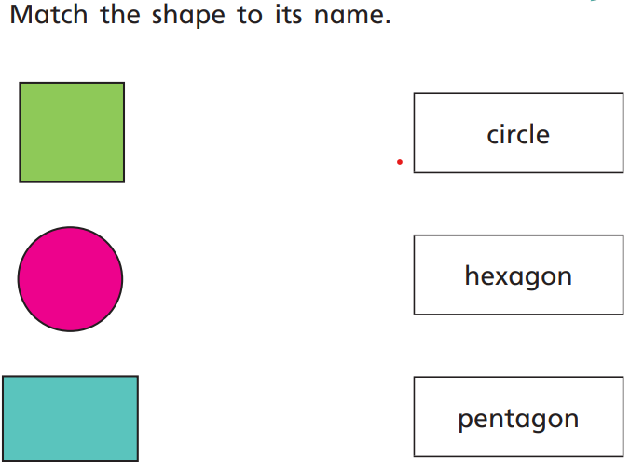
English  Experience lesson | Click the link to watch Mrs Robinson explain this lesson:  https://www.loom.com/share/809a14af7b2e456a82c1cfff26f25c7d  Look at the picture of Grandma when she was young: “Architect of the year”  Research: What do architects do?  Watch the following clip to find out more about architects’ work and how they design buildings. Think about how buildings are designed and what materials are used (e.g. shape, height and colour).  https://www.bbc.co.uk/teach/class-clips-video/pshe-ks1-ks2-proud-to-be-an-architect/zbf76v4  Activity  - Draw a picture of the outside view of your own home and label different parts with materials used to build it.  - Draw a bird’s eye plan of your own bedroom and label the furniture inside the room.
Spellings | past  Click on the link to watch our spelling lesson.  https://www.loom.com/share/5c201dd7bcfb427483fcaf773193ca72  father  class  grass  pass  plant  path  bath  hour  move
History | How could we keep boats safe at sea?  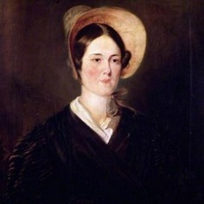  Listen to the story of Grace Darling. How do we keep sailors safe at sea today?  Cut and stick the images in chronological order of Grace Darling’s story. Retell the story of Grace Darling in full sentences on the lines next to each image. There is a word bank to help you.
Purple Mash | 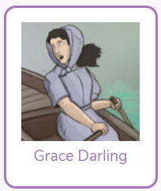  Click on the 2do and create a fact file about Grace Darling
Story | Listen to the story of “The Invisible String’ by Patrice Karst, read by Mrs van Rooyen.  https://www.loom.com/share/e139ac0a2fbf408da4791ac4e53b7d9d  