Fairtrade fortnight 22nd February – 7th March

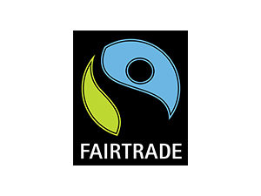

What’s Fairtrade? Fairtrade is about better prices, decent working conditions, local sustainability, and fair terms of trade for farmers and workers in the developing world.

Please use the Fairtrade resources to cover this in more detail. We have included: a PowerPoint, lunchbox activity, word-searches, Fairtrade colouring sheets and a Fairtrade banana split recipe.

The links below also explain Fairtrade to children in more detail. Pablo the Super-Banana takes children on a journey with the Fairtrade farmers and their families.
https://www.fairtrade.org.uk/
Pablo the Super-Banana (for early years groups) | Fairtrade Schools
