Summer – Location, Location

Science | History | Geography | Art | DT | Music | IT
Plants  Environment | The Great Fire of London  Samuel Peyps  Thomas Farriner | India  Continents and oceans | Taj Mahal scene | Tudor houses: model making  Fire engine: model making | Listen to Sitar music | Using IT to create, store and retrieve or work.

Sparling Starts/  Energisers/ Fabulous Finishers | - Planting out our seedlings in our allotment and harvesting produce.  - Baking bread to launch the Great Fire of London topic.  - Visit to Stony Stratford to learn about Human and Physical features.  - Visit to The Magdalen Tower to Learn about the Great Fire of Stony Stratford.  - Cooking a curry.  - Burn down “London”
Key Artists/  Art works | SAYED HAIDER RAZA  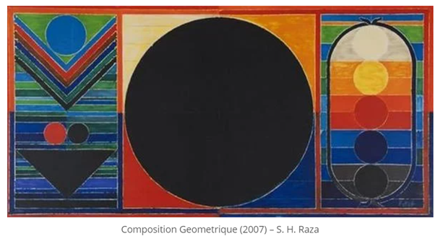  NANDALAL BOSE  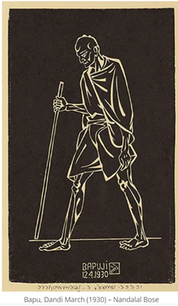
Key Composers/  Compositions: | 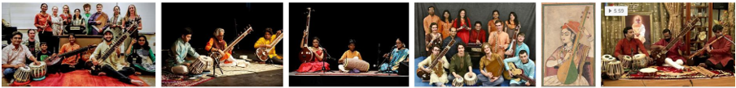  Listen to traditional Indian Sitar music and perform a dance to modern Bollywood music.

Science
 | Finger-Tip Knowledge (Plants) | Vocabulary | Skills
Plants | Germination is the process from where a seed goes from being dormant to beginning to grow.  All plants have a life cycle that culminates in creating and dispersing its own seeds.  Plants require sunlight, water, suitable temperature, pace and nutrition to grow and be healthy.  Compost can be used instead of soil as a growing medium and is broken down organic material, such as leaves and other dead plants. We can make our own compost to use on a compost heap.  Potatoes are tubers and not ‘seeds’. Potato plants need a lot of water.  Insects are attracted to flowers, which pollinates them.  Green potatoes are toxic. Potato plants can create seed heads which look like tomatoes- These are toxic.  We can eat and need lots of plants and seeds as part of a healthy, balanced diet. However, many are toxic which means that they cannot be eaten. | germination When the conditions are right, the seed soaks up water and swells, and the tiny new plant bursts out of its shell. This is called germination.  sprout When a plant sprouts, it grows new shoots.  shoot A shoot grows upwards from the seed or plant to find sunlight.  seed dispersal Seed dispersal is when the seeds move away from the parent plant. They can be moved by the wind or animals.  sunlight All plants need light from the sun to grow well. Some plants need lots of sunlight. Some plants only need a little sunlight.  water All plants need water to grow.  Withoutwater, seeds and bulbs will not germinate.  Temperature is the measure how warm or cold something or somewhere is. Some plants like cooler temperatures and some like warmer temperatures.  nutrition Food or nourishment. Plants make their own food in their leaves using sunlight. | - Observe and describe how seeds and bulbs grow into mature plants  - Predict the effect of different conditions on the germination of seeds.  - Observe and describe how plants need water, light and a suitable temperature to grow and stay healthy.  4. Observe and describe how seeds and bulbs grow into mature plants  5. Conduct a test and record the results of tasting different fruits and vegetables.
Environment | The environment is where we live. Our planet provides everything that we and all living things need. We call it our environment.  Humans create waste that needs to be managed. Otherwise it can damage our environment and lifecycles that rely on it. We have a responsibility for reducing waste.  There are ways to get rid of waste. All have some impact on our environment. Some can be burnt or incinerated; some is buried and some in recycled or reused.  Humans are changing the world by affecting the climate. This can cause more floods, more droughts, more storms and can melt sea ice.  Organic waste can be used to create compost.  Some waste can be recycled but needs to be sorted into different materials first (paper, glass, metal, some plastics).  Some products are a mixture of materials which cannot be recycled. Some products share logos or information about recycling.  Energy makes everything work. Electricity, gas and oil are all sources of power. They give us energy to make things work.  Non-renewable power sources such as coal, oil and gas can’t be replaced once they have been used. Scientists think these are running out. Renewable power sources can be replaced. This means they will never run out. Solar power, wind power, geothermal power, biomass and wave power.  Saving water is an important part of reducing climate change. We can reduce water by changing our everyday habits. | environment Our planet provides everything that we and all living things need. We call it our environment.  climate Climate is the weather. The earth’s climate is just right, meaning that things can live on the planet.  climate change Climate change is a change in the overall weather and temperature on Earth. (Not the day-to-day weather). The Earth is getting warmer due to some of the things humans are doing. This means it will be more difficult for livings things to survive.  atmosphere The layer of air surrounding the Earth.  greenhouse gas Greenhouse gases are special types of gas in the atmosphere. They let sunlight through but stop heat from escaping, like a greenhouse, so the Earth warms up.  Endangered Being endangered means that scientists think that a type of animal or plant is at risk.  Extinct Extinct means that there are none of that type of animal or plant left alive.  Renewable Renewable power sources can be replaced. This means they will never run out. Solar power, wind power, geothermal power, biomass and wave power are all renewable power sources.  Non renewable Non-renewable power sources such as coal, oil and gas can’t be replaced once they have been used. Scientists think these are running out. | 1.Observe how waste can impact on the local environment where we live and how we have means to dispose of that waste,  2.Classify different materials which can and cannot be recycled.  3. Communicate and follow instructions on how to create recycled paper.  4.Observe and record how energy is used around school.  5.Test and measure how much water can be saved by turning off the tap while washing hands.

What do plants need to grow?
What is the difference between a vegetable and a fruit?
Are all plants edible?
What is the difference between a seed and a bulb?
Can I grow my own food?
Why is it important to grow our own food?
How can I identify different flowers and trees?
What does ‘native’ mean?
Can I make a difference to the environment?
How can I reduce the waste that we make?
Why is protecting our environment important?
Where does our waste go?
How much water do we use everyday?
How can I recycle?

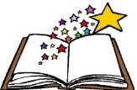  Books to be  Read | 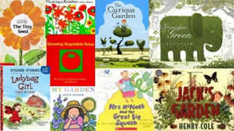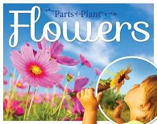
 | 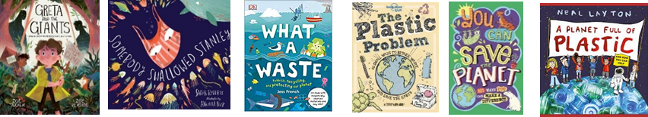

 | National Curriculum PoS | Learning | Lesson Knowledge
Week 1  Classify | Observe and describe how seeds and bulbs grow into mature plants  Find out and describe how plants need water, light and a suitable temperature to grow and stay healthy | What is the difference between a seed and a bulb?  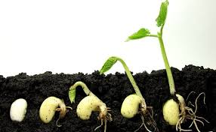  Growing Sunflowers | Plants need space and light to be healthy  Seeds need water and the right temperature to germinate and grow  Soil or another growing medium like compost is important to support root growth and for the plant to uptake nutrients and water.
Week 2  Observe | Observe and describe how seeds and bulbs grow into mature plants  Find out and describe how plants need water, light and a suitable temperature to grow and stay healthy | What is the life cycle of a plant?  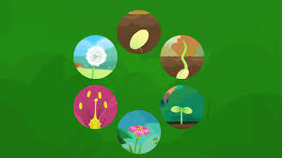  Growing sunflowers | Children understand that plants need space and light to be healthy  Children know that seeds need water and the right temperature to germinate and grow  Predict, and begin to give reasons for, what will happen to the cress in the dark cupboard  Start a record of the growth through observation  Soil or another growing medium like compost is important to support root growth and for the plant to uptake nutrients and water.
Week  3  Communicate | Observe and describe how seeds and bulbs grow into mature plants  Find out and describe how plants need water, light and a suitable temperature to grow and stay healthy | What do plants ned?  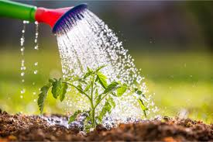  Context: Potato Tubers | Potatoes can be chitted to produce shoots first. Seed potatoes are not ‘seeds’ but can be used to produce more potatoes. They are tubers.  Potatoes are used to create many foods, such as crisps, chips and mashed potato. Potato plants need a lot of water. They can produce flowers which insects are attracted to.  Potato plants can produce seed heads which look like tomatoes- but are toxic. Green potatoes occur when they are exposed to light and are toxic.
Week 4  4  Observe | Observe and describe how seeds and bulbs grow into mature plants  Find out and describe how plants need water, light and a suitable temperature to grow and stay healthy | What is inside a flower?  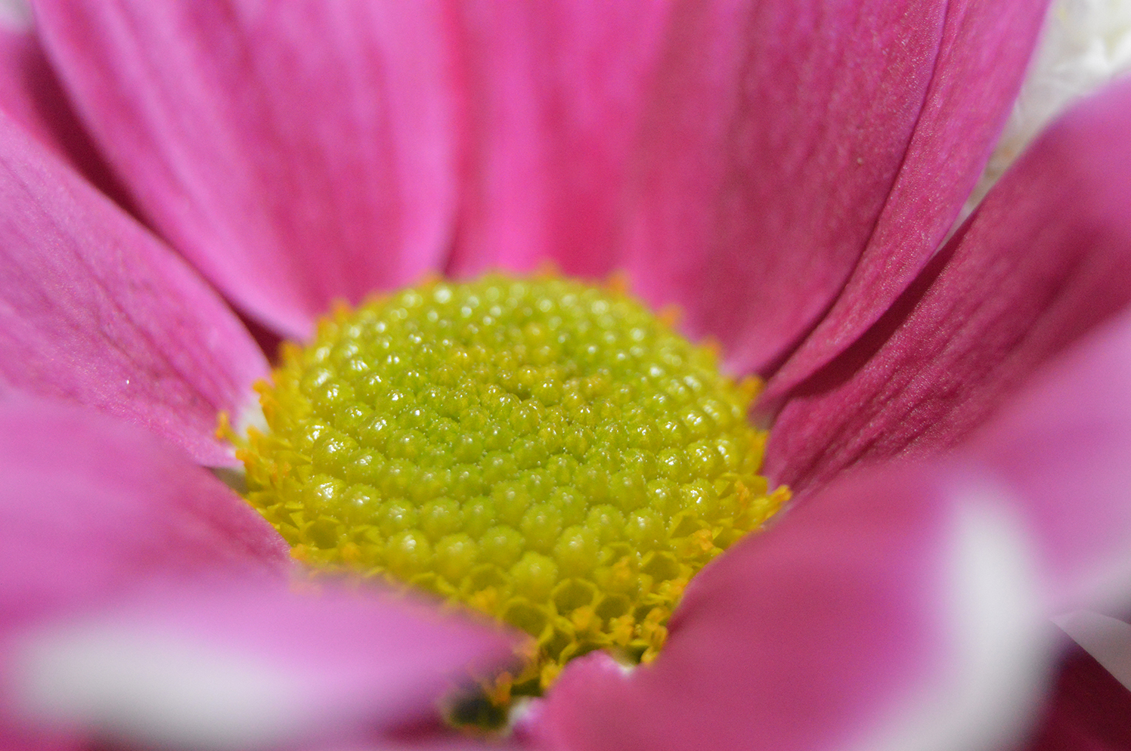  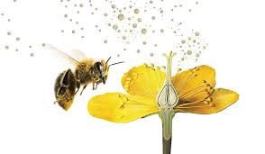 | Plants make flowers to attract insects to pollinate them.  They can be different colours, patterns and shapes but can also be colours that only insects can see.  Inside a flower the structures are pollen, anther, stamen, stigma, ovary, sepal and petal.
Week 5  Observe | Observe and describe how seeds and bulbs grow into mature plants  Find out and describe how plants need water, light and a suitable temperature to grow and stay healthy | Are all plants edible?  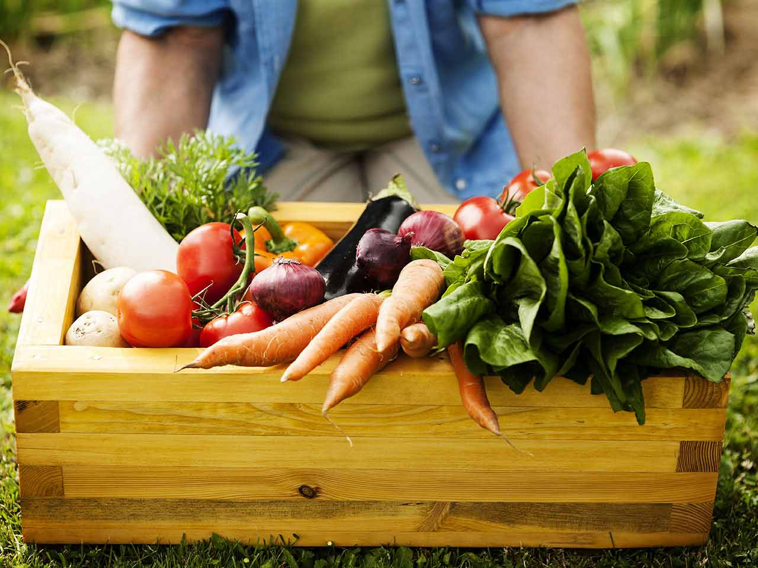  Are there any other ways that we can use plants?  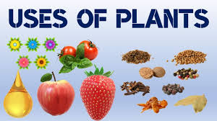 | Taste is one of our senses  Many plants and seeds are edible. This means we can eat them and need them as part of a balanced diet.  Many plants and seeds are not edible. They can be toxic and dangerous if eaten.  We can eat parts of plants. Some plants can produce fruits which can be eaten.
Week  6  Observe | Asking simple questions and recognising that they can be answered in different ways  Observe closely, using simple equipment  Using their observations and ideas to suggest answers to questions  Identify and compare the suitability of a variety of everyday materials, including wood, metal, plastic, glass, brick, rock, paper and cardboard for particular uses. | Where does our waste go?  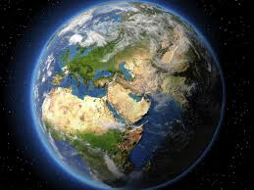  Context: Summer walk collecting and looking for rubbish in our environment. | The environment is where we live. Our planet provides everything that we and all living things need. We call it our environment.  Humans create waste that needs to be managed. Otherwise it can damage our environment and lifecycles that rely on it. Understand the importance of reducing waste and Develop a personal sense of responsibility for reducing waste.  There are ways to get rid of waste. All have some impact on our environment. Some can be burnt or incinerated; some is buried and some in recycled or reused.
Week  7  Classify | Asking simple questions and recognising that they can be answered in different ways  Observe closely, using simple equipment  Using their observations and ideas to suggest answers to questions  Identify and compare the suitability of a variety of everyday materials, including wood, metal, plastic, glass, brick, rock, paper and cardboard for particular uses. | How can we reduce our waste?  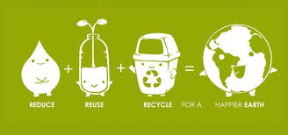  Context: Sorting recyclable materials. | We can reduce the waste that gets burned or sent to landfill.  We can reduce, reuse, recycle, compost.  Organic waste can be used to create compost.  Some waste can be recycled but needs to be sorted into different materials first (paper, glass, metal, some plastics).  Some products are a mixture of materials which cannot be recycled. Some products share logos or information about recycling.
Week 8  Communicate | Asking simple questions and recognising that they can be answered in different ways  Observe closely, using simple equipment  Using their observations and ideas to suggest answers to questions  Identify and compare the suitability of a variety of everyday materials, including wood, metal, plastic, glass, brick, rock, paper and cardboard for particular uses. | What is recycling?  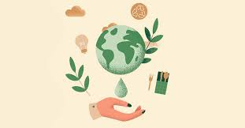  Context: making recycled paper  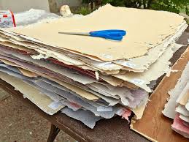 | Paper is a material which can be recycled and processed to be made into paper again.  The process reduces waste.
Week  9  Observe | Asking simple questions and recognising that they can be answered in different ways  Observe closely, using simple equipment  Using their observations and ideas to suggest answers to questions  Gathering and recording data to help in answering questions  Ask simple questions and recognising that they can be answered in different ways  Observe closely, using simple equipment  Using their observations and ideas to suggest answers to questions | How do we use energy?  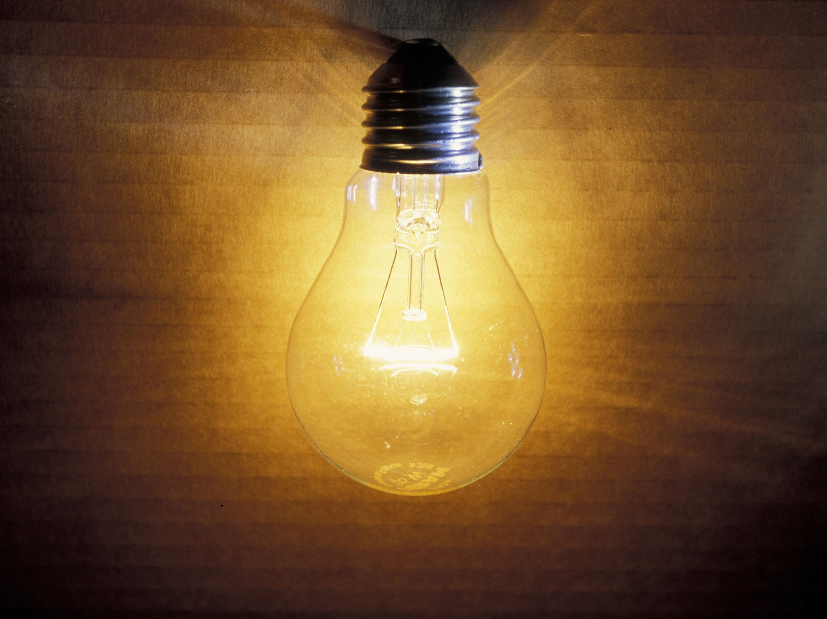  Context: measuring energy around the school. | Energy makes everything work.  Electricity, gas and oil are all sources of power. They give us energy to make things work.  Non-renewable power sources such as coal, oil and gas can’t be replaced once they have been used. Scientists think these are running out. Renewable power sources can be replaced. This means they will never run out. Solar power, wind power, geothermal power, biomass and wave power.
Week  10  Test | Performing simple tests.  Set up a test and record the results.  Observe closely, using simple equipment by measuring the different amounts of water used.  Accurately measure water and record measurements. | How much water do we use everyday?  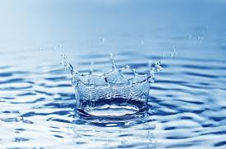  Context: Investigating how much water can be saved by turning off the tap while washing hands. | Salt water is from the sea or ocean.  Freshwater is what land animals need to drink. It is not salty and is found in streams, rivers, lakes and reservoirs.  Groundwater is water that's found underground. It can be contaminated by pollution.  Being wasteful can contribute to climate change. Saving water is an important part of reducing climate change. This is called water conservation.  We can reduce water by changing our everyday habits.

History/Geography
 | Finger Tip Knowledge | History Knowledge | Vocabulary | Skills
History – Significant People  Environment | The Fire Started at a bakery on Pudding Lane.  Samuel Pepys kept a diary.  Sir Christopher Wren redesigned London after the fire.  Fires help to develop new firefighting equipment. | The Great Fire of London (Sun 2nd September 1666 - Thur 6th September): A fire started in Thomas Farriner’s bakery on Pudding Lane on 2/9/1666. The fire spread quickly towards London Bridge. more than 300 houses were destroyed. People fled from London as the fire continued to spread. Some houses were blown up to help contain the fire. The city was very dry and the buildings were close together and made from wattle and daub. St Paul’s Cathedral was destroyed by the fire.  Samuel Pepys (1633-1703): Navy administrator and an MP. He wrote a diary at the time of the GFoL which has been used for many years as a strong piece of evidence/research on the fire and the 17th century.  Thomas Farriner (1615-1670): Owned a bakery on Pudding Lane in London. It was in this bakery that the Great Fire of London started. | The Great Fire of London  Pudding Lane  Past  Spreading of the fire  Thomas Farriner  Samuel Pepys  Diary | Speak about how he/she has found out about the past (organisation and communication)  Record what they have learned by drawing and writing (organisation and communication)  Show an awareness of the past, using common words and phrases relating to the passing of time  Describe where the people and events he/she studies fit within a chronological framework and identify similarities and differences between ways of life in different periods  Use a wide vocabulary of everyday historical terms  Ask and answer questions, choosing and using parts of stories and other sources to show that he/she knows and understands key features of events  Show understanding of some of the ways in which we find out about the past and identify different ways in which it is represented  Describe events beyond living memory that are significant nationally or globally e.g. the Great Fire of London, the first aeroplane flight or events commemorated through festivals or anniversaries  Discuss the lives of significant individuals in the past who have contributed to national and international achievements and use some to compare aspects of life in different periods
Geography - India | Finger tip knowledge  India is part of Asia.  India lies in the Northern Hemisphere  The weather is mainly hot most of the year with significant variations from region to region  The Taj Mahal is in Agra  The capital city of India is New Dehli | Geographical Knowledge  There are 7 continents which include: North America, South America, Europe, Africa, Antarctica, Asia and Australasia. There are 5 oceans which include: Pacific Ocean, Atlantic Ocean, Arctic Ocean, Indian Ocean and the Southern Ocean.  India is part of Asia.  India lies in the Northern Hemisphere  India occupies the greater part of South Asia | Vocabulary  Key Human Features:  town  houses  shops  roads  city  shops  roads  Temple  Key Physical Features:  field  soil  river  flat  hot  mainland  Locate:  Northern Hemisphere  Southern Hemisphere  Equator  North Pole  South Pole | Skills  Name and locate the world’s 7 continents and 5 oceans  Use world maps, atlases and globes to identify the United Kingdom and its countries, as well as the countries, continents and oceans studied at this key stage  Use simple compass directions (north, south, east and west) and locational and directional language [for example, near and far, left and right], to describe the location of features and routes on a map  Use aerial photographs and plan perspectives to recognise landmarks and basic human and physical features; devise a simple map; and use and construct basic symbols in a key  Use simple fieldwork and observational skills to study the geography of their school and its grounds and the key human and physical features of its surrounding environment.

What changes were made after the GFoL?
How do we know about the GFoL?
How can we research historical events?
What are the similarities and differences between Agra and Stony Stratford?

Books to be  Read | 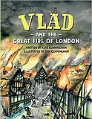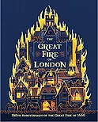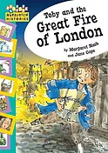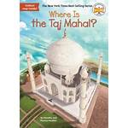

 | National Curriculum PoS | Learning | Lesson Knowledge
Week 1 Geography  1  Geography | Use world maps, atlases and globes to identify the United Kingdom and its countries, as well as the countries, continents and oceans studied at this key stage  Name and locate the world’s 7 continents and 5 oceans | Key Question  Where is India?  What is the climate like in India?  Using the atlases find India. Where is it? Is it near or far way? Is it near to the equator? What do you think that the climate is like in India?  BBC Two - Primary Geography, India - Clips  Watch the video and discuss what the different parts of India are like.  Using the blank map labels the continents.  Compare and create the Indian flag and the flag of the United Kingdom. | India is part of Asia.  India lies in the Northern Hemisphere  India, country that occupies the greater part of South Asia. It is a constitutional republic that represents a highly diverse population consisting of thousands of ethnic groups. Its capital is New Delhi. With roughly one-sixth of the world’s total population, it is the second most populous country, after China  The weather is mainly hot most of the year with significant variations from region to region. The coolest weather lasts from around the end of November to the beginning of March, with fresh mornings and evenings, and mostly sunny days. The really hot weather, when it is dry, dusty and very hot, is between March and June.
Week 2 Geography | Understand geographical similarities and differences through studying the human and physical geography of a small area of the United Kingdom, and of a small area in a contrasting non-European country | What are the similarities and differences between Agra and Milton Keynes?  Look at the book ‘Where is the Taj Mahal?’ Think carefully what are the similarities and differences between Milton Keynes and Agra?  Complete the similarities and differences sheet. | The Taj Mahal is in Agra, there is a population of 1.5 million. Milton Keynes has the MK city church and there is a population of 250 thousand.
Week 3 Geography | Use simple fieldwork and observational skills to study the geography of their school and its grounds and the key human and physical features of its surrounding environment. | How could we describe the Human and Physical features of our school and its grounds?  Look at an aerial view of our school on Google Earth. How would we describe our school and its grounds? Is it by the coast? Is it in the mainland? Is it in a Forest? Is it near a river?  Complete the description of our school. | Russell Street School is located in the centre of Stony Stratford town. It is near to houses and a road. There are shops nearby.  It is flat.
Week 4 Geography | Use basic geographical vocabulary to refer to:  key physical features, including: beach, cliff, coast, forest, hill, mountain, sea, ocean, river, soil, valley, vegetation, season and weather  key human features, including: city, town, village, factory, farm, house, office, port, harbour and shop  Use aerial photographs and plan perspectives to recognise landmarks and basic human and physical features; devise a simple map; and use and construct basic symbols in a key | Experience Lesson:  Walk around the town, up and down the High Street and around the Mill Field. At various points describe the human and physical features- recapping the vocabulary used. (This could be two lessons)  Create/use a map of the town and label key human and physical features.  Compare this to an aerial view/map of Agra- what do you notice?  Discuss and compare using geographical vocabulary. | Stony Stratford  Key Human Features:  town  houses  shops  roads  Key Physical Features:  field  soil  river  Agra:  Human Features  City  shops  roads  Temple  Physical features  flat  hot  mainland
Week 5 Geography | Identify seasonal and daily weather patterns in the United Kingdom and the location of hot and cold areas of the world in relation to the Equator and the North and South Poles | Where is the United Kingdom on a map?  What is the difference between weather and climate?  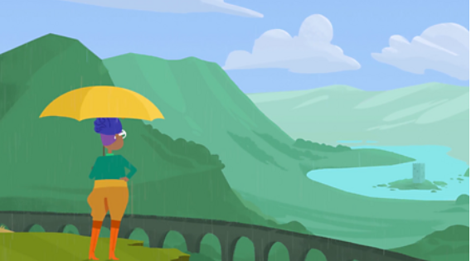  Which parts of the world are hot? Which are cold?  Locate the equator and northern and southern hemispheres on a map of the world.  Using Purple Mash, create a weekly weather report for Stony Stratford.  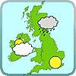 | Locate:  Northern Hemisphere  Southern Hemisphere  Equator  North Pole  South Pole.
History Week 1  Week  1 | Describe events beyond living memory that are significant nationally or globally e.g. the Great Fire of London, the first aeroplane flight or events commemorated through festivals or anniversaries.  Show understanding of some of the ways in which we find out about the past and identify different ways in which it is represented  Speak about how he/she has found out about the past (organisation and communication)  Record what they have learned by drawing and writing (organisation and communication) | Key question  Where did the fire start?  Why did the fire start?  What happened in the Great Fire?  Read or tell the story of the fire in as much detail as possible, illustrating it with pictures.  Model using Magic Grandad and writing down key facts.  Children to research using Magic Grandad to find out how the fire started and where.  In mixed ability groups children to sort pictures of then and now in London.  Children to write and draw key information down with their learning partner.  http://www.fireoflondon.org.uk/game  http://www.schoolsliaison.org.uk/kids/aston/ks1/firelondon/greatfire.htm | - The GFoL was a fire in London in 1666.  - The GFoL began on Pudding Lane in Thomas Farriner’s bakery and lasted for 4 days.  - Compare 17th century London to modern London
History Week 2 | Describe where the people and events he/she studies fit within a chronological  Describe events beyond living memory that are significant nationally or globally e.g. the Great Fire of London, the first aeroplane flight or events commemorated through festivals or anniversaries | Key question:  What were the order of events?  Discuss with the children the story of the fire. Ask questions to check how much they have understood, using pictures to reinforce the story.  Why did the fire start? Where did it start? What happened? Why did it end? What were the results of the fire? Why was it called the Great Fire?  Give the pupils a list of the events and ask them to list the main events in chronological order cut out and stick in their books.  Children to be given differentiated sheets.  Children are to match dates and pictures with writing about the events in chronological order. | - Sept 2nd 1666: The fire starts at Thomas Farriner’s bakery on Pudding Lane.  - As news of the fire spreads, people run to escape from its path.  - Samuel Pepys starts to record the unfolding events in his diary.  - Houses are pulled down to prevent the spread.  - People leave London on the River Thames with their belongings.  - The fire spreads close to the Tower of London.  - St Paul’s Cathedral is destroyed.  - The wind dies down and the fire is finally under control.
History Week 3 | Show an awareness of the past, using common words and phrases relating to the passing of time.  Ask and answer questions, choosing and using parts of stories and other sources to show that he/she knows and understands key features of events  Describe where the people and events he/she studies fit within a chronological framework and identify similarities and differences between ways of life in different periods | How was the fire extinguished?  How are fires put out today?  Discuss with children how the fire was put extinguished and how it is different from today. Talk about what was used and why. Invite the children to ask questions using historical terms.  Use Magic Grandad to explain what was used and why.  http://www.fireoflondon.org.uk/game  Use pictures of firefighting equipment from then and now. In mixed ability pairs ask children to discuss a feature of firefighting e.g. alarm bells, fire brigade, hoses , safety clothing, fire breaks, fire engines, water sources. Explain about the fire that happened in Stony Stratford recently. How was it extinguished?  Which method is best? Why | - They put the fire out with buckets of water  - Modern fire brigade has changed a lot since 1666  - The current fire brigade are better equipped to fight fire safely
History Week 4 | Ask and answer questions, choosing and using parts of stories and other sources to show that he/she knows and understands key features of events  Describe events beyond living memory that are significant nationally or globally e.g. the Great Fire of London, the first aeroplane flight or events commemorated through festivals or anniversaries | Why did the fire spread so quickly?  Show the pupils pictures of typical  seventeenth-century houses, churches and street scenes. Encourage them to describe the street scene and what the houses are made from.  Discuss with the children the reasons why the fire spread rapidly and why people took refuge in churches and in boats on the river.  Go to https://www.bbc.co.uk/newsround/37222884 Children to be given pictures showing the burning houses scene and they are to write sentences explaining why the fire spread.  Children can use pictures, sentence starters and word mats. Extension: refer to the materials houses were made from, the wind, the dry summer, fire fighting methods, etc. | The fire spread quickly because:  - The houses were made of wattle and daub (burnt easily)  - Houses were built close together  - There had been a very long dry summer  - A strong wind blew the flames  In 1666 there was little equipment to put the fire out.
History Week 5 | Discuss the lives of significant individuals in the past who have contributed to national and international achievements and use some to compare aspects of life in different periods  Describe events beyond living memory that are significant nationally or globally e.g. the Great Fire of London, the first aeroplane flight or events commemorated through festivals or anniversaries  Describe where the people and events he/she studies fit within a chronological framework and identify similarities and differences between ways of life in different periods  Show an awareness of the past, using common words and phrases relating to the passing of time | Who was Samuel Pepys?  What is a diary?  How do we know what happened in the  Great Fire?  Discuss with the children what an eyewitness is, and how an eyewitness can help us to know what happened in the past. Show children some pictures of the fire produced at the time.  Help them to recognise those things an eyewitness would see, eg people in boats on the river, the direction of the fire’s smoke.  Show them the portrait of Samuel Pepys. Tell the children about him, his work and his diary.  Discuss what a diary is, whether it is fact or fiction, and the sort of information people keep in diaries. Why might diaries from the past be useful to us today?  Read short, edited extracts from Pepys’ diary about the fire and what happened in London afterwards.  Children to write an entry using tea bag/ burnt paper as if they are Samuel Pepys.  Children to be given word mats and writing prompts to support them. Make links to English. | - A diary is a personal piece of writing with explanations of why and how events took place.  - An eye witness is someone who saw an event take place first hand.  - Samuel Pepys wrote in his diary about the GFoL - this is a main piece of evidence that helps us understand GFoL
History Week 6 | Show understanding of some of the ways in which we find out about the past and identify different ways in which it is represented  Speak about how he/she has found out about the past (organisation and communication)  Record what they have learned by drawing and writing (organisation and communication) | Which historical sources are useful?  Which sources are less useful?  Talk about which sources we have used to find out about the GFoL.  Concentrate on Samuel Pepys diary, a contemporary painting of the GFoL and other paintings from books which were not contemporary, prints of the time, computer programmes.  Discuss which we have found most useful and why. Which are the most reliable? Why? Which are most likely to help us find out about what it was really like?  Children are to write about 2 sources - Samuel Pepys’ diary and the computer programme/game. Have pictures of these things as prompts and explain that the primary sources are more likely to be accurate although secondary sources are useful. | - Some sources of information are useful, others are less useful  - We can use a variety of sources to factually research a topic  - primary sources are direct sources of information  - secondary sources are ‘second hand’ information -these can be reliable but can also be less reliable
History Week 7 | Describe where the people and events he/she studies fit within a chronological framework and identify similarities and differences between ways of life in different periods  Describe events beyond living memory that are significant nationally or globally e.g. the Great Fire of London, the first aeroplane flight or events commemorated through festivals or anniversaries  Use a wide vocabulary of everyday historical terms  Record what they have learned by drawing and writing (organisation and communication) | How was London rebuilt after the fire?  Who designed London after the fire?  Show the children pictures of the streets of London before the fire, and discuss.  What was dangerous? What could make the new houses safer? What can be done to make the streets cleaner? What could they do to make the streets wider?  Make a list on the board of things that would make London a safer place.  Discuss the equipment the fire-fighters used to put out the fire. What modern equipment would have helped, and make a list on the board.  Children to draw a scene from London in the past and London today. They are to label features and write 2 sentences to say how it has changed/compare. Extension: compare to Victorian London from previous term.  Children to be given word prompts and have adult support where required. | - Houses being built close together/narrow streets were not safe.  - Streets were dirty  - London was improved when it was rebuilt. it was made safer.  - Lots of lessons were learnt as a consequence of GFoL  - Fire brigades have better more effective equipment now.

Art/DT
 | Key works of art to recognise/ Artists to know: | Vocabulary/ Knowledge (see BIG Questions) | Skills (ART) | Skills (DT)
Art  DT | 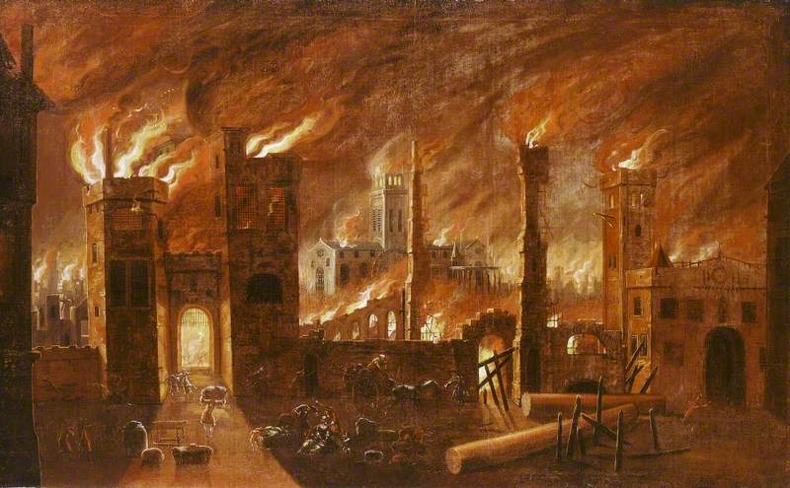  The Great Fire of London by Jan Griffier (1652-1718)  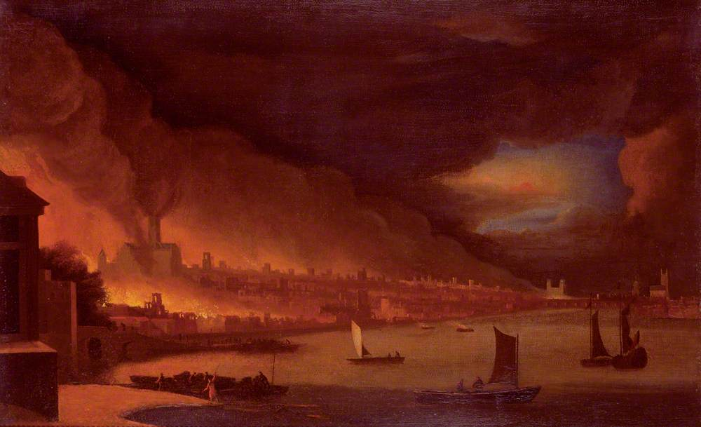  The Great Fire of London - Waggoner  There are some pieces of GFoL art by unknown artists held in museums and galleries:  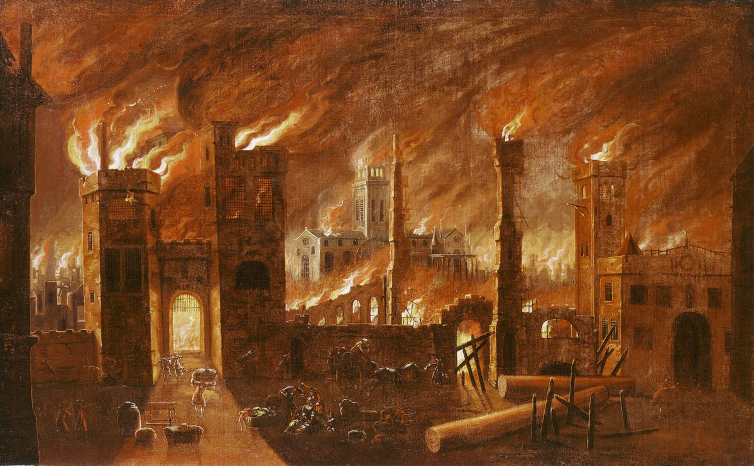 | Tudor house  Materials  Wattle and daub  Wooden frame  Flammable  Design  Create  Evaluate  Model  Mechanisms  Levers  Sliders  Axles  Wheels  Rotate  Moving  Taj Mahal  India  Symmetrical  17th Century | - Children know how to use different grades of pencil in my drawing for a specific purpose.  - Children know how to use charcoal, pencil, pens and pastels.  - Children know how to create different tones using light and dark.  - Children know how to mix paint to create all the secondary colours.  - Children begin to make tints by adding white.  - Children begin to make tones by adding black. | - design purposeful, functional, appealing products for himself/herself and other users based on design criteria  - generate, develop, model and communicate his/her ideas through talking, drawing, templates, mock-ups and, where appropriate, information and communication technology  - select from and use a wide range of materials and components, including construction materials, textiles and ingredients, according to their characteristics  - choose materials and explain why they are being used depending on their characteristics  - evaluate his/her ideas and products against design criteria  - join materials together as part of a moving structure  - explore and use mechanisms e.g. levers, sliders, wheels and axles, in his/her products

What is an axle?
Why do we need to design something before making it?
Why did the buildings in London burn so quickly?
Where did the fire start?
What happened after the fire?

Books to be  Read | 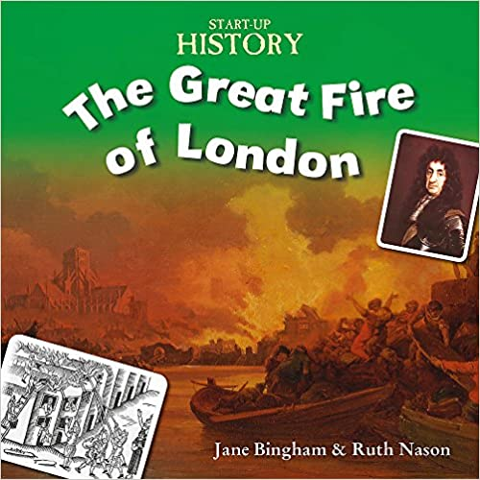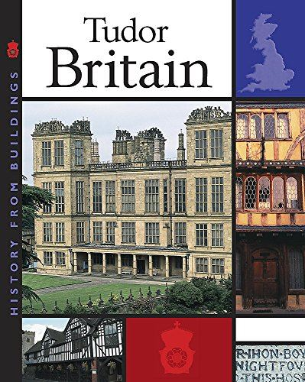

 | National Curriculum PoS | Learning Intention | Lesson Knowledge
Week 1 – DT | - generate, develop, model and communicate his/her ideas through talking, drawing, templates, mock-ups and, where appropriate, information and communication technology | 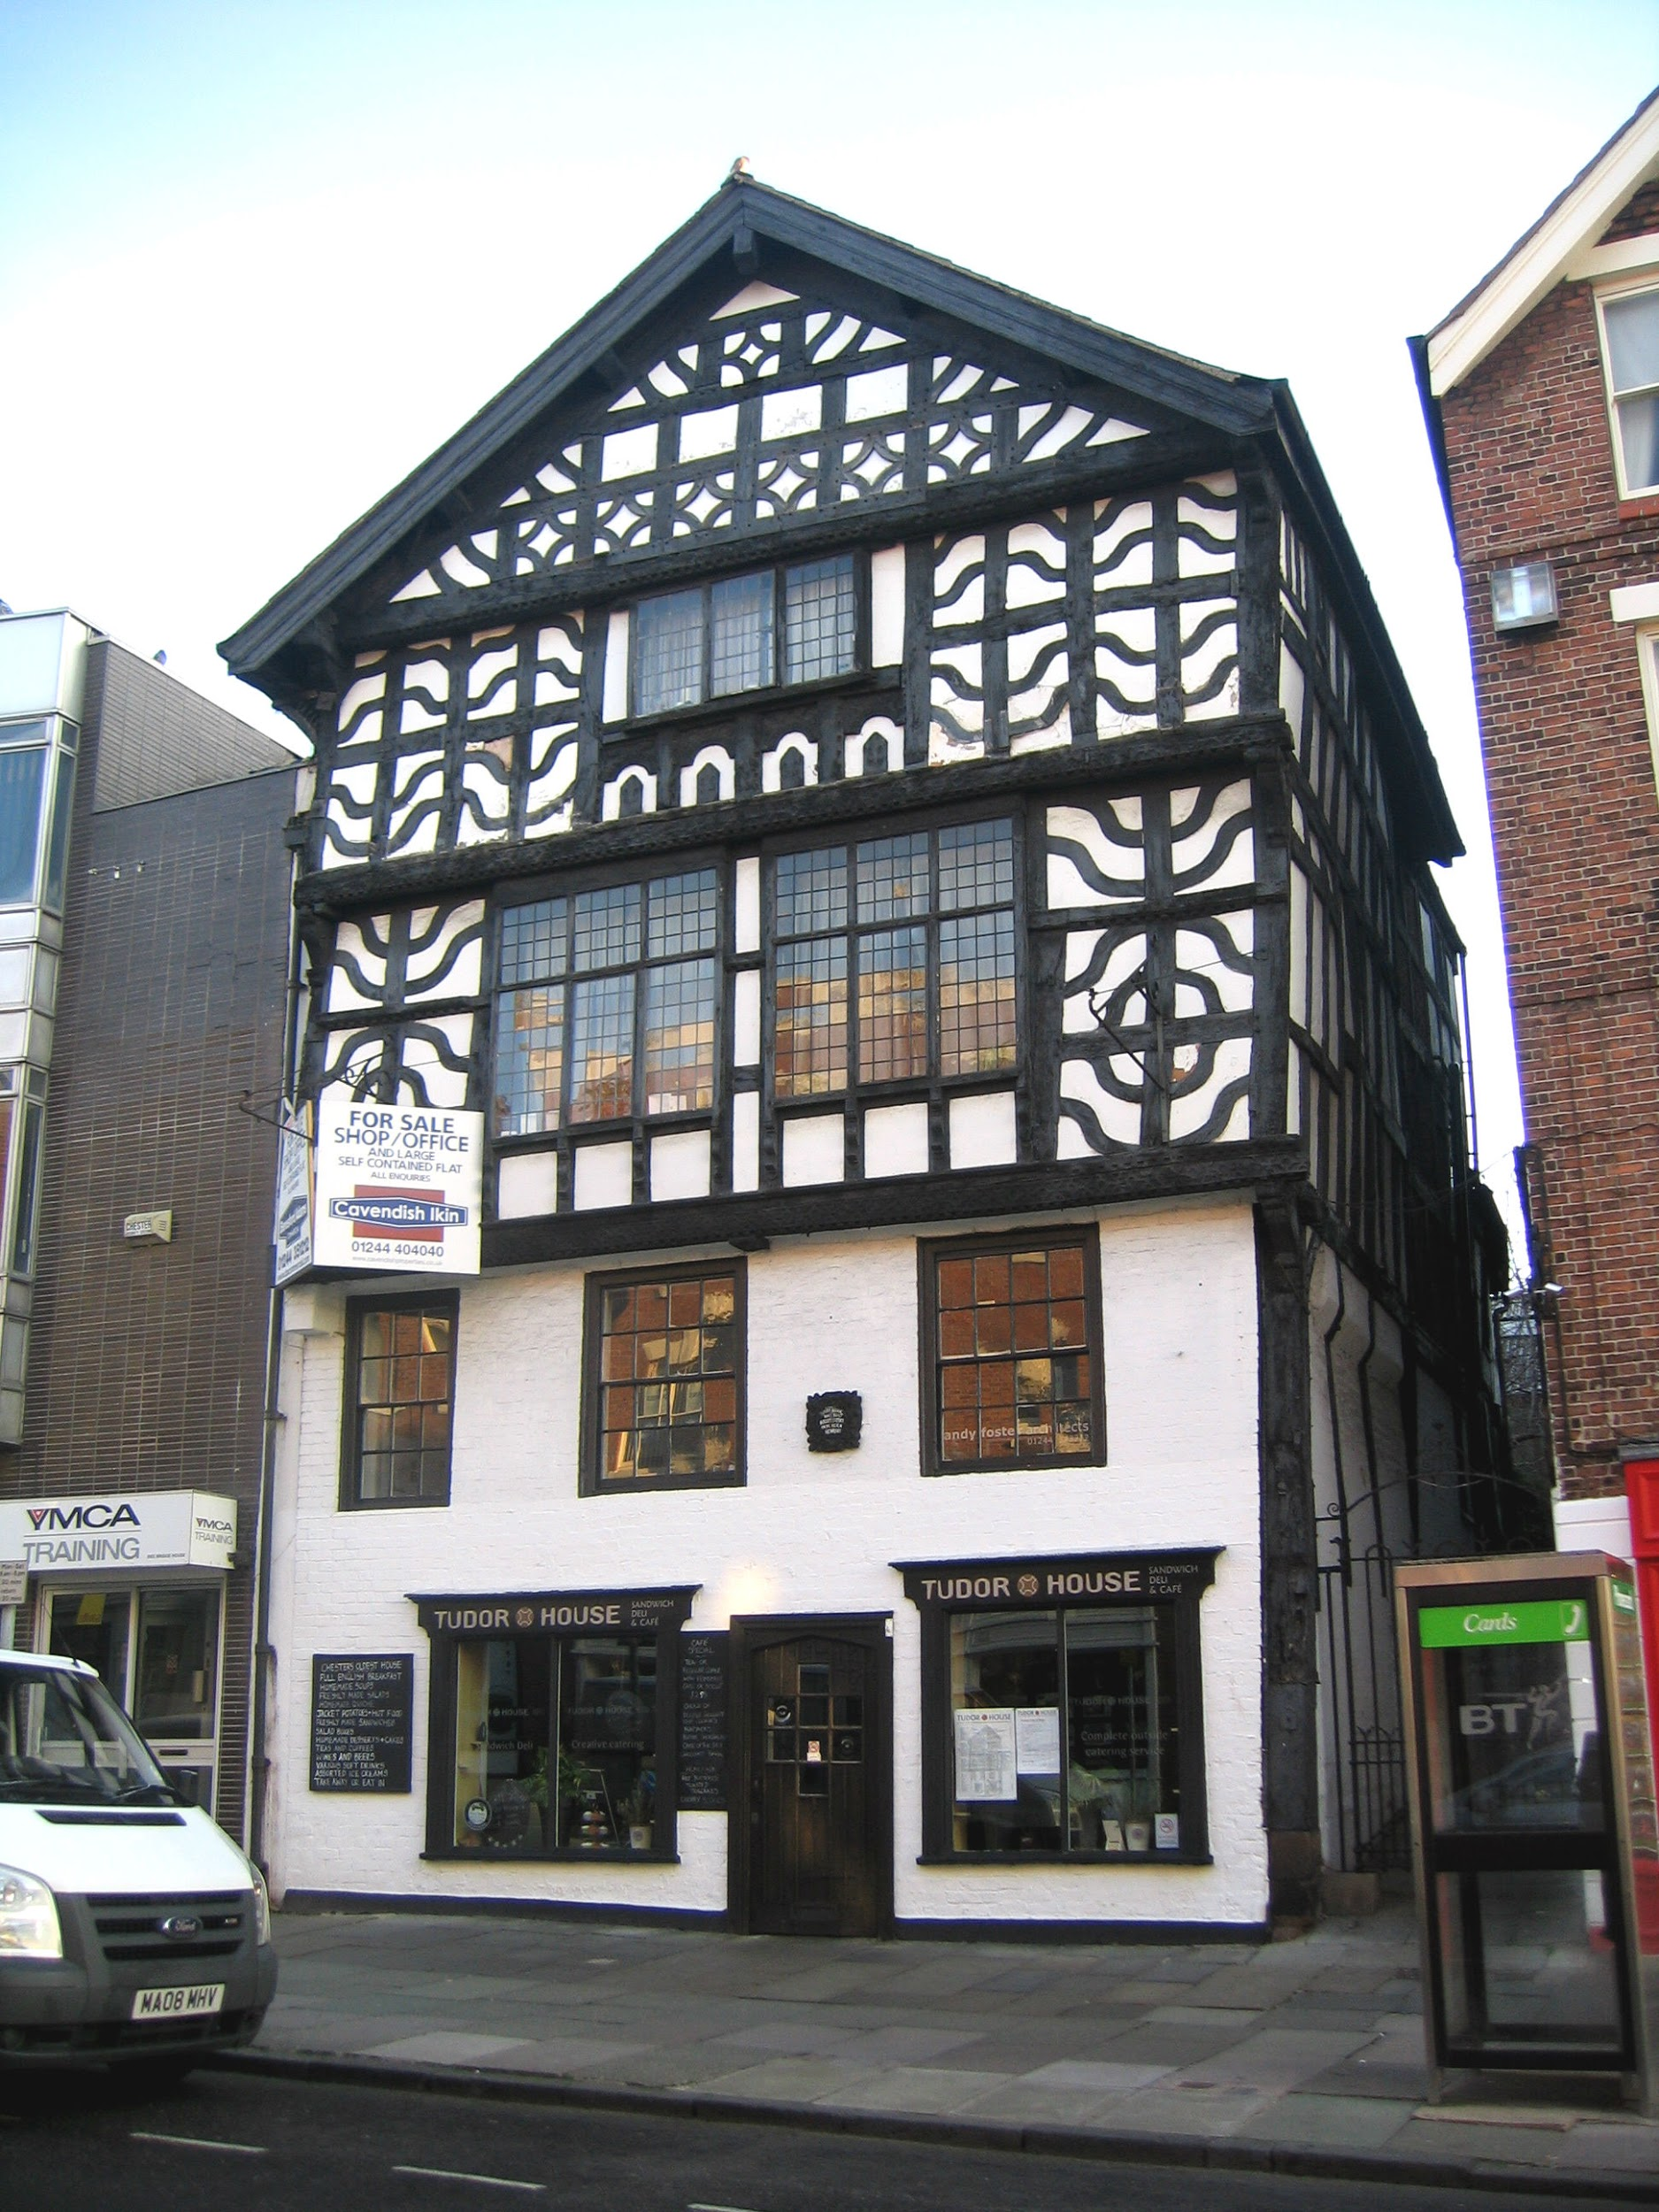  What does a Tudor house look like?  Show photographs of the style of houses in 1666.  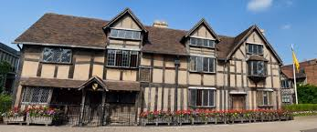  Discuss the materials the houses were made from: wattle and daub, wooden frames, straw roof, pitch to preserve and strengthen wood (flammable)  Discuss the panelled patterns on the houses and how close together they were built.  Children to draw a Tudor style house and label the key features of houses compared to now.  Draw a house from 1666 and now. Label the materials and key features of the houses. Extension: Write sentences to discuss the differences between the houses | Tudor houses were made from wattle and daub and had straw roofs.  Houses were made from flammable materials.  Houses were built close together, particularly on the first floor upwards.
Week 2 - DT | - design purposeful, functional, appealing products for himself/herself and other users based on design criteria  - choose materials and explain why they are being used depending on their characteristics | To design their own Tudor style house  Recap the materials and key features of houses in 1666. Again look at photographs. Why do you think they were so badly destroyed? (narrow streets, wooden houses) What materials were they made from?  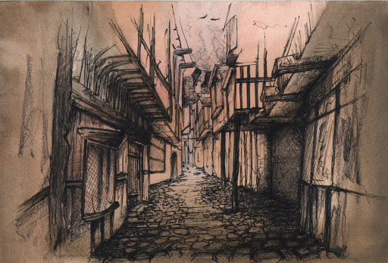  Watch the video clip  The Great Fire of London 1666 - YouTube  Discuss the differences between houses today and materials used to build houses then. Explain that we will be designing and creating our own houses in keeping with GFoL style – link to use of materials in science. Discuss the design of the house first.  Children use the design sheet to design and label their Tudor house. Specification: 3D, sturdy and visually of a Tudor style. What materials will you use for each part of the house? Extension: Why will you use those materials?  NB: Collect cereal boxes for the next lesson. | Houses were badly destroyed because they were close together and built from flammable materials.  Tudor houses had a wooden frame that made patterns on the building.  A design is a drawing of something you plan to make. A list of materials enables you to plan for your work.  Some materials are more appropriate for a purpose than others.
Week 3 -DT | - Generate, develop, model and communicate his/her ideas through talking, drawing, templates, mock-ups and, where appropriate, information and communication technology  - Select from and use a wide range of materials and components, including construction materials, textiles and ingredients, according to their characteristics  - Choose materials and explain why they are being used depending on their characteristics | To create a model of a Tudor house  Model showing children how they can use their design sheet to create their GFoL house. Reinforce that children must use the materials they chose at the design stage. Children must collect their own materials.  Children can use their chosen materials to make their house. Children must consider how to decorate their house. Once complete, evaluate their creation by completing the evaluation sheet.  Plenary: Take photos of the children with their houses. After that, take the houses out onto a safe space in the playground. Line them up to replicate London in 1666. Set them alight and see how quickly they burn. 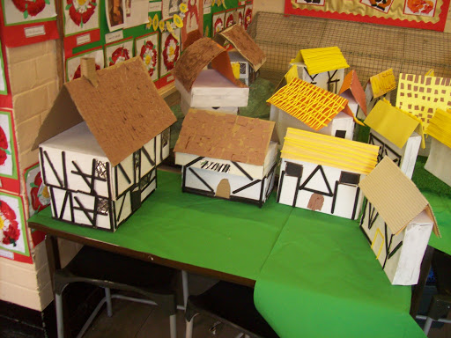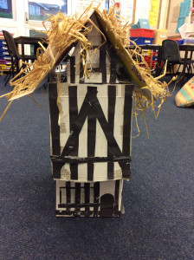 | Following a design or plan helps when making something.  Some materials are more appropriate for a purpose than others.  Some materials are best suited to join other materials.  The houses in London in 1666 burnt quickly because they were close together.
Week 4 - DT | - explore and use mechanisms e.g. levers, sliders, wheels and axles, in his/her products  - generate, develop, model and communicate his/her ideas through talking, drawing, templates, mock-ups and, where appropriate, information and communication technology | What are mechanisms?  Examine a range of toys and vehicles and pictures of toys and vehicles with various mechanisms. Identify their names and parts. Identify parts that move and parts that don’t. Identify the features of the vehicles and what they are used for. Introduce new key vocab- chassis, wheel, axle, cab etc.  Experiment with K-nex, Tic-Tac, straws and card - joining parts together and making frames / moving parts. Look at the ways that wheels and axles can be joined (wheels fixed onto the axle which rotates / axle is fixed and the wheels rotate).  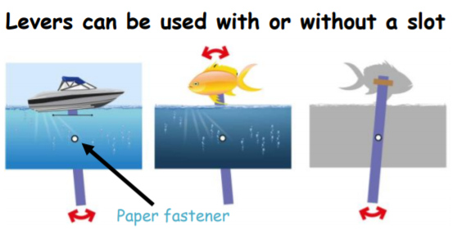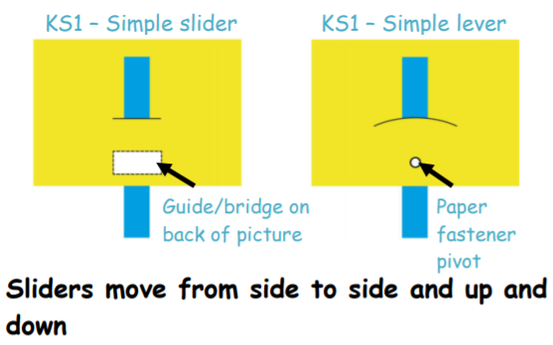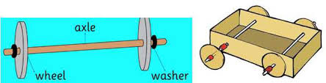 | Mechanisms are parts that work together to make something move.  Levers and sliders can move things up and down or side to side.  Wheels work with an axle to turn and move e.g. like on a vehicle or a pushchair.  An axle is fixed, a wheel moves/rotates.
Week 5 - DT | - design purposeful, functional, appealing products for himself/herself and other users based on design criteria  - choose materials and explain why they are being used depending on their characteristics  - generate, develop, model and communicate his/her ideas through talking, drawing, templates, mock-ups and, where appropriate, information and communication technology | To design a moving vehicle.  Explain to the children that in 1666 there were no ‘fire engines’ and we’re lucky enough to have them in modern times. Discuss the function of a fire engine – what are the important design features? Generate ideas with talk partners for – size of model in cms, shape of model, how many wheels, how it might be finished (what to include on the outside). Generate ideas for the tools that we might need and introduce a glue gun and other tools that may be used. Discuss the materials that we could use and give chn the chance to look at and hold some potential chassis materials – evaluate them and agree on using wood. Discuss joining techniques and what will be suitable for this purpose.  Children are to complete their fire engine design sheet to meet this brief:  - it must move  - it must be strong  - it must have 4 wheels  - it must have axles  - it must be brightly coloured | Fire engines did not exist in 1666.  Fire engines have sirens, a ladder, a hose, doors, wheels, main body.  Following a design or plan helps when making something.  Some materials are more appropriate for a purpose than others.  Some materials are best suited to join other materials.
Week 6 DT | - join materials together as part of a moving structure  - select from and use a wide range of materials and components, including construction materials, textiles and ingredients, according to their characteristics  - choose materials and explain why they are being used depending on their characteristics  - explore and use mechanisms e.g. levers, sliders, wheels and axles, in his/her products | How do we use tools safely?  Show a few examples of the work children the children may create. Model making the body of the fire engine. Children begin making the body of their model. Support where required - children to work in partners.  Discuss: Who can talk the class through what they have done so far and how? What will the next stage be?  Model to the class how they will complete stage 2 of their engines.  Recap the safety points for using the glue gun today.  Children are to join the axles and wheels to their chassis using the glue gun/PVA glue as appropriate. See diagrams for axles and attachments.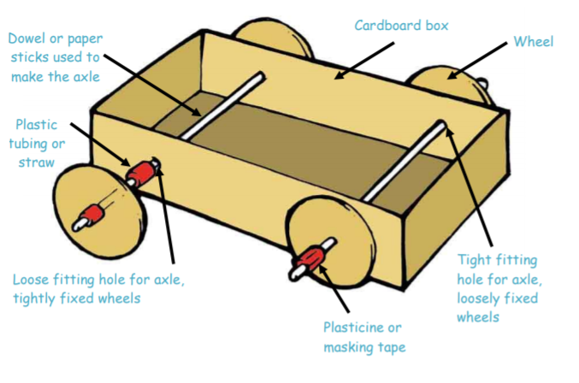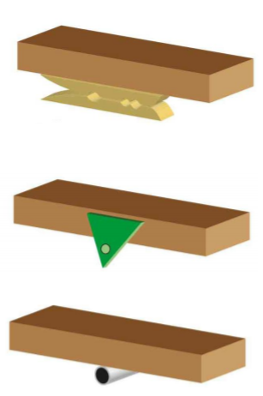 | How to use tools and equipment safely.  Different tools and equipment may need handling differently.  Some materials are more appropriate for a purpose than others.  It is important to follow a design/plan to ensure you make the model correctly.
Week 7 - DT | - generate, develop, model and communicate his/her ideas through talking, drawing, templates, mock-ups and, where appropriate, information and communication technology  - select from and use a wide range of materials and components, including construction materials, textiles and ingredients, according to their characteristics  - choose materials and explain why they are being used depending on their characteristics | How do we use tools safely?  Model to the class how they will complete the next stage of their engines.  Recap the safety points for using the glue gun/scissors etc today. Ensure all chn know what they are going to use for the different parts of their fire engine.  Children complete the finer details of their model: use ICT and art/ DT materials as appropriate to finish the model to a high standard thinking about what a fire engine needs- e.g. ladder, hose, windows etc. and the project brief.  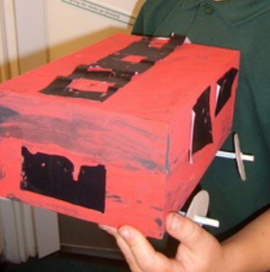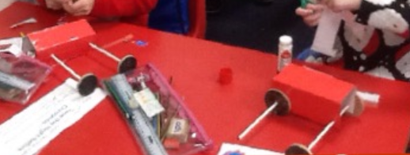 | How to use tools and equipment safely.  Different tools and equipment may need handling differently.  Some materials are more appropriate for a purpose than others.  It is important to follow a design/plan to ensure you make the model correctly.
Week 8 - DT | - evaluate his/her ideas and products against design criteria | LI evaluate our vehicles using our design.  Discussion as a whole class and amongst children, look at their model and plan, draw out a positive comment and something that could be improved on to help chn to begin evaluating their model. Feedback initial thoughts and explain that children will complete evaluation questions.  Children are to complete the evaluation sheet and stick a photo at the top of their finished model. Stick in topic books along with their design sheet. Children are to explain what they would change and why. They must also explain why they think these changes would improve their design and how. | Children will know how to reflect on their own work.  Suggest improvements for their own work.
Art  Lesson  1 | - Children know how to use different grades of pencil in my drawing for a specific purpose.  - Children know how to use charcoal, pencil, pens and pastels.  - Children know how to create different tones using light and dark. | What does the Taj Mahal look like?  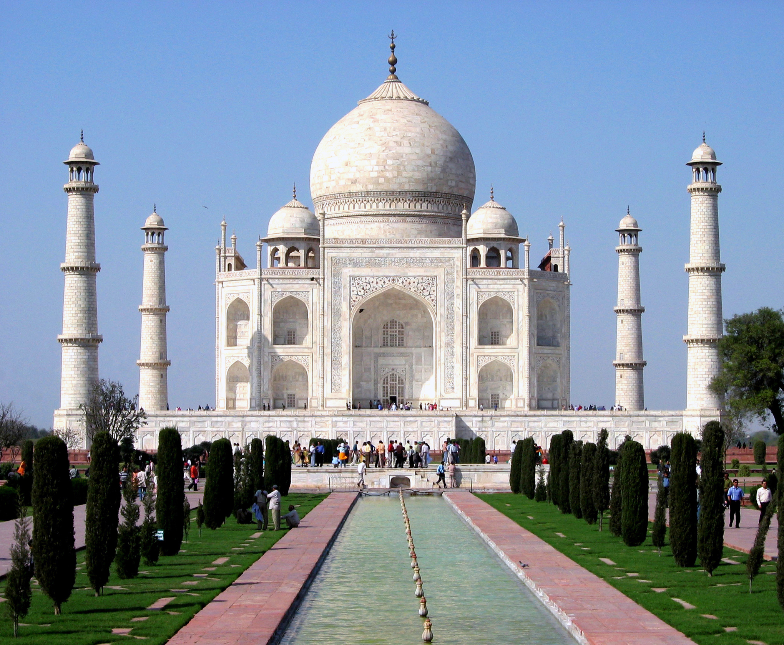  Share this image. What do you think it is? Where do you think it is? How is it different to the Tudor building we have learnt about? What do you like about this image? Click on the image and watch the clip.  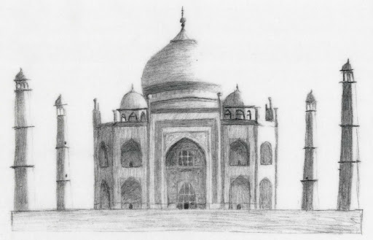  Using observational skills, discuss the symmetry of the Taj Mahal and the shapes we may draw to help form the outline of the building. Today we are going to sketch the outline of the building using sketching pencil or charcoal.  We will create a background in the next lesson. | Know that:  - The Taj Mahal is in India  - The building is symmetrical  - It is one of the 7 wonders of the world  - It was built in the 17th century (the same era as the GFoL)  - The emperor had it built as a memorial for his wife after she died  - The building looks the same from all sides  - It took over 20 years to build  Art:  - using pencils and charcoal in different ways creates different effects - marks, shades, tones  - we can use different grades of pencil to make darker and lighter tones
Art  Lesson  2 | - Children know how to mix paint to create all the secondary colours.  - Children begin to make tints by adding white.  - Children begin to make tones by adding black. | What is a background?  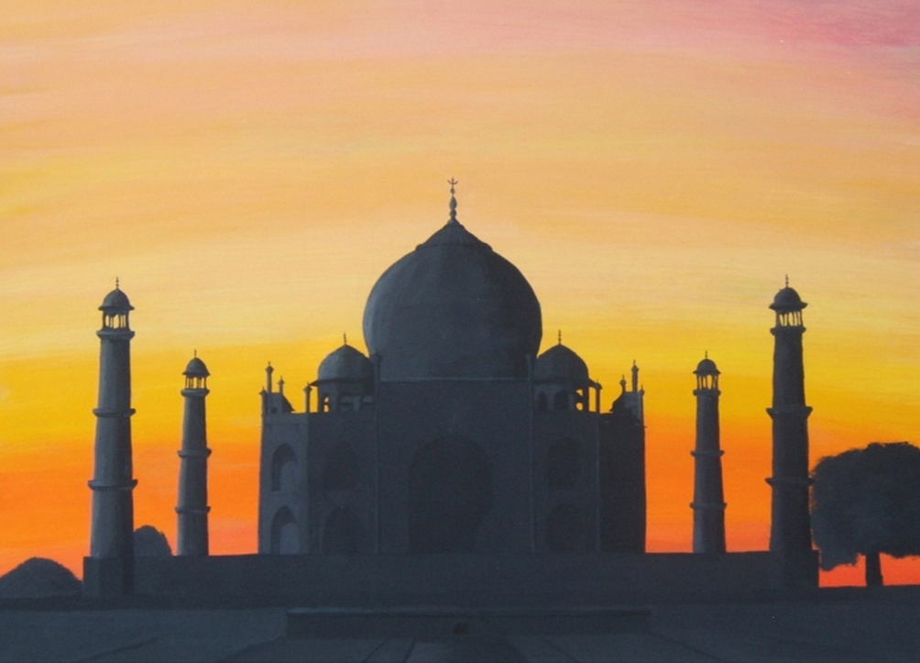  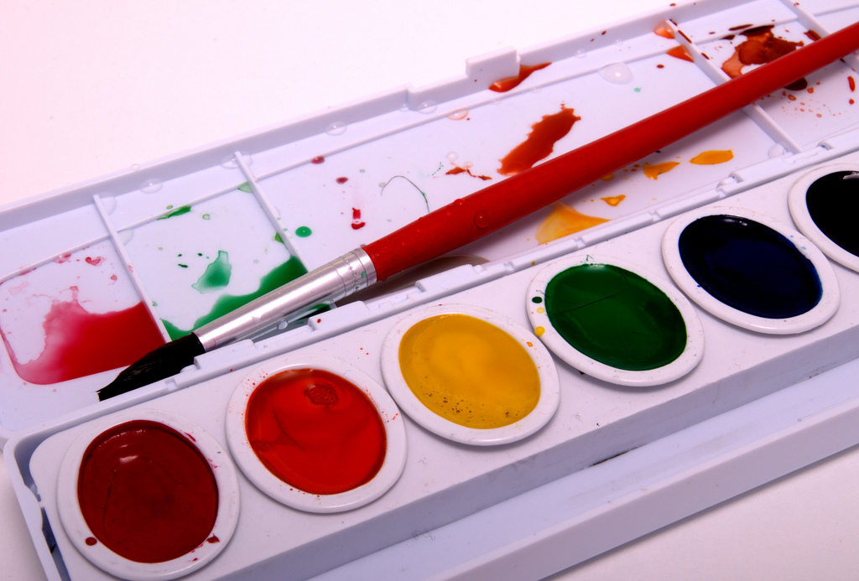  Show the children this image and discuss the background. What is a background? A background is the setting of the picture. The way a background is added can add drama and detail to the artwork. Today you will create a watercolour background for your Taj Mahal artwork. Watch the clip to see how to use watercolour paints correctly.  Once dry, assemble your art by sticking your Taj Mahal on top of your background. Here is an example:  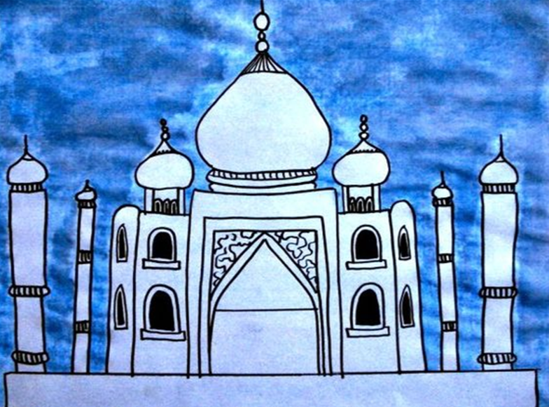 | Know that:  - red and yellow make orange  - blue and red make purple  - yellow and blue make green  - white can be added to lighten tones  - black can be added to darken tones  The correct techniques to use watercolour paints

Computing
Finger tip knowledge | Vocabulary | Skills
We can save and retrieve our work so we can edit and improve it.  We can copy information and photographs into our texts.  We can change font sizes, colours and types to add impact to our work | save  retrieve  document  font  edit  delete | Use technology purposefully to create, organise, store, manipulate and retrieve digital content  Recognise common uses of information technology beyond school  Use technology safely and respectfully, keeping personal information private; identify where to go for help and support when they have concerns about content or contact on the internet or other online technologies.

Why do we need to save our work?
How does changing font size, shape etc improve our work?
How do we know information we look for is accurate?
What is ‘fake news’?

 | National Curriculum PoS | Learning Intention | Lesson Knowledge
Week 1 /2  Computing | Use technology purposefully to create, organise, store, manipulate and retrieve digital content | How can we insert text and images into our work?  Recap the six stem sentences from the Great Fire of London. Discuss the vocabulary needed for this lesson, including font, image, text, save, retrieve. Watch the video.  Pupils insert the six stem sentences onto the texts boxes changing text, size, colour, type.  At the end of lesson, show how we can save our work into our own work and then to the class noticeboard so that other class members can view it.  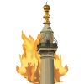 | Children know how to select the appropriate piece of technology for a particular purpose and communicate this.  Children know how to save their work to a folder and retrieve it when needed.  Children know how to understand how to edit and copy information using a variety of media.
Week 3  3  Computing | Use technology purposefully to create, organise, store, manipulate and retrieve digital content | How can we insert text and images into our work?  Recap the six stem sentences from the Great Fire of London. Discuss the vocabulary needed for this lesson, including font, image, text, save, retrieve.  This week we are going to focus on inserting images. We can either, insert images from the clip arts, or use the + sign in the top right hand corner and insert photographs that way.  At the end of lesson, show how we can save our work into our own work and then to the class noticeboard so that other class members can view it.  Discuss how we can use the internet to search for images, using swiggle, and how we can add them to text. Reminds them of the following:  -Not everything that they see/read online is accurate  -People own those photographs and we can’t share pictures that we don’t own. | Children know how to select the appropriate piece of technology for a particular purpose and communicate this.  Children know how to save their work to a folder and retrieve it when needed.  Children know how to understand how to edit and copy information using a variety of media
Week 4  3  Computing | Use technology purposefully to create, organise, store, manipulate and retrieve digital content  Recognise common uses of information technology beyond school  Use technology safely and respectfully, keeping personal information private; identify where to go for help and support when they have concerns about content or contact on the internet or other online technologies. | How can we find accurate information on the internet?  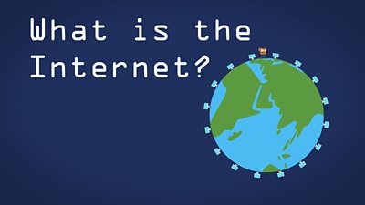  What is the internet?  What do we use it for outside of school? Why?  Gather a list of children’s ideas. What are the advantages and disadvantages of using the internet for those activities  i.e shopping; advantages, quick, easy disadvantages: don’t get to go out, shops are closing.  What are the advantages and disadvantages of looking for information online. Discuss how anyone can put information on the internet, some of it may not be true and the people could be trying to get personal information from you. | Children know how to capture a digital image, retrieve and manipulate it.  Children know how to save their work to a folder and retrieve it when needed.  Children know how to begin to understand how to edit and copy information using a variety of media.
Week 5/6  Computing | Use technology purposefully to create, organise, store, manipulate and retrieve digital content | How can we find accurate information on the internet?  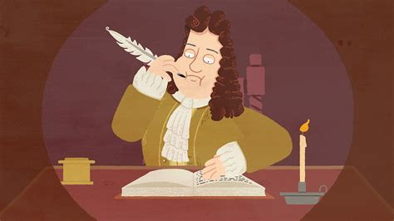  Recap what the internet is and what it is used for . Explain that today we are going to use a search engine to find information about Samuel Pepys- in particular we want to find information from his diary that he kept during the Great Fire of London.  Using Purple Mash create a diary entry for a day in the life of Samuel Pepysm or complete the image of what he would have seen from his window. | Children know how to understand how to edit and copy information using a variety of media.  Children know how to capture a digital image, retrieve and manipulate it.  Children know how to save their work to a folder and retrieve it when needed.  Children know how to begin to understand how to edit and copy information using a variety of media.
Week 7  7/8  Computing | Use technology purposefully to create, organise, store, manipulate and retrieve digital content  Recognise common uses of information technology beyond school | 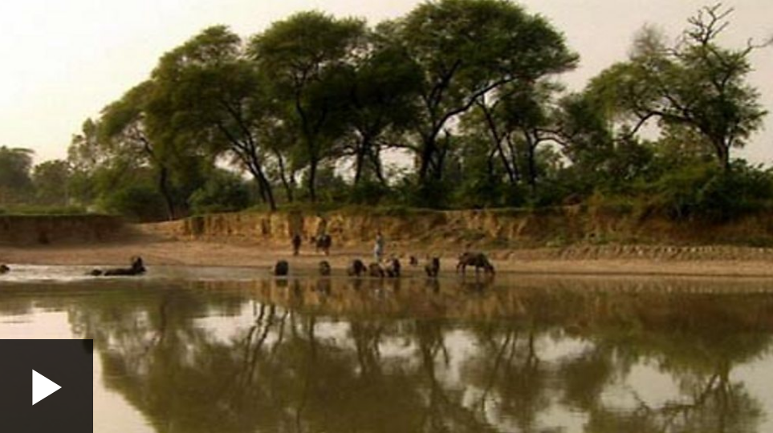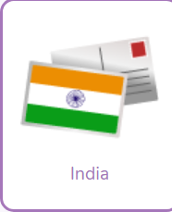  How can we organise information?  Watch the video clip about places to visit in India. Jot down your ideas about places that you would like to visit and some of the things that you might see.  Log onto Purple Mash and imagine that you have visited India and you are sending a postcard back home.  Include:  One interesting city | Children know how to save their work to a folder and retrieve it when needed.  Children know how to begin to understand how to edit and copy information using a variety of media.  Use technology purposefully to create, organise, store, manipulate and retrieve digital content  Recognise common uses of information technology beyond school  Use technology safely and respectfully, keeping personal information private; identify where to go for help and support when they have concerns about content or contact on the internet or other online technologies.

RE
 | Finger Tip Knowledge | Vocabulary | Skills
RE | Jewish people worship in a synagogue  Jewish people celebrate Passover and Hanukkah  Jeiwsh people have special stories that link to their celebrations. | Hanukkah  Passover  Torah  Synagogue  Menorah  Beliefs  Symbols | Give a simple account of the core beliefs of the religions studied.  Retell a selection of key stories, making links to the core beliefs.  Give examples of the festivals/rituals that link to key beliefs (e.g. Christmas, Easter, Passover, Sukkot).  Talk about their own experiences in the light of the religious knowledge gained  Express their own opinions appropriately  Talk about the differences that beliefs make to the way believers live. Make simple comparisons to their own lives

What do people believe about God, people and the natural world?
How does God care for people in stories found in the Jewish Bible and what do Jews learn from these stories?
Who am I?
What do Jews believe about how people should live with others?
How and why are some stories and books sacred and important in religion?
What special texts are used in a synagogue?
Why is the Torah special for Jewish people?

 |  | Learning | Lesson Knowledge
Week  1 | See MK Local Syllabus  Believing | Do you think it is important to look after our world? How could you help to look after our world? Do you do things to help look after our world?  Watch the video clip  Create a poster encouraging people to help the planet.  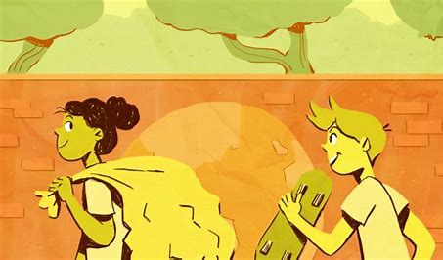 | We can all do things to help the planet.  We need to be responsible citizens so that we can all have a clean planet.  Even small changes make a big difference.
Week  2 | See MK Local Syllabus  Behaving | What ideas have you heard about God? Do you believe in God?  Think about your own beliefs . Link to the religious knowledge gained. Think about how what you believe in can have an impact on how you live. Give examples of how beliefs are linked to worship and prayer. Create a mind map of what you believe in  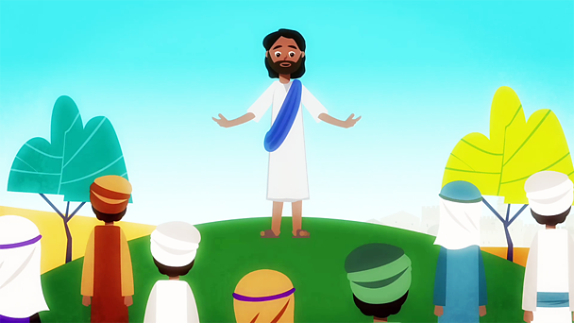 | People have different beliefs.  It is important to respect other people’s beliefs  Different religions have different gods.
Week  3 | MK Syllabus  Belonging | 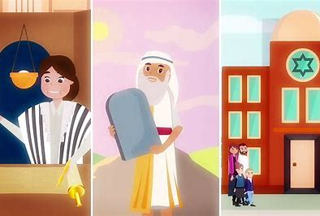  What does it mean to belong to a Jewish family?  How do Jews use Synagogues? | Jewish people worship in a synagogue.  The Torah is a special book to Jewish people.
Week  4 | See MK Local Syllabus  Believing | How and why are some stories and books sacred and important in religion?  What special texts are used in a synagogue? Why is the Torah special for Jewish people?  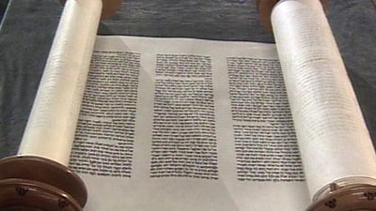  What is special to you? Which texts do you know are special to other religions? | Jewish people worship in a synagogue.  The Torah is a special book to Jewis people.  Retell a selection of key stories, making links to the core beliefs
Week  5 | See MK Local Syllabus  Behaving  Give a simple account of the core beliefs of the religions studied.  Retell a selection of key stories, making links to the core beliefs. | Why do Jewish people celebrate Passover?  How and why are celebrations, including religious celebrations, important to people?  What special times do Jews celebrate? How and why do they celebrate these special times?  Watch the film about Passover.  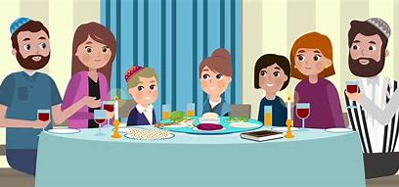 | Recognising that celebrations symbolise important events.  Understanding that different religions have different celebrations and stories.
Week  6 | See MK Local Syllabus  Believing.  Give a simple account of the core beliefs of the religions studied.  Retell a selection of key stories, making links to the core beliefs. | Why do Jewish people celebrate Hanukah?  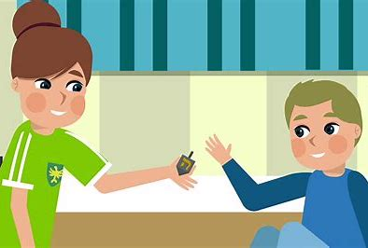  What is a miracle? Why is the miracle important to Jesish people? Which other miracles do you know?  Draw a menorah and finish the stem sentences. | Recognising that celebrations symbolise important events.  Understanding that different religions have different celebrations.  Knowing religious stories.
Week  7 | Believing. Behaving,  Give a simple account of the core beliefs of the religions studied.  Retell a selection of key stories, making links to the core beliefs  Give examples of the festivals/rituals that link to key beliefs  Give examples of how beliefs are linked to worship and prayer. | What is Shabbat? Watch the two videos.  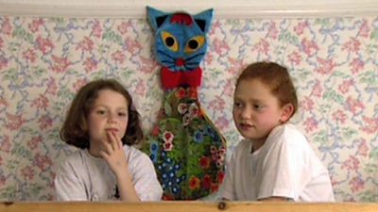  How do Jewish people celebrate Shabbat?  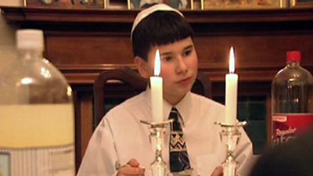  Shabbat (the Sabbath) is the most important time of the week for Jews. It begins on Friday evenings and ends at sunset on Saturdays. During Shabbat, Jews remember that God created the world and on the seventh day he rested. Jews believe God's day of rest was a Saturday. Shabbat can be celebrated at home or in a Synagogue. | Recognising that celebrations symbolise important events.  Understanding that different religions have different celebrations.  Knowing religious stories.
Week  8 | See MK Local Syllabus  Behaving  Give examples of how beliefs are linked to worship and prayer. | What does a Rabbi do?  The services in the synagogue are led by a religious leader called a rabbi, which means ‘Teacher’ in Hebrew.  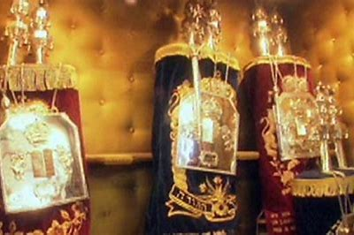  Think about people who help us. What do they do to help us? Why do we go to school? What is the role of our teachers? A rabbi is viewed not only as a spiritual leader but as a counselor, a role model and an educator. Where have we heard the words ‘role model’ before. Draw a picture of a role model and finish the stem sentences. | Knowing what a ‘role model’ is  Making links between the role of the Rabbi and other role models.
Week  7 | See MK Local Syllabus  Believing | How and why are some stories and books sacred and important in religion?  Recap the religious stories that we know and discuss other non-religious books. What are your favourite stories? Why do you like them? Do you learn anything from them? Have you learned anything about qualities like honesty, loyalty, courage in stories you have read? What ideas have you learned from the stories we have heard from the Bible? What things/books are most special to you? Why are they special? How do you care for them?  Discuss the children’s choices and why they have made them. | Religions have stories that often have a message about ‘values’ such as honestly, loyalty and courage.
Week  8 | See MK Local Syllabus  Believing | How and why do symbols express meaning including religious meaning?  How can symbols help us understand things? What symbols do you use often? How and why do you use them? How can clothes, colours and movements be symbols?  Look at a selection of religious symbols and explain what they represent.  Create a symbol for yourself that would tell others something about you? | Symbols represent different aspects of religious life.  They can include clothes and colours.

