Home Learning Overview – Year 2 – Week 8
Friday: Click on the link below to watch the introduction to the day
https://www.loom.com/share/f90b68c307c84425bfc519682edc0873

Maths  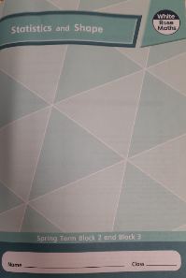  All activities are now in the accompanying workbooks in your packs or on the website. Please only follow the stated pages from each lesson. | Day 5  In Today’s maths lesson, we will be starting to look at 3D shapes. We will concentrate on identifying and counting the different faces on those shapes. Click on the pictures to watch a maths song and a recorded lesson. Complete pages 58-61 in your maths booklets.  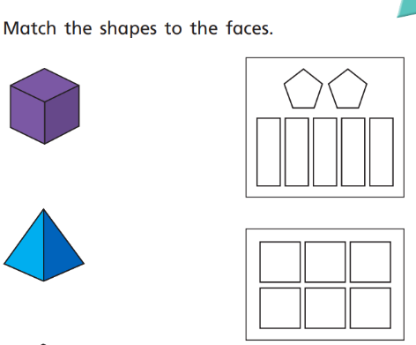
English | Click on the link to see Mrs Palmiero explain this lesson.  https://www.loom.com/share/0539e791cc63469a8001cd41d5497651  Chunk 1 - Imperative verbs  Look at the double page spread – “Grandma, wake up.” Think about how the verb is used. It is an imperative or bossy verb which means that it is used as a command.  Activity  In your jottings box gather a bank of imperative verbs in commands which Tom could use to awaken his new Grandma. Here are some examples:  wake up  open your eyes  stand up  listen to me  Provided sentence:  In memory of Grandma, Tom made his plans and set to work. As the seasons came and went he finally completed his Grandma.  Sentence stacking: Try and think of your own sentence including your command to explain how Tom tried to awaken new Grandma. E.g.:  Tom looked deep into her eyes and shouted “listen to me.”  Chunk 2- Onomatopoeia  Click on the link below and watch the film clip of shooting stars in the night sky:  https://www.youtube.com/watch?v=vLUNWYt3q1w  Compile a bank of onomatopoeic words in your jottings box. Remember that onomatopoeic words sound like the noises they are describing. Examples:  whoosh  fizz  whizz  boom  In the same jottings box think of some past tense verbs to describe how the shooting stars moved. Examples:  darted  cascaded  shot  Sentence stacking - Use three of the onomatopoeic words followed by the verb in your sentence to explain how the shooting stars moved across the night sky. E.g.:  Whizz! Flash! Boom! The stars danced across the moonlit sky.
Spellings | many  clothes  busy  Click on the link to watch our spelling lesson.  https://www.loom.com/share/e50908ff9a904324aaf163e73ffe48ec  people  water  again  half  money  Mr  Mrs
PSHE | Think back to the goals you set for yourself. How will you achieve them? Have you already achieved a goal? How?  When we work towards completing a goal, it is okay if things do not always go to plan. It is at times like this that we persevere and don’t give up. Watch the clip and discuss the times the children talk about perseverance: https://www.youtube.com/watch?v=8Ae412XTxl0  When did you persevere even when things got tricky? What strategies did you use to overcome the challenge? Complete the sheet provided.
Purple Mash | Click on the 2do and write a book review on your favourite book. You can use a book you have read yourself or a one of the stories that the teachers have read.

