The Marvellous Mae Jemison

My fantastic facts!

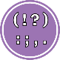 Punctuation: Use capital letters and full stops.

 Basics: Fred talk to check your spellings.

Mae Jemison is