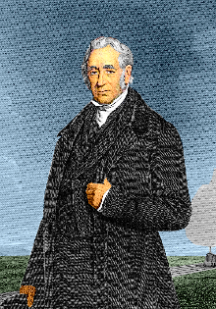
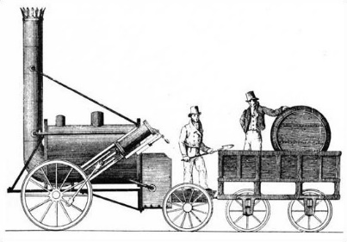
George Stephenson
Fill in the boxes and answer the questions below. You can research George Stephenson before completing the sheet.

Born: | Died:
Why is George Stephenson a significant person in British history?

________________________________________________________________ ________________________________________________________________ ________________________________________________________________ ________________________________________________________________ ________________________________________________________________ ________________________________________________________________
List three facts about George Stephenson’s locomotive the Rocket:

- _____________________________________________________________
- _____________________________________________________________
- _____________________________________________________________
Draw a picture of The Rocket below:

