My Character Description
Noticing: How does the girl look?
Basics: What adjectives could we use?

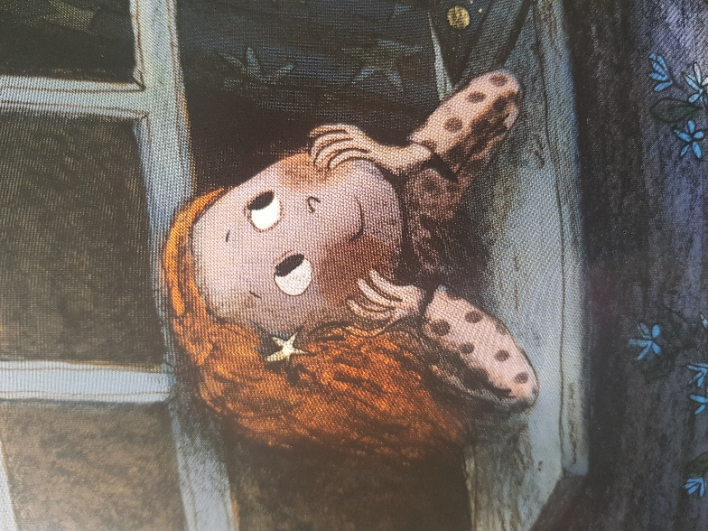

The girl looks

Her smile is

She has
Word Bank:
kind
long
small
happy
hair
orange

