Home Learning Overview – Year 2 – Week 8
Wednesday: Click on the link below to watch the introduction to the day
https://www.loom.com/share/ae0b4707acee4e4e95ce1039515011e8

Maths  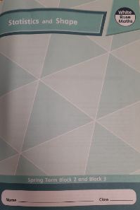  All activities are now in the accompanying workbooks in your packs or on the website. Please only follow the stated pages from each lesson. | Lesson 3  Today, we will be looking at 2D shapes, their features and using these to help us to sort those shapes. Click on the pictures to watch a maths video and a recorded lesson. Complete pages 50-53 in your booklets.  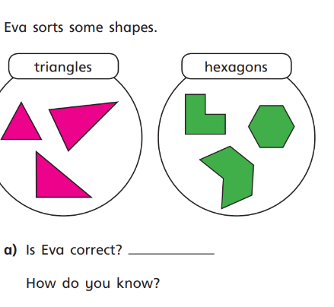
English  Lesson 3 | Click on the link to see Mrs Palmiero explain this lesson  https://www.loom.com/share/b9b1473676754b408a9605128c3cef29  Seasons – Noticing  Tom worked hard planning and building as the seasons changed.  Draw a picture of the changing seasons and write a caption for each on the sheet provided. Try to include at least one adjective in each caption. Here are some examples:  Gusty winds and orange leaves swirling from trees.  Snow covered hills and shimmery icicles on rooftops.  Spring rain and delicate flowers peeping above the ground.  Golden sunshine on yellow fields.
Spellings | many  clothes  busy  Click on the link to watch our spelling lesson.  https://www.loom.com/share/e50908ff9a904324aaf163e73ffe48ec  people  water  again  half  money  Mr  Mrs
Computing | 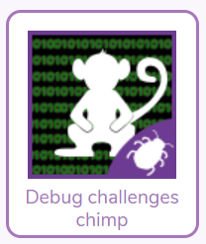  Over the weeks we have learnt lots about algorithms. Watch the video to learn about computer bugs then have a go at the debugging challenges in Purple Mash.
Purple Mash | 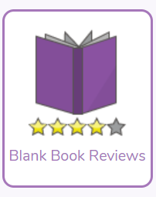  Click on the 2do and write a book review on your favourite book. You can use a book you have read yourself or a one of the stories that the teachers have read.

