Extension: Can you label the parts of the tree?

We are in the season of ______________. Can you illustrate this tree with how it should look in this season?

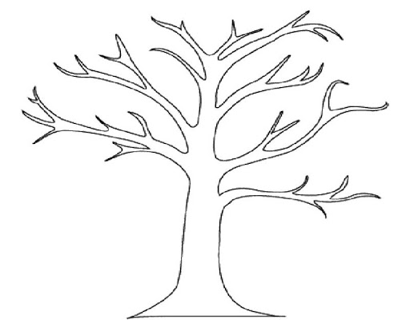

Season Activity