Home Learning Overview – Year 2 – Week 7
Wednesday: Click on the link below to watch the introduction to the day
https://www.loom.com/share/8da1e1e0bb1049adb1667a3ade35a95a

Maths  All activities are now in the accompanying workbooks in your packs or on the website. Please only follow the stated pages from each lesson.  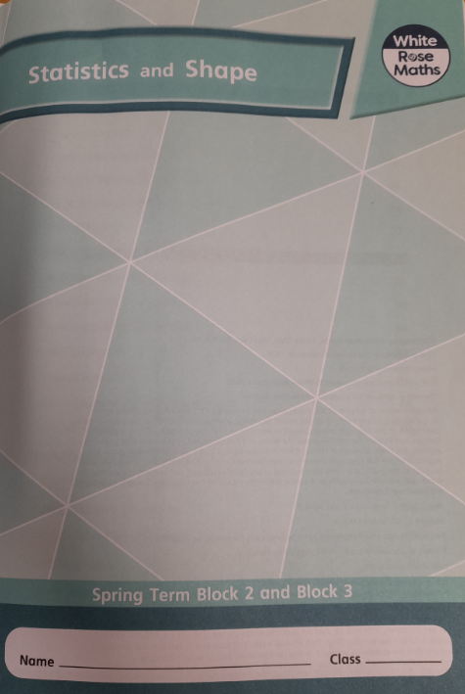 | Lesson 3  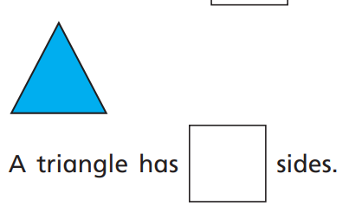  Today, our maths lesson is about counting the sides of 2D shapes and how that can help us to identify certain 2D shapes. Click on the pictures to watch the recorded lesson and a maths song! Complete pages 30 to to 33.
English  Grammar - Comparative and superlative adjectives | Click on the link to watch Mrs Palmiero explain this lesson:  https://www.loom.com/share/f04817069f3d451ab4eeac552010a476  Work through the PowerPoint about comparative and superlative adjectives. Identify the difference between comparative and superlative adjectives and their suffixes.  Activity:  Complete the worksheet in your pack.
Spellings | past  Click on the link to watch our spelling lesson.  https://www.loom.com/share/5c201dd7bcfb427483fcaf773193ca72  father  class  grass  pass  plant  path  bath  hour  move
Computing | Key question: What does’ de bug’ mean?  Explain that sometimes when we use a set of instructions if there is some information missing or a missing step in the instructions can mean that the instructions do not create the correct outcome. Give the examples of what could happen if for example traffic lights weren’t using the correct algorithm and demonstrate brushing teeth in the wrong order.  Demonstrate the game then let the children solve the problems independently. There are different levels to try. Drop and drag the directions from the right hand side into the command box underneath.
Purple Mash | 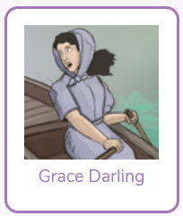  Click on the 2do and create a fact file about Grace Darling
Story | Listen to the story of “The Invisible String’ by Patrice Karst, read by Mrs van Rooyen.  https://www.loom.com/share/e139ac0a2fbf408da4791ac4e53b7d9d  