What is the difference between ‘strength’ and ‘rigidity’?
- Strength is the ability to resist breaking.
- Rigidity is the property of a material to resist being bent or forced out of shape.

I want you to build a paper tower from a single piece of A4 paper and think about the rigidity and strength of the material as you do it.
What is the tallest tower you can make?

You can use scissors but no glue, tape or other materials.
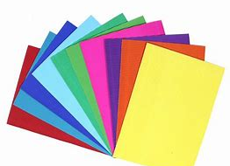

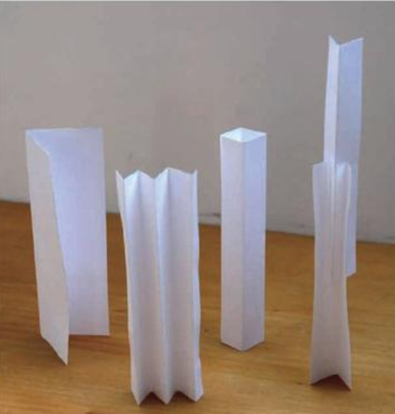
Can you change the shape of the shape of the paper to change its strength and rigidity? How many ways can you do this?
Here are some ideas.
Reflection
A tree is strong and resists breaking. If the tree was too rigid, it would snap in the wind. A tree is flexible and moves with the wind and returns back to its normal shape. This property is important when building bridges and towers too!

