Measuring

Can you draw the following objects using the 1cm squared paper to help you?

- Can you draw a stick which is shorter than this stick?

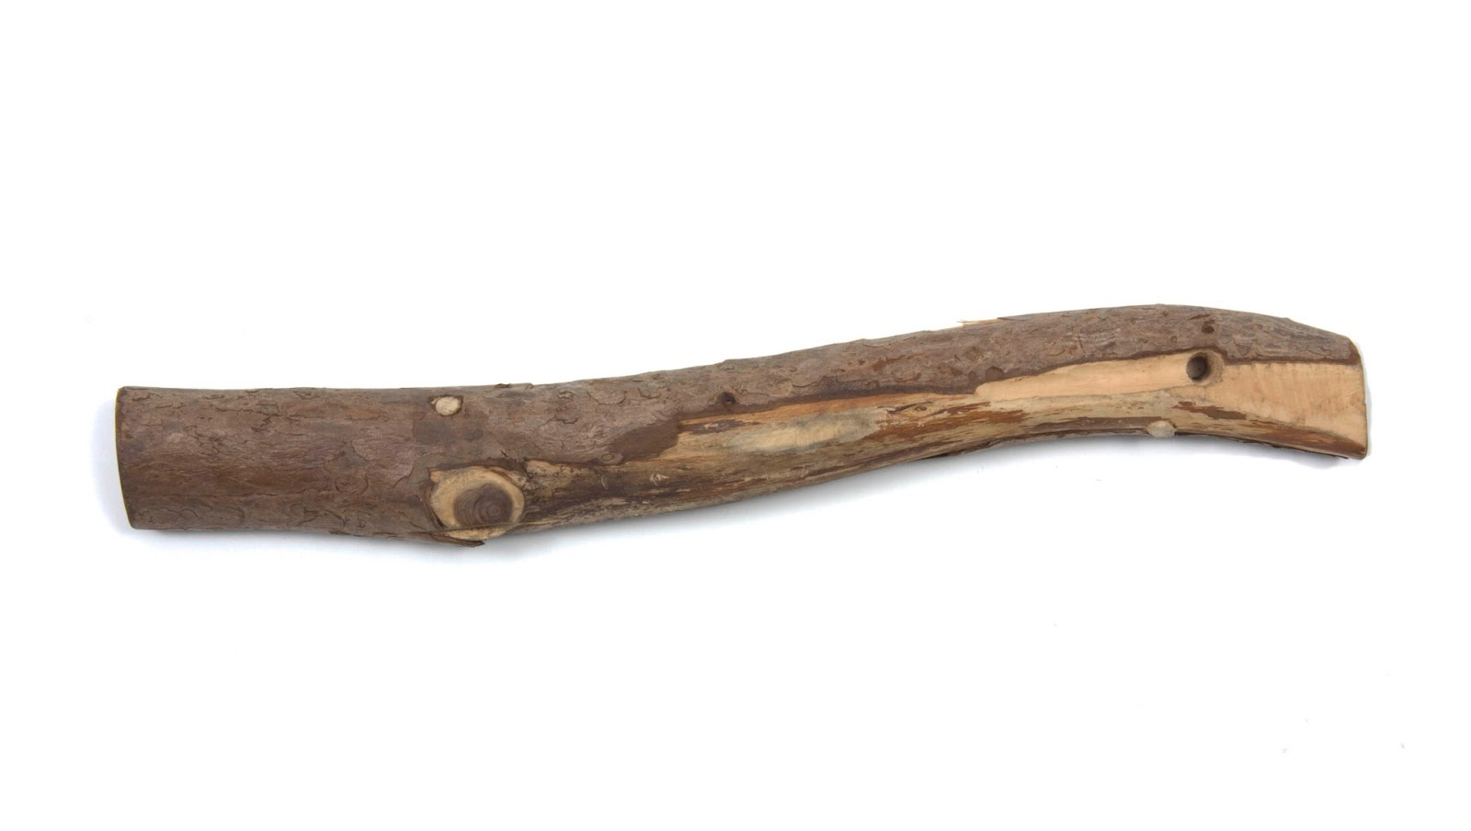

- Can you draw a snowman which is taller than this snowman?

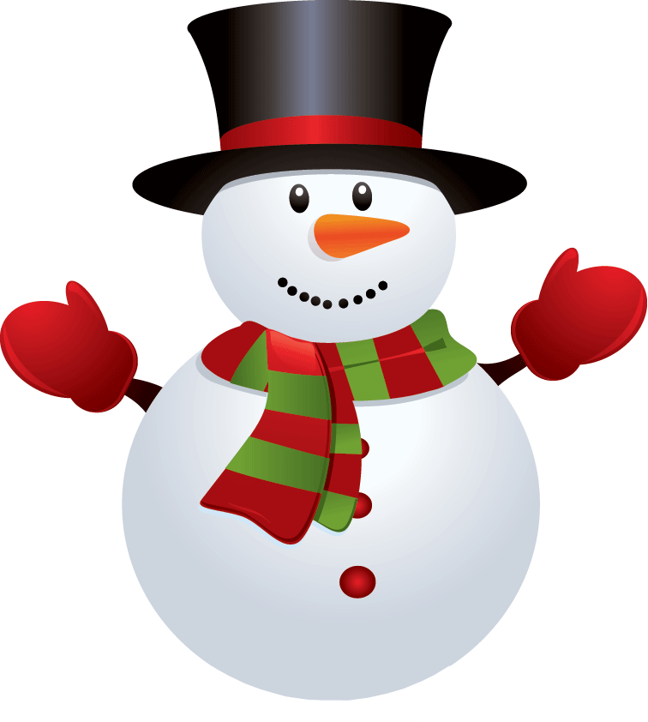
- Can you draw a car which is longer than this car?
