Home Learning Overview – Year 2 – Week 8
World Book Day
Thursday: Click on the link below to watch the introduction to the day
https://www.loom.com/share/1c763a619ea34a9a980200e3fa0ae817

Maths  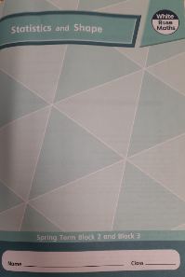  All activities are now in the accompanying workbooks in your packs or on the website. Please only follow the stated pages from each lesson. | Lesson 4  Today, we will be making patterns with 2D shapes. Click on the pictures to watch a recorded lesson and a maths song. Complete pages 54 to 56 in your maths booklets.  https://www.bbc.co.uk/teach/supermovers/ks1-maths-counting-with-john-farnworth/zbct8xs  https://vimeo.com/508434253  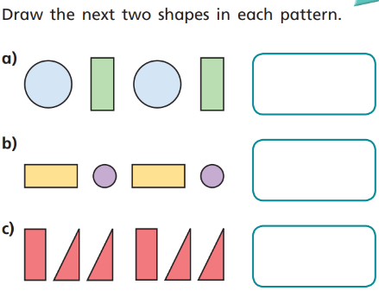
English  World Book Day – create a costume | Today is World Book Day. Click on the link below to listen to Mrs Robinson and Mrs Palmiero sharing two of their favourite stories.  Mrs Robinson: https://www.loom.com/share/4401c867e6254d288fad57aecc278090  Mrs Palmiero: https://www.loom.com/share/e86420c4a06d418dbd80e8087899bc48  Mrs Robinson’s costume: https://www.loom.com/share/0b9541fdbdf84aa697ebb042f6186cbe  Mrs Palmiero’s costume: https://www.loom.com/share/60bfa05d023e4cafb5845a7042667e73  Activity  Choose a character from one of the stories you have listened to or perhaps think of a character from another of your favourite books. We are going to show you how to make a costume, mask or headwear for your character using bits and pieces that you can find around your house. Click on the links below to see how your teachers have made their costumes, head-dresses or masks.  Make a list of the materials you think you will need and collect them before you start.  When you have finished take a photo of yourself in your outfit and remember to tell us which character you are when you email it over. If you have the book that your character comes from, you could hold that up too. Good luck!
Spellings | many  clothes  busy  Click on the link to watch our spelling lesson.  https://www.loom.com/share/e50908ff9a904324aaf163e73ffe48ec  people  water  again  half  money  Mr  Mrs
World Book Day Activities | Think about your favourite character from a book. Draw a picture of them and explain why they are your favourite character. Complete the character profile.  Design a new book cover for your favourite book.  Share a story with your grown up/brother/sister/even another friend or relative on a video call.  There are some live events on the World Book Day website: https://www.worldbookday.com/events/  The Masked Reader PowerPoint – can you guess the famous readers and the book they are reading? Good luck!
Purple Mash | 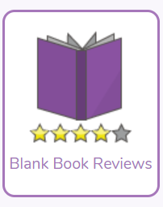  Click on the 2do and write a book review on your favourite book. You can use a book you have read yourself or a one of the stories that the teachers have read.

