**My description of the setting**

 Noticing: What can you see in the picture?

 Basics: What adjectives could we use?

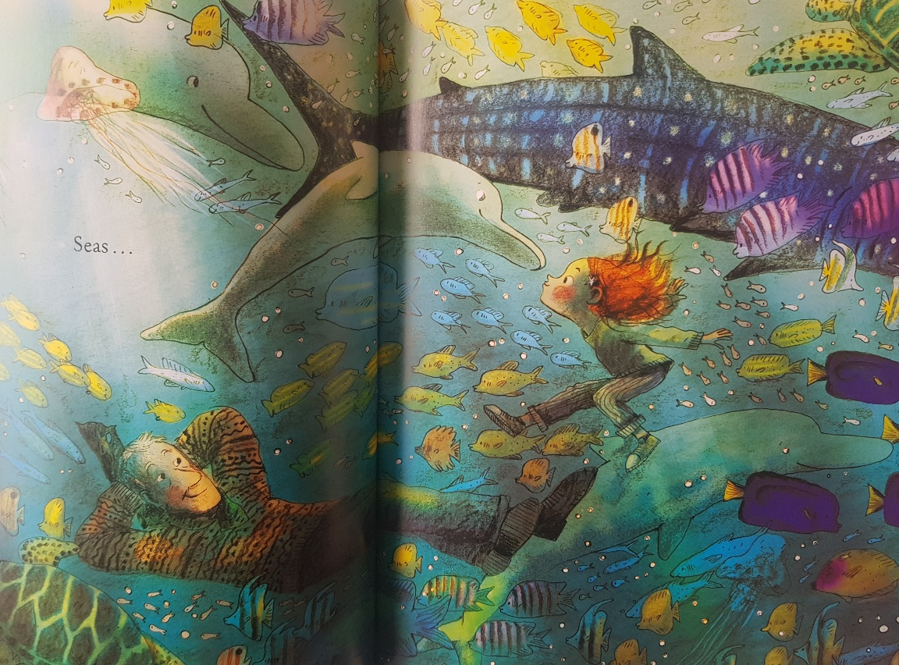

The fish are

I can see