Home Learning Overview – Year 2 – Week 7
Monday: Click on the link below to watch the introduction to the day:
https://www.loom.com/share/b3dbba683c26409f846683b5ea598b72

Maths  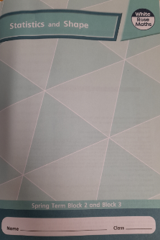  All activities are now in the accompanying workbooks in your packs or on the website. Please only follow the stated pages from each lesson. | Lesson 1  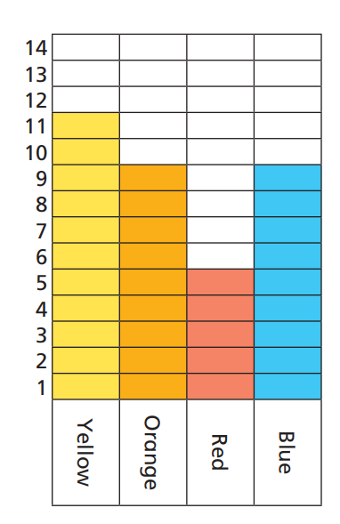  Click on the pictures to watch a maths song and a recorded lesson. In the lesson today, we will be looking at how to use block charts. Block charts are another way for us to represent, compare and use information easily. Complete pages 22 to 25 in your booklets.
English  Lesson 1 – Sentence Stacking | Click the link to see Mrs Palmiero explain this lesson:  https://www.loom.com/share/4871d3bd9df84dc286679f43371aa60f  Read the first line of the book The Building Boy by Ross Montgomery and David Litchfield:  Each night before the boy went to bed, he would light a fire. Think about the first part of this sentence; Each night before the boy went to bed ….. What does it tell us? It tells us about time, the time the story is beginning.  Chunk 1 - Noticing  Watch the following clip which shows the sun setting and the night drawing in. https://www.youtube.com/watch?v=-ZNv5V_LJxg  Use the noticing lens to observe what happens when day turns to night. In your jottings box on the sentence stacking sheet write down some other time phrases which describe what you have noticed as night time begins:  e.g. the sun set  it got dark  the light faded  Think about the rest of the story on this first page; He would squeeze beside Grandma on her favourite chair. What do you notice about Tom’s relationship with his Grandma? Collect some more loving actions words and write them in your Chunk 1 chotting box.  e.g. cuddled  snuggled  hugged  Activity:  Write the first sentence for Plot Point 1 of the story including your own time phrase and verb to show Tom and his Grandma’s closeness. Use the conjunction and to join the two parts of your sentence.  Example:  The sun set and Tom cuddled up to his Grandma on the cosy armchair.  Chunk 2 - Basics  In your jottings box write down some adjectives to describe the relationship between Tom and Grandma e.g. warm, close, loving  Activity:  Write a sentence about their relationship using the adjective you thought of.  Example:  Grandma and Tom had a very close relationship.  Extra challenge: Chunk 3 - Checking/sounds  Think about some of the other sounds that Tom and his Grandma might have heard in the quiet of the night. Write the phrases in the same way as they are written in the book with the object at the end of the phrase and the sound word in the middle. Examples: the flickering of the fire, the dripping of a tap, the ticking of the clock.  Activity:  Use the sentence opening: The house was quiet except for…  Then add two of your ideas to finish your sentence. Example:  The house was quiet except for the dripping of the tap and the ticking of the clock.
Spellings | past father  Click on the link to watch our spelling lesson.  https://www.loom.com/share/5c201dd7bcfb427483fcaf773193ca72  class  grass  pass  plant  path  bath  hour  move
Science | What is the difference between ‘strength’ and ‘rigidity’?  Build a paper tower from a single piece of A4 paper and think about the rigidity and strength of the material as you do it.  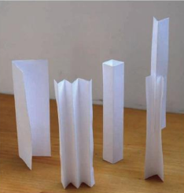  Can you change the shape of the shape of the paper to change its strength and rigidity? How many ways can you do this?
Purple Mash | 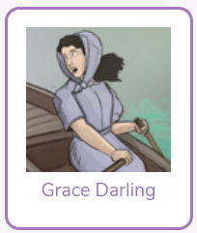  Click on the 2do and create a fact file about Grace Darling
Story | Listen to the story of “The Invisible String’ by Patrice Karst, read by Mrs van Rooyen.  https://www.loom.com/share/e139ac0a2fbf408da4791ac4e53b7d9d  