**My wish upon a star…**

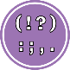 Punctuation: Use capital letters and full stops.

 Basics: Say your sentence, count the words, then check it makes sense.

My wish is to

My wish is to