

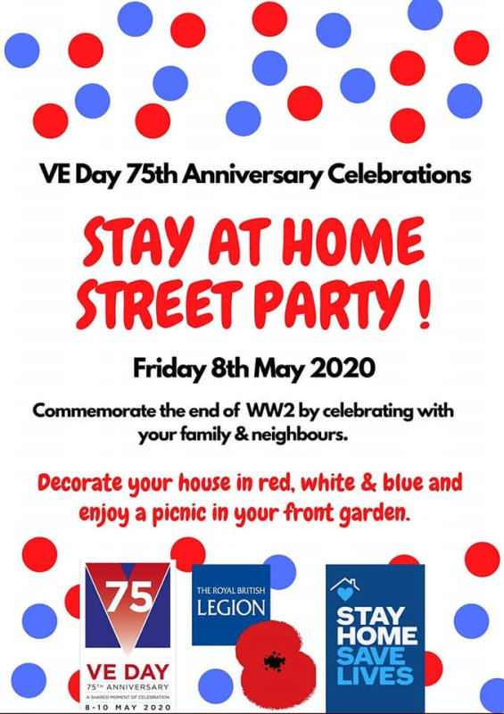



]



[**https://www.twinkl.co.uk/offer**](https://www.twinkl.co.uk/offer)

**Sign up for a free account. Use the offer code: PARENTSTWINKLHELPS**

**Activity Ideas:**

Design and make a medal.

<https://www.twinkl.co.uk/resource/t3-h-123-design-a-ve-day-medal-activity-sheet>

Decorate your house with flags or bunting.

<https://www.twinkl.co.uk/resource/t-t-2548139-union-jack-template-display-bunting>

<https://www.twinkl.co.uk/resource/t-m-477-union-jack-colouring-poster>

Learn about somebody in your family who was alive in the war.

Have a tea party.

Make your own secret code.

<https://www.twinkl.co.uk/resource/t2-or-407-code-cracking-for-beginners-morse-code-activity-sheet>

Make a paper plane and decorate it to look like an RAF plane.



<https://www.twinkl.co.uk/resource/t2-t-803-simple-ww2-spitfire-glider-activity-paper-craft>

Listen to 1940’s music.

**Other VE Activities**

<https://www.twinkl.co.uk/search>



