Home Learning Overview – Year 2 – Week 7
Friday: Click on the link below to watch the introduction to the day
https://www.loom.com/share/dc58ac9ac12a48b5885cb783e34bd01d

Maths  All activities are now in the accompanying workbooks in your packs or on the website. Please only follow the stated pages from each lesson.  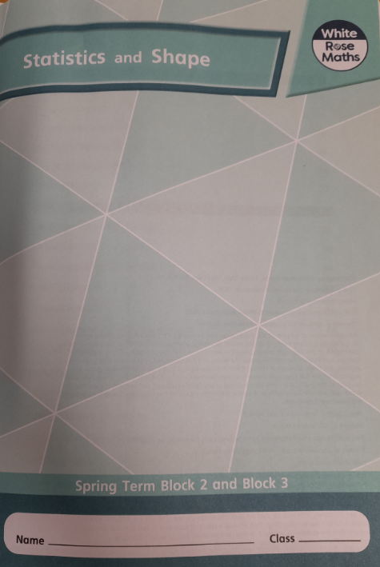 | Lesson 5  Click on the pictures to watch the recorded lessons and a maths song! Today, our maths lesson will focus on drawing 2D shapes. Try to use a ruler and the grids to be as accurate as possible!  Complete pages 38 to 41.  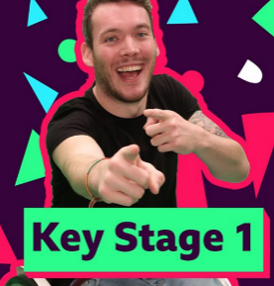  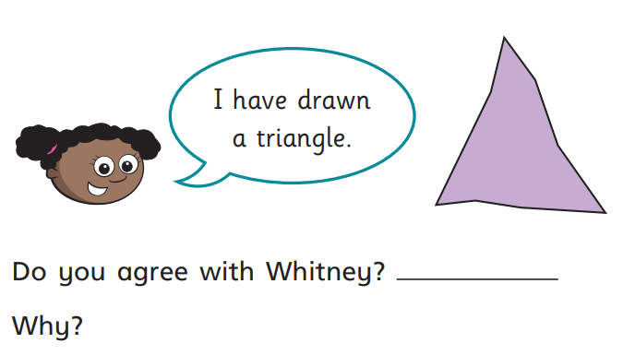
English  Experience lesson – thoughts and feelings | Click on the link to watch Mrs Robinson explain this lesson:  https://www.loom.com/share/d8c329eaaad64b8b92a14ade141c9762  In the book, The Building Boy really misses Grandma. At the moment we all know what it is like to miss family and friends. Julia Donaldson explores these feelings in her book The Paper Dolls. Click on the link below to listen to The Paper Dolls written and read by Julia Donaldson.  https://www.youtube.com/watch?v=wGoYFuq8sBc  Activity:  Draw a person that you are missing in the middle of a piece of paper. Around the picture, write words that explain how you feel and the things that you miss about them.
Spellings | past  Click on the link to watch our spelling lesson.  https://www.loom.com/share/5c201dd7bcfb427483fcaf773193ca72  father  class  grass  pass  plant  path  bath  hour  move
PSHE | Think about our previous learning about similarities and differences and stereotypes. Are stereotypes fair? Why/why not? It doesn’t matter if a boy wants to play with a doll or a girl wants to play with a car. Remind the child that they can have similarities and differences with their peers and still be friends. We don’t have to be the same or enjoy the same things to be friends. Think about one of your closest friends and complete the questions on the worksheet:  - How is your friend different to you?  - How is your friend similar to you?  - How does it feel to be friends with this person?  - How would you stand up for your friend if someone was bullying them?
Purple Mash | 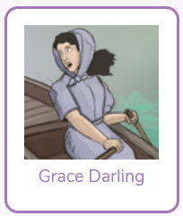  Click on the 2do and create a fact file about Grace Darling
Story | Listen to the story of “The Invisible String’ by Patrice Karst, read by Mrs van Rooyen.  https://www.loom.com/share/e139ac0a2fbf408da4791ac4e53b7d9d  