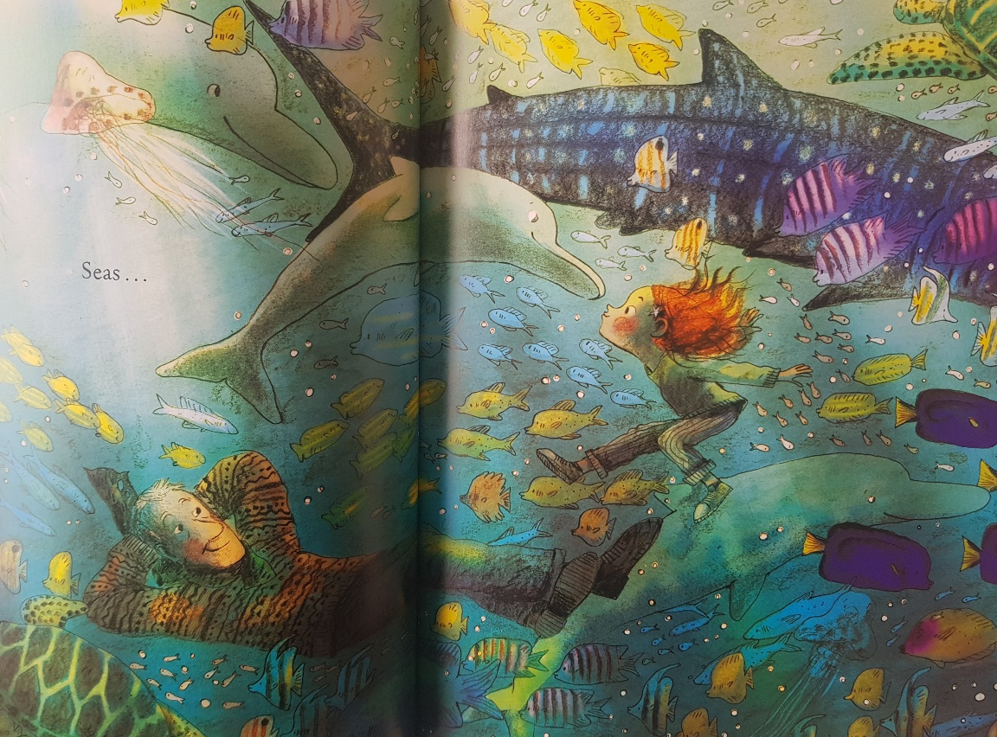
Noticing: What can you see in the picture?
Basics: What adjectives could we use?
My description of the setting

The ocean is…
I can see…
The dolphin is…
The fish look…

colourful
bright
floating
exciting
busy

