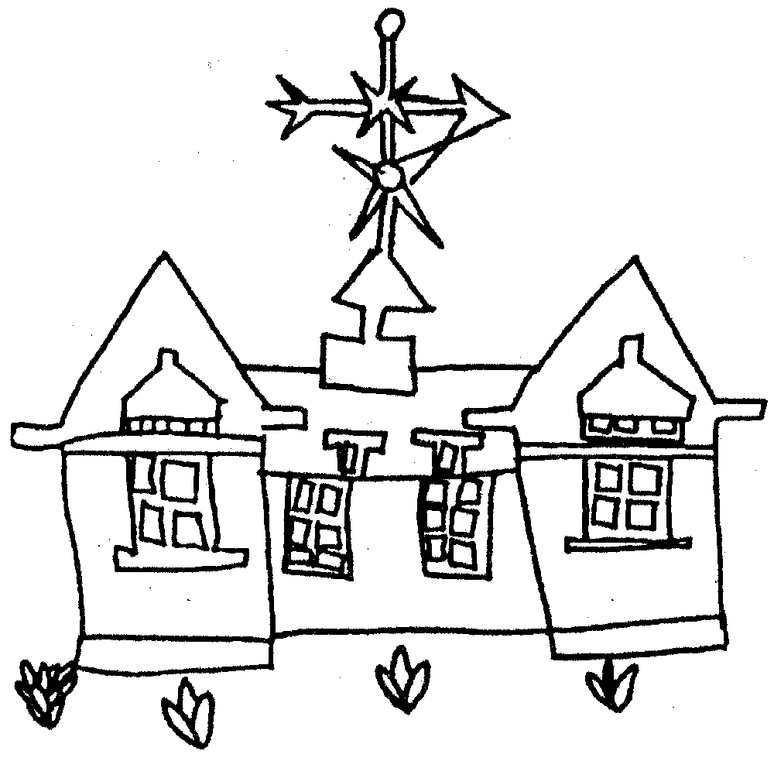
APPLICATION DETAILS

Please complete this form in BLOCK CAPITALS so the school record has the correct information relating to your child. Please return to the school office.

Child’s Surname: …………………………………………. First Name: ….. ..…………………….….…..........

Preferred Name: ……………………………………......... Middle Names:……………….…………….……....

Name as shown on birth certificate (if different):………………………….………………………….……….….…

Date of birth: …………………………………………………… Male / Female (Please delete as appropriate)

Address:…………………………………………………………………………………………………..………..……

Post Code: ………………………………….… Home Phone Number: ……………………………………………

EMERGENCY CONTACT NUMBERS
It is extremely important that we are able to make contact with you during the day should there be a problem with your child. Please therefore give daytime details and at least one other contact person and indicate the order in which they should be contacted. Please give names and address of both parents (where possible).

Mother’s full name and address…………………………………………………………………….....Mrs/Miss/Ms
……………………..……………………………………………………………………………………….…………….
Telephone number/s Home…………………………………………………………………………….……………..
Work……………………………………………………………………………………………
Mobile………………………………….……………………………………………………….
Email address:……………………………….……………………………………………….
Contact Order (please circle) 1 2 3 4

Father’s full name and address ……………………………………………………………………………………….
……………………. ……………………………………………………………………………………………………..
Telephone number/s Home ……………….…………………………………………………………………………
Work …………………………………………………………………………………………...
Mobile: ……………………………………………………………………………..…………
Email address:……………………………….………………………………………………,
Contact Order (please circle) 1 2 3 4

Additional Emergency Contact/s
Name and address | Relationship to child | Telephone numbers
Contact Order (please circle) 1 2 3 4 |  | Home:  Work:  Mobile:
Contact Order (please circle) 1 2 3 4 |  | Home:  Work:  Mobile:

MEDICAL DETAILS
Doctors Surgery: ………………………………………….....................................................................

Telephone Number: ………………………………...............................................................................................

Address: ……………………………………………………………………………………………………………....

Are there any medical problems likely to cause difficulty or be relevant while attending this school e.g. emotional, diet, fits, medication, etc.? ………………………………………………………………………………..
……...…………………………………………………………………………………………………………………….
Details of any regular medication: (e.g. asthma inhaler, epipen) …………………………………………………………..
Is your child allergic to plasters? Yes / No
Is your child vegetarian? Yes / No Other dietary requirements eg halal, kosher etc…………………

Does your child have a statement of special educational needs
or Education Health Care Plan? YES / NO

Does your child have any special educational needs? YES / NO
If yes please specify ……………………….……………………………………………………………………………
……………………………………………………………………………………………………………………………..

Has either parent worked for HM armed forces in the past 3 years? YES / NO
Is your child in care to a Local Authority? YES / NO

First Language …………………………………… Home Language …………………………………..………

Religion............................................ English as a second language YES/NO

Country of Birth……………………………………… Nationality…………………………………..……….

Nursery/playgroups/school attending/attended (delete as appropriate)………………………...........................
Address..............................................................................................................................................................

Tel no:.................................................................... Date started: ……………………...

SIBLINGS
Please provide names and dates of birth of all brothers / sisters

Name | Date of Birth | Current school (if appropriate)

TRAVEL ARRANGEMENTS (Please tick)

Walk |  | Public transport
Private car/van |  | Local Authority transport

Are you entitled to claim Income Support, Job Seeker’s Allowance (Income based), Child Tax Credit (not including Working Tax Credit and your income does not exceed £16,190.00 (as at 12.11.14) or the Guarantee element of State Pension Credit ? YES/NO

If yes, you may be eligible to free school meals (Nursery), free school visits, Breakfast Club (Early Years and Key Stage 1) and Extra Curriuclar Clubs and music lessons (Key Stage 1).

Please register on the Citizens Portal following the link below:

https://www.milton-keynes.gov.uk/schools-and-lifelong-learning/information-for-parents/school-meals

Please give details of any special family circumstances that the school should be aware of, for example if the child’s parents are separated, divorced or deceased. Please also state if the child is part of a single-parent family.
………………………………………………………………………………………………………………………….….

……………………………………………………………………………………………………………………………………….…

Is your child subject to a residency or court order ? YES/NO

If yes, please give details of the person who has the order:

Name: …………………………………………………………………………………………………………….……..

Address: ………………………………………………………………………………………………………………….

Telephone number/s Home: ……………………………………………………………………………………….…
Work: ………………………………………………………………………………………..….
Mobile: …………………………………………………………………………………….…...

Please confirm access rights of any other parent:……………………………………………………………….….
………………………………………………………………………………………………………………………….…

The following information is optional.

Is there anything the school needs to know about you and/or your partner/spouse that might affect your access needs, eg do you need wheelchair access, information in large print or do you have a hearing impairment? YES/NO

If YES, please specify

……………………………………………………………………………………………………………………………..

……………………………………………………………………………………………………………………………..

Data Protection Act 1998: The school is registered under the Data Protection Act for holding personal data. The school has a duty to protect this information and to keep it up to date. The school is required to share some of the data with the Education Authority and with DE

Signed: ………………………………………………………………... Date …………………………………………

Name: (please print) ……………………………………………………………………………………………………

Relationship to child ……………………………………………………………………………………………………

.

Milton Keynes Council
Ethnic Background Record Form
- To be completed by Parents/Carers

Pupil’s name …………………………………………………………………………………………………………….

Our ethnic background describes how we think of ourselves. This may be based on many things including, for example, our skin colour, language, culture, ancestry or family history. Ethnic background is not the same as nationality or country of birth.

Using the list below, please tick one box only to indicate the ethnic background of the pupil named above. Please also tick whether a parent/carer or pupil filled in the form.

WHITE BLACK OR BLACK BRITISH

English Black Caribbean background
Scottish Ghanaian
Welsh Nigerian
Other White British Sierra Leonean
Irish Somali
Traveller of Irish Heritage Other Black African
Gypsy / Roma Any Other Black background
- Italian Please specify ……………………..
- White Western European
- White Eastern European
- Any Other White background
Please specify ……………………..

MIXED OR DUAL BACKGROUND ASIAN OR ASIAN BRITISH
White and Black Caribbean Indian
White and Black African Pakistani
White and Pakistani Bangladeshi
White and Indian Asian and any other ethnic group
Any other mixed background
Please specify ……………………….

OTHER GROUPS
I do not wish an ethnic
category to be recorded
Chinese
Japanese
- Any other ethnic group
THIS INFORMATION WAS PROVIDED BY
- Parent/Carer Signed ……………………………………..
- Student Date ………………………………………...

