Smashing Similes

Complete these sentences using similes. Use the words in the box below to help you.
cheetah
thunder
dolphin
sun
mouse

house

tree

- The boy ran quickly like a _________________________________.

- The coins shone as brightly as the _________________________________.

- Jessie swam as smoothly as a _________________________________.

- The giant’s laugh was as loud as _________________________________.

- The man was as tall as a _________________________________.

- The baby was as quiet as a _________________________________.

Look at the picture of the winter scene and create 2 similes to describe the cold.

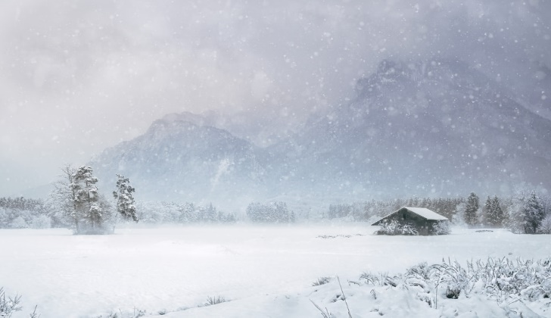
Useful nouns:
snowflakes
wind
crystals
ice
icicles

Useful adjectives:
icy
cold
freezing
bitter
bleak

Here are some examples:
as cold as ice crystals.
as bleak as a bitter wind.

