Home Learning Overview – Year 2 – Week 8
Monday: Click on the link below to watch the introduction to the day
https://www.loom.com/share/dbdbd41b5f8e45a291c40dd1e980be2c

Maths  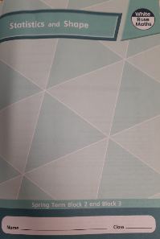  All activities are now in the accompanying workbooks in your packs or on the website. Please only follow the stated pages from each lesson. | Lesson 1  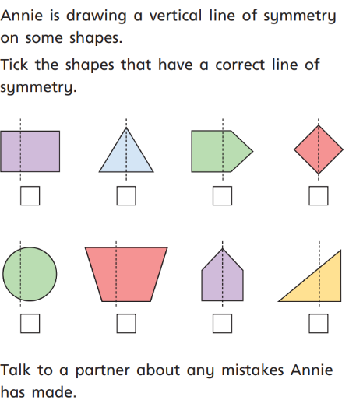  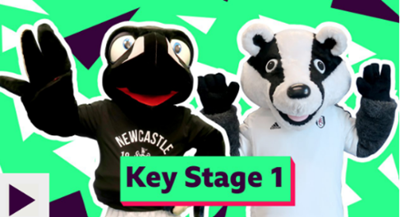  In today’s lesson, we will be looking at how to draw lines of symmetry on to 2D shapes. Have a ruler with you! Click on the pictures to watch a maths song and a recorded lesson. Complete pages 42 to 45 in your work packs.
English  Lesson 1 - Similes | Click on the link to see Mrs Robinson explain this lesson:  https://www.loom.com/share/2631c3f31fdc4d6fb3a2aad1e249156f  The focus of this lesson is to understand what a simile is and how they are used. Work through the Similes PowerPoint. Have a pencil and paper handy because there are some quiz questions to answer at the end.  Activity  Once you have completed the PowerPoint, have a go at the worksheet in your pack. Part 2 of the activity will be used in the following lesson.
Spellings | many  clothes  Click on the link to watch our spelling lesson.  https://www.loom.com/share/e50908ff9a904324aaf163e73ffe48ec  busy  people  water  again  half  money  Mr  Mrs
Science | 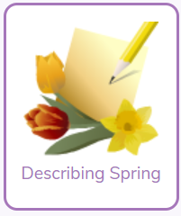  How are plants’ and animals’ behaviour affected in Spring?  Watch the video and then complete the describing spring activity on Purple Mash.
Purple Mash | 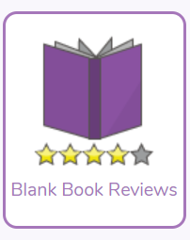  Click on the 2do and write a book review on your favourite book. You can use a book you have read yourself or a one of the stories that the teachers have read.

