My Character Description
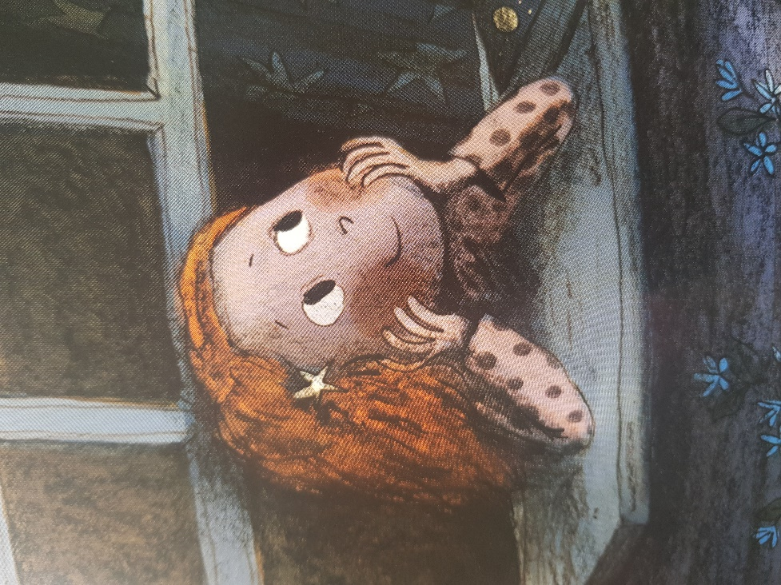
Noticing: How does the girl look?
Basics: What adjectives could we use?
Sentence starters:
I think that the girl is…
She looks…
Her hair…
Her smile…

Word bank:
kind
thoughtful
fantastic
bright
gentle
happy
copper

