**My meteor facts**

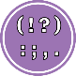 Punctuation: Use capital letters and full stops.

 Basics: Use finger spaces and check it makes sense.