Year 1 W/C 1st March
Day 3

Daily welcome and introduction to the learning.
Please use the link below:
Wednesday 3rd March (loom.com)
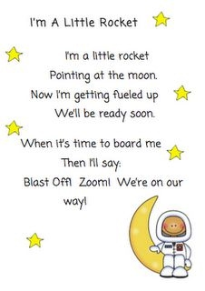
Phonics: Watch the RWI phonics lesson for today
https://www.youtube.com/channel/UCo7fbLgY2oA_cFCIg9GdxtQ?mc_cid=71ef745098&mc_eid=c9705b8c67
All videos are available from 9.30am for 24 hours.
English:
Recap the story using the video link: https://www.youtube.com/watch?v=oSkihS5mm-c
Use the template to write down facts you have learnt about meteors.
Differentiated activity: Use the template to share facts about meteors.
Please see the following video link for an explanation of today’s activities:
https://www.loom.com/share/2825eaef9e954dcc9e8cb07d4e028f83
Maths: Watch the video link below or the PowerPoint (Adding lengths).
Complete the worksheet ‘Adding lengths’.
https://vimeo.com/511039862 (Adding lengths)
Differentiated activity: Complete one out of the three ‘measuring lengths and heights’ worksheets today.
Moon Zoom Project: The project is explained in the day 1 video 22/2/21
Project ideas: | Create a map of your journey to Mars | Create a Mars mask
Design and create a vehicle to discover Mars in. | Create a space ship for a friendly alien. | Make space biscuits.

P.E:In P.E this week, you are going to be learning a Space dance – linked to our Moon Zoom topic. We hope you enjoy learning these new moves! Why do you think it’s important to exercise?
https://www.youtube.com/watch?v=52pdktAMDe4

