Home Learning Overview – Year 2 – Week 8
Tuesday: Click on the link below to watch the introduction to the day
https://www.loom.com/share/54ea04a8e7af41ca9040d81c05422a73

Maths  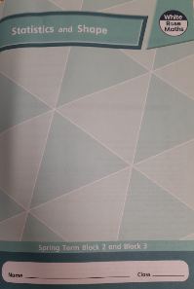  All activities are now in the accompanying workbooks in your packs or on the website. Please only follow the stated pages from each lesson. | Lesson 2  In today’s lesson, we will continue to develop our knowledge and skills by practising lines of symmetry. Have a ruler with you! Click on the pictures to watch a maths song and a recorded lesson. Complete pages 46 to 49 in your work packs.  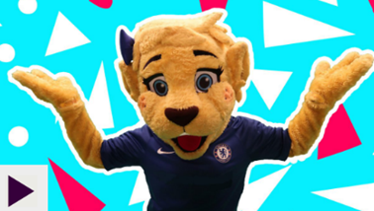  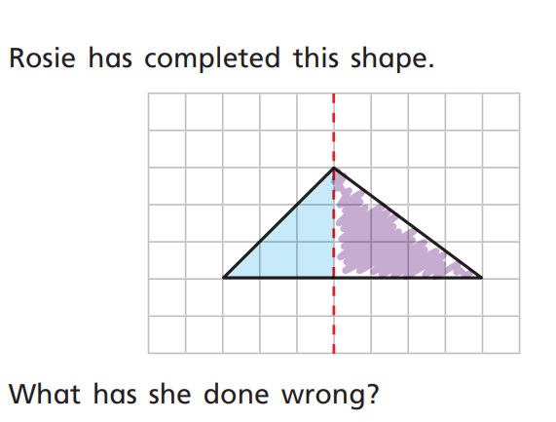
English  Lesson 2 – Sentence Stacking | Click on the link to see Mrs Palmiero explain this lesson  https://www.loom.com/share/3898cd43e52847ee929a8e817a0d1758  Chunk 1- Negative adjectives  Look at the first pages from the book. Think about how Tom feels in the room now his Grandma has gone. All the things that once made him feel happy now make him feel sad/negative.  Activity  Chotting: In your jottings box write expanded nouns using negative adjectives to describe these things. E.g.:  empty chair, dark corners, lonely dog  Sentence stacking: Write a sentence about three of the things you have describe using a comma. E.g.:  Tom looked at the empty chair, the dark corners and the lonely dog.  Chunk 2 - Past tense  In your jottings box make a list of all the things that Tom did with his Grandma. Remember to use past tense verbs. E.g.:  played cards, looked at photographs, read stories  Sentence stacking: Using the sentence opener, write about 2 or 3 things Tom remembered doing with his Grandma. Extra challenge: write about three things and use a comma in a list. E.g.:  Tom remembered when they had played cards, looked at photographs and read stories.  Chunk 3 Simile  Look back at the winter similes you generated in the previous lesson. Now write a sentence including one of your similes. For example:  Without Grandma the house felt as cold as ice.
Spellings | many  clothes  Click on the link to watch our spelling lesson.  https://www.loom.com/share/e50908ff9a904324aaf163e73ffe48ec  busy  people  water  again  half  money  Mr  Mrs
History | Why is George Stephenson a significant individual in history?  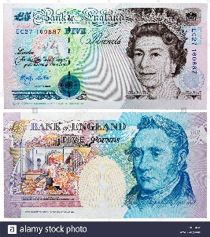  Share an image of an old five pound note with George Stephenson on. Ask the children who they think this might be. Look at the note and see if there are any clues about what the man was called, what he did and why he is important.  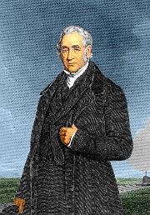  Click on the image to watch the video and share the PowerPoint about George Stephenson. Complete the fact file.
Purple Mash | Click on the 2do and write a book review on your favourite book. You can use a book you have read yourself or a one of the stories that the teachers have read.

