Home Learning Overview – Year 2 – Week 7
Thursday: Click on the link below to watch the introduction to the day
https://www.loom.com/share/7c0860196ab24795916427e92bade99f

Maths  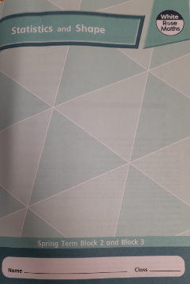  All activities are now in the accompanying workbooks in your packs or on the website. Please only follow the stated pages from each lesson. | Lesson 4  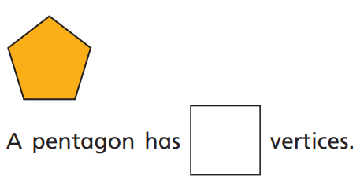  Click on the pictures to watch a maths song and the recorded lesson. A vertex is a point where two or more lines meet on a shape. How many vertices can you count? Can it help you identify different shapes? Complete pages 34 to 37.
English  Sentence Stacking | Click on the link to watch Mrs Palmiero explain this lesson:  https://www.loom.com/share/e395148ac8744be69fd76406bffd520a  Chunk 1 - Basics  Look at the clip showing lots of different types of buildings. Use superlative adjectives (an adjective using the suffix -est) to describe them. https://www.youtube.com/watch?v=IQ11x9_S87I  Remember these will end with the suffix -est. Write them in your jottings box. E.g. tallest, brightest  The following sentence is a provided sentence and is to be copied onto your sheet:  Grandma had been an architect.  Activity:  Use 2 of your superlative adjectives joined by the conjunction and to describe the buildings she made. Example:  She had made the tallest skyscrapers and the brightest churches.  Chunk 2 - Alliteration  Look carefully at the picture of Grandma’s thought bubble house. In your jottings box think of some alliterative expanded nouns for different parts of the house.  e.g. wonderful windows, red rooftop, dazzling doors  Activity:  Include these ideas in a sentence about a house she would make for Tom.  Example: For Tom she would make a house with wonderful windows and a red rooftop.  When you have finished your sentence stacking make sure you click on the link below to hear the next part of the story.  https://www.loom.com/share/e8d276e8c9034527854f915f6e614723
Spellings | past  Click on the link to watch our spelling lesson.  https://www.loom.com/share/5c201dd7bcfb427483fcaf773193ca72  father  class  grass  pass  plant  path  bath  hour  move
R.E | Click on the picture and listen to the story of Jesus and his disciples.  Why did Jesus need the disciples? Why do you think he chose fishermen?  We all need friends. Using the worksheet, create a picture of a group that you belong to. It can be your school, your family, your class, brownies, or a sports team.  Explain why you enjoy being with them.
Purple Mash | 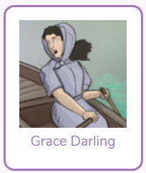  Click on the 2do and create a fact file about Grace Darling
Story | Listen to the story of “The Invisible String’ by Patrice Karst, read by Mrs van Rooyen.  https://www.loom.com/share/e139ac0a2fbf408da4791ac4e53b7d9d  