Spring – The Victorians

Science | History | Geography | Art | DT | Music | IT
Materials and their properties | Queen Victoria  Florence Nightingale  Mary Seacole  Captain Scott  The Wright Brothers | Location  Human and Physical | Drawing  Painting | Flight: model making | The music from the film ‘oliver Twist’  Learning to play the recorder | Algorithms

Sparling Starts/  Energisers/ Fabulous Finishers | - British Science Week 5th march- 14th March 2021  - Professor Bubbleworks- 15th March  - Victorian School Day- visit to Victorian buildings in Stony Stratford
Key Artists/  Art works | Henri Matisee 31 Dec 1869 - 03 Nov 1954 (age 84)  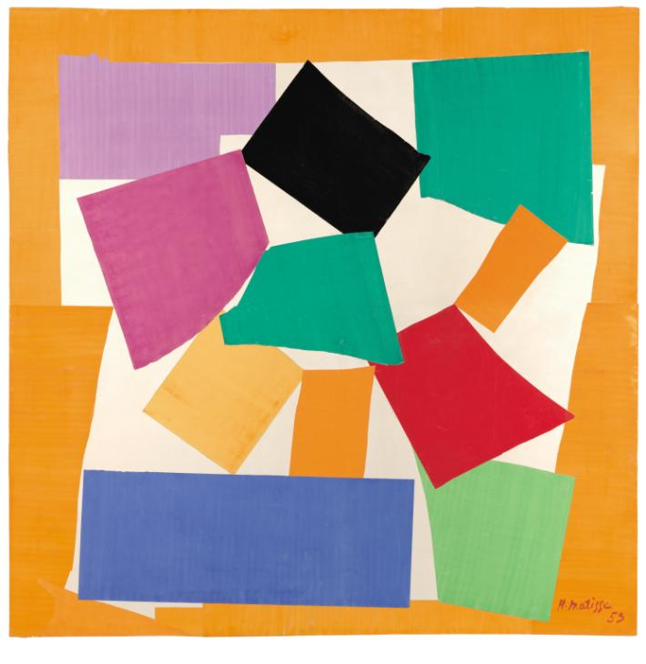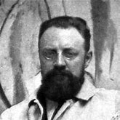  Henri Matisse was a French artist known for making colourful works of art. He used a variety of materials in his work, including paint, bronze (for his sculptures), and he also made drawings using charcoal. As Matisse became older, he began to work with brightly coloured paper and would ‘paint with scissors’ to cut out shapes, animals, leaves, dancers and flowers and then arrange them.  William Morris - patterns, stained glass windows  William Morris (24 March 1834 – 3 October 1896) was a British textile designer, poet, novelist, translator, and socialist activist associated with the British Arts and Crafts Movement.  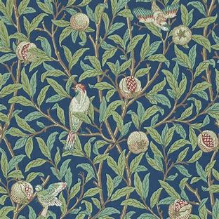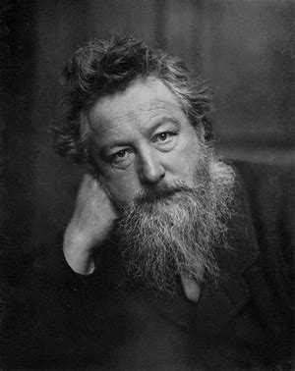  LS Lowry  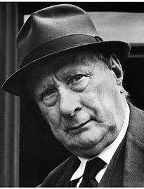  LS Lowry was a painter who painted pictures of the industrial heartlands of England. He is famous for using ‘matchstick men’ in his creations and reflecting everyday life.
Key Composers/  Compositions: | Music from the musical Oliver Twist
Science
 | Finger Tip Knowledge (materials) | Vocabulary | Skills
Materials & their Properties | Cotton comes from a plant  Rubber is made from the latex in a tree called the rubber tree (dandelions contain latex!)  Brick baked clay  Floating and sinking is related to buoyancy and density.  Some materials have the ability to take in and hold water.  Hard materials can also have the ability to absorb water.  Some materials are found naturally and some materials are manmade, for example plastic.  Some materials can have forces put on them, such as pulling, twisting, bending and squashing. Other materials can resist forces. This makes them useful for particular uses.  Different materials have different elasticities.This is the ability to go back to its original shape after being squashed or bent. | Reflective – will bounce light off its surface  Magnetic – is attracted to magnets  Translucent – will let some light through, but not enough to see detailed shapes.  Rigid – unable to be bent or forced out of shape  Suitability - Suitability means having the properties, which are right for a specific purpose.  Properties - This is what a material is like and how it behaves (soft, stretchy, waterproof).  Durabilty- The property that a material can withstand damage or wear.  Absorbent – The property that a material can take in and hold water.  Strength- Strength is the ability to resist breaking.  Recycle - Some materials have the property of being able to be recycled. This means that they can be processed and remade into something else to be used again.  Elasticity – The property of a material to go back to its original shape after being stretched or squashed. | - Identify and compare the suitability of a variety of everyday materials, including wood, metal, plastic, glass, brick, rock, paper and cardboard for particular uses  - Classify materials into man made or natural.  - Describe and observe how the shapes of solid objects made from some materials can be changed by squashing, bending, twisting and stretching.  - Predict which materials are buoyant and which not buoyant.  - Test the elasticity of different materials.  - Predict the outcome of a test to see how absorbent different materials are  - Conduct a fair test and record data, which measures the absorbency of different materials.  - Observe the effect of waterproofing different materials using wax.  - Observe how changing the shape of paper can affect its strength and rigidity.  10. Classify materials into soluble and insoluble.  11. Observe how materials change when heat is added.  12. Observe the weather in the season of spring.

- Why do we need different materials?
- Can materials be adapted for different purposes?
- What are different materials made from?
- Where do different materials come from?
- Are all materials natural?

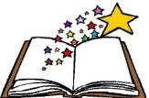  Books to be  Read | 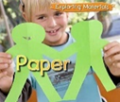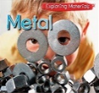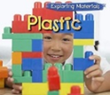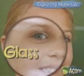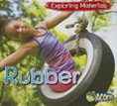

 | National Curriculum PoS | Learning | Lesson Knowledge
Week 1 Observe | •Identify and compare the suitability of a variety of everyday materials, including wood, metal, plastic, glass, brick, rock, paper and cardboard for particular uses  •Find out how the shapes of solid objects made from some materials can be changed by squashing, bending, twisting and stretching. | How many different materials are used around school?  Distinguish between an object and the material from which it is made. Children observe objects around school and the classroom going on a sensory walk. When observing objects, think about the materials they are made from and recording their findings. | - Objects are made from materials.  - Wood, plastic, glass, metal, water, rock.  - Names of everyday objects, such as pencil, Wellington boots, chair legs, window, ruler, exercise books, classroom walls, cutlery and water bottles.
Week 2 Classify | •Identify and compare the suitability of a variety of everyday materials, including wood, metal, plastic, glass, brick, rock, paper and cardboard for particular uses  •Find out how the shapes of solid objects made from some materials can be changed by squashing, bending, twisting and stretching. | Are some materials more suitable than others?  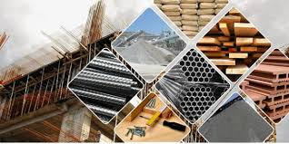  We use different materials to do different jobs but are some more suitable than others.  Children can classify different materials in boxes in the classroom and think about their suitability or unsuitability to be used for different objects. | • Some materials are found naturally and are processed, such as wood and rubber.  • Some materials are created by people, for example plastic.  • Different objects around school have different purposes and are made from different materials or a number of different materials.
Week 3 Observe | •Identify and compare the suitability of a variety of everyday materials, including wood, metal, plastic, glass, brick, rock, paper and cardboard for particular uses  •Find out how the shapes of solid objects made from some materials can be changed by squashing, bending, twisting and stretching. | Can you change the shape of different materials?  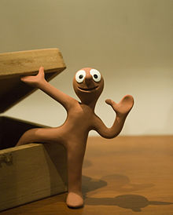  Children subject different materials to different forces, such as twisting, pulling, squeezing and bending. Then, record how these materials responded. Selection of different materials in trays on each table. | • Some materials have forces put on them to be twisted, stretched, bent, and squashed. These properties can make materials useful for particular uses.  • Rigidity is the ability of a material to resist being bent or flexed.  • Some materials are rigid. This property can make materials useful for particular uses.
Week 4 Predict | •Identify and compare the suitability of a variety of everyday materials, including wood, metal, plastic, glass, brick, rock, paper and cardboard for particular uses  •Find out how the shapes of solid objects made from some materials can be changed by squashing, bending, twisting and stretching. | Why do some materials float and other materials sink?  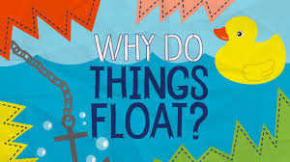  Some materials float. This property is called buoyancy. Some materials sink. This means that they are not buoyant. Children to predict and then explore a range of different materials to see if they are buoyant or not.  Do you think that changing the liquid will change how materials float or sink?  Will changing the shape of the material change the results? | • Some materials can float and some materials sink when placed in water.  • Some materials float and others sink. This can be related to buoyancy and density.  • Some materials may sink but if we change the shape of the object it may float.
Week 5 Test | •Identify and compare the suitability of a variety of everyday materials, including wood, metal, plastic, glass, brick, rock, paper and cardboard for particular uses  •Find out how the shapes of solid objects made from some materials can be changed by squashing, bending, twisting and stretching. | What is ‘elasticity’?  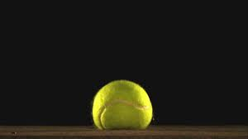  What happened in the video? Why do balls bounce? Different materials have different elasticities. This means how quickly and well they can go back to their original shape after being squashed or bent. Children test the elasticity of different balls and their materials by testing how high each ball can bounce in a fair test after being dropped from the same height. Did any balls bounce for longer? Which ball bounces the highest? Did any not bounce?  Can you imagine what life would be like if we bounced like balls? What surfaces would be best to walk on? How could we decrease how it bounces? Drop a ball into a tub of water. Can you describe what happened? | • Explore the properties of different balls  • Conduct a fair test to check a prediction.  • Different materials will affect how high and for how long a ball will bounce.
Week 6 Predict | •Identify and compare the suitability of a variety of everyday materials, including wood, metal, plastic, glass, brick, rock, paper and cardboard for particular uses  •Find out how the shapes of solid objects made from some materials can be changed by squashing, bending, twisting and stretching. | Why is ‘absorbency’ useful?  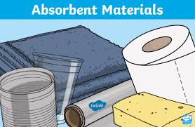  Absorbency is the ability of a material to take in and hold water. Children predict and test a range of different materials, and materials with different thickness for absorbency.  Why were some materials more absorbent than others? How could this property be useful? | • Absorbency is the ability of a material to take in and hold water.  • Materials can have a number of different properties which make is useful for a particular use.  • How would life be different if absorbent materials didn’t exist?  • A waterproof material is one which repels and resists water travelling through it.
Week 7 Test | •Identify and compare the suitability of a variety of everyday materials, including wood, metal, plastic, glass, brick, rock, paper and cardboard for particular uses  •Find out how the shapes of solid objects made from some materials can be changed by squashing, bending, twisting and stretching. | Can ‘hard’ materials be absorbent?  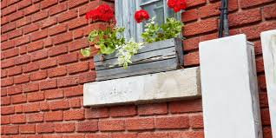  Children consider what buildings are made of and why. Generate questions about the absorbency of building materials. Devise an investigation to test a variety of materials for their absorbent property.  Make predictions and to observe and record results.  What did you find? Why might this cause problems for building? Over time, water can erode and damage buildings. Water can freeze and crack stone and brick. It is important to protect hard materials that are exposed to rain. How do you think we could do this? | • Absorbency is the ability of a material to take in and hold water.  • Materials can have a number of different properties which make is useful for a particular use.  • How would life be different if absorbent materials didn’t exist?  • A waterproof material is one which repels and resists water travelling through it.  • ‘Hard’ materials such as wood and stone can absorb water. Water can affect buildings and so we need to protect buildings from water.
Week 8 Observe | •Identify and compare the suitability of a variety of everyday materials, including wood, metal, plastic, glass, brick, rock, paper and cardboard for particular uses  •Find out how the shapes of solid objects made from some materials can be changed by squashing, bending, twisting and stretching. | Can absorbent materials be made waterproof?  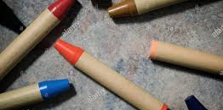  Explore different fabrics and investigate how waterproof they are using a dropper of water. How can we make the fabrics waterproof? Colour them in with wax crayon and repeat the investigation! What were your findings? Wax is a waterproof material. This means that it doesn’t allow water to pass through it. | • The absorbency of fabrics and the effect of adding a layer of wax crayon  • Wax is a waterproof material. Waterproof is the ability of a material to not allow liquid to pass through it.
Week 9 Observe | •Identify and compare the suitability of a variety of everyday materials, including wood, metal, plastic, glass, brick, rock, paper and cardboard for particular uses  •Find out how the shapes of solid objects made from some materials can be changed by squashing, bending, twisting and stretching. | What is the difference between ‘strength’ and ‘rigidity’?  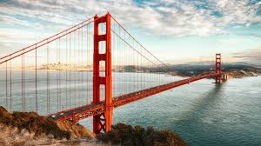  STEM activity: Children to work in mixed groups to create a bridge which can span 30cm and hold a toy car. Can you change the shape of the bridge to increase its strength and rigidity?  Consider the question: what happens if the paper is folded into a concertina shape? What did you find? Paper can be folded and changed to create more strength and rigidity. | - Rigid – unable to be bent or forced out of shape  - Strength- Strength is the ability to resist breaking.
Week 10 Classify | •Identify and compare the suitability of a variety of everyday materials, including wood, metal, plastic, glass, brick, rock, paper and cardboard for particular uses  •Find out how the shapes of solid objects made from some materials can be changed by squashing, bending, twisting and stretching. | Do some materials change when they are added to water?  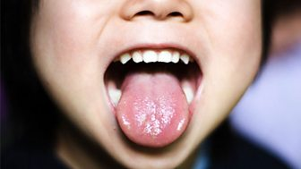  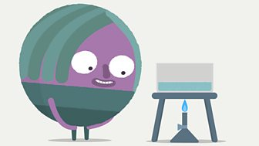  Some materials seem to disappear when added to water. We say they have dissolved. They are still there, but the particles are so small you can no longer see them. There are some materials that do not dissolve in water. Children test different materials and classify materials that can dissolve and that can’t dissolve in water.  How can you tell that sugar that's dissolved in water is still there? By tasting.  If you taste the water, you will find that it's sweet! The sweet taste shows that the sugar is still there, even though you can't see it. The water will look clear, but the sugar will still be there! | - sugar and salt dissolve in water. They are soluble. This means that they have mixed and changed with the water. A material mixed with water is called a solution.  - Sand is insoluble because it stays the same and sinks to the bottom. It doesn’t mix so it is insoluble.
Week 11 Observe | •Identify and compare the suitability of a variety of everyday materials, including wood, metal, plastic, glass, brick, rock, paper and cardboard for particular uses  •Find out how the shapes of solid objects made from some materials can be changed by squashing, bending, twisting and stretching. | How can heat change materials?  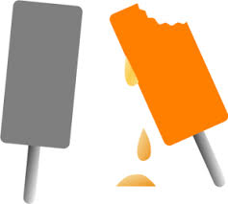  Discuss how some materials change shape when they are heated up. Heat up chocolate in your hand. What did you notice? Why does that happen? Chop up old wax crayons, heat them up and turn them into different shapes. What did you observe? What happened when the material cooled down?  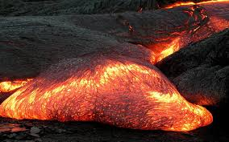 | melting is when a material will change from a solid to a liquid if you add heat.  Some materials need more heat and others only a little to melt.  temperature is the measure of how hot or cold something is. We can measure temperature in degrees celsius.  When a material is being heated, it can change shape. This makes it easier to make into another shape or another object
WeeK 12 Observe | Observe changes over time, and, with guidance, observe changes over time, patterns and relationships. | How are plants’ and animals’ behaviour affected in Spring?  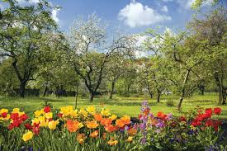  Children observe, discuss and record the weather on a spring day, including precipitation, wind and temperature. What signs of spring have you observed? How do you think that has affected the wildlife and their habitats? | There are 4 seasons: Spring, summer, autumn, winter. The length of the day changes in each season.  There are different kinds of weather. In different seasons, different kinds of weather are more typical.  Precipitation is rain, sleet, snow or hail.  Trees change and animals show different habits in different seasons

History
 | History Knowledge | Vocabulary | Skills
History – Significant People | Sir Joseph Wilson Swan (31 October 1828 – 27 May 1914) was an English physicist, chemist, and inventor. He is known as an independent early developer of a successful incandescent light bulb.  Queen Victoria: was Queen of the United Kingdom of Great Britain and Ireland from 20 June 1837 until her death in 1901.  Florence Nightingale: was an English social reformer, statistician and the founder of modern nursing. Nightingale came to prominence while serving as a manager and trainer of nurses during the Crimean War, in which she organised care for wounded soldiers.  Mary Seacole: Mary Jane Seacole was a British-Jamaican nurse, healer and businesswoman who set up the "British Hotel" behind the lines during the Crimean War.  Grace Darling: Grace Horsley Darling was an English lighthouse keeper's daughter. Her participation in the rescue of survivors from the shipwrecked Forfarshire in 1838 brought her national fame. The paddle steamer ran aground on the Farne Islands off the coast of Northumberland in northeast England; nine members of her crew were saved.  In class, create a timeline throughout Queen Victoria's life. Add events as they are studied throughout the term. | Incandescent  Reign  Nursing  Crimean  Nursing  Crimean | Speak about how he/she has found out about the past (organisation and communication)  Record what they have learned by drawing and writing (organisation and communication)  Show an awareness of the past, using common words and phrases relating to the passing of time  Describe where the people and events he/she studies fit within a chronological framework and identify similarities and differences between ways of life in different periods  Use a wide vocabulary of everyday historical terms  Ask and answer questions, choosing and using parts of stories and other sources to show that he/she knows and understands key features of events]  Show understanding of some of the ways in which we find out about the past and identify different ways in which it is represented

Why is Florence Nightingale famous?
What made Mary Seacole unique?
Why is Victoria such a famous queen?
Why is Charles Dickens an important person from history?

Books to be  Read | 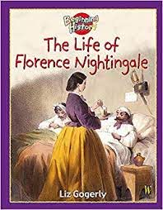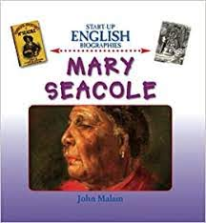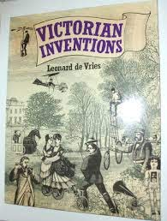

 | National Curriculum PoS | Learning | Lesson Knowledge
Week 1 | Discuss the lives of significant individuals in the past who have contributed to national and international achievements | Key question: Who was Queen Victoria?  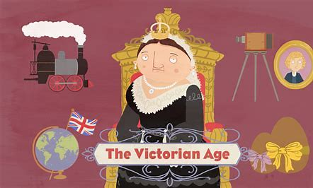  Show the children a picture of Queen Victoria. Look closely at the picture. What do we know by looking at the picture? What do we want to find out?  Children to note questions, use iPads to research and record findings in their topic books.  Create a class line that we will add an event to in each lesson. | 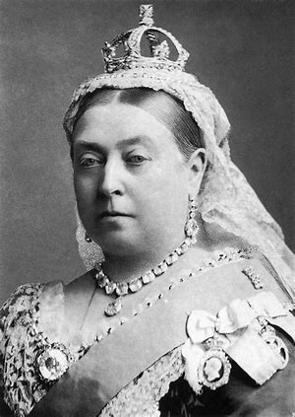  Queen Victoria Victoria (Alexandrina Victoria; 24 May 1819 – 22 January 1901) was Queen of the United Kingdom of Great Britain and Ireland from 20 June 1837 until her death. Parliament voted her the additional title of Empress of India in 1876. Known as the Victorian era, her reign of 63 years and seven months was longer than that of any of her predecessors.
Week 2 | Discuss the lives of significant individuals in  the past who have contributed to national and international achievements. Some should be used to compare aspects of life in different periods | Key question: How were Mary Seacole and Florence Nightingale similar and different?  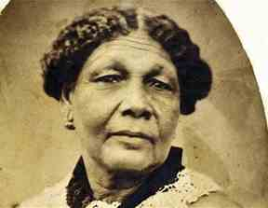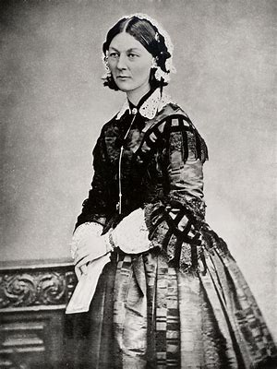  Share films below: Mary Seacole & Florence Nightingale.  Ask the children to recall information about both significant individuals on post it notes.  Children to complete a comparison chart comparing both Mary Seacole and Florence Nightingale.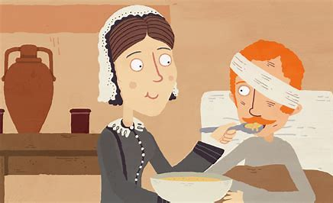  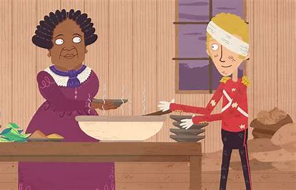 | Florence Nightingale  Born: 12 May 1820 in Florence, Italy  Lived in: England, UK  Occupation: Nurse  Died: 13 August 1910  Best known for: Founding modern nursing  Also known as: Lady with the Lamp  Mary Seacole  Mary was born in 1805 in Kingston, Jamaica. Her father was a Scottish soldier and her mother was Jamaican. Mary Seacole was mixed-race and described herself as ‘Creole’. Mary’s mother ran a boarding house in Kingston.
Week 4 | Discuss the lives of significant individuals in the past who have contributed to national and international achievements and use some to compare aspects of life in different periods  Describe significant historical events, people and places in his/her own locality | Key question: What were schools like in the Victorian Era?  Ask: What is school like for you? Jot ideas onto IWB.  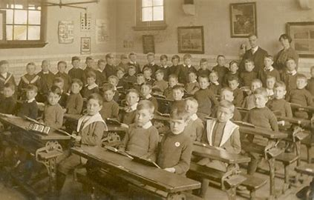  Watch the video clip. What are the similarities and differences between school in the Victorian days and school today? | - Children sat in rows.  - Boys and girls were taught different subjects.  - When Victoria came to the throne schools were only for the wealthy.  - In 1870 schools began to cater for the rich and poor alike. Various names were given to the schools including the British schools and the Ragged schools; the latter getting the name from the poor children attending the school. Russell Street was a British School, previously based in The Plough pub.
Week 5 | Discuss the lives of significant individuals in  the past who have contributed to national and international achievements. Some should be used to compare aspects of life in different periods | Question: Why is Joseph Swan famous?  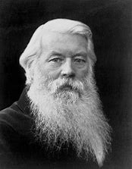  Look at the picture of Joseph Swan. What do you know about this man by looking at this picture? Discuss Swann’s invention and achievements- what do you think the impact was of Swann's work? Click on the picture to find out about the competition between Edison and Swann. Add to the timeline. | Sir Joseph Wilson Swan FRS (31 October 1828 – 27 May 1914) was an English physicist, chemist, and inventor. He is known as an independent early developer of a successful incandescent light bulb, and is the person responsible for developing and supplying the first incandescent lights used to illuminate homes and public buildings, including the Savoy Theatre, London, in 1881.
Week 6 | Discuss the lives of significant individuals in  the past who have contributed to national and international achievements. Some should be used to compare aspects of life in different period | Question: Who was Isambard Kingdom Brunel? Isambard Kingdom Brune lived around 200 years ago, during the Victorian Age.He was a famous engineer whose designs changed the lives of many people  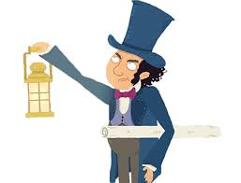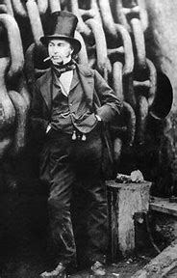 | Isambard Kingdom Brunel FRS was an English civil engineer who is considered "one of the most ingenious and prolific figures in engineering history", "one of the 19th-century engineering giants", and "one of the greatest figures of the Industrial Revolution, changed the face of the English landscape with his groundbreaking designs and ingenious constructions". Brunel built dockyards, the Great Western Railway, a series of steamships including the first propeller-driven transatlantic steamship, and numerous important bridges and tunnels. His designs revolutionised public transport and modern engineering.
Week 7 History/ Geography | Identify seasonal and daily weather patterns in the United Kingdom and the location of hot and cold areas of the world in relation to the Equator and the North and South Poles  Name and locate the world's seven continents and five oceans | Why was Captain Scott called “Scott of Antartica”?  Look at the photograph of Captain Scott. What can you tell about this man from looking at the photograph? Where is he? What has he got in his hand? Who do you think he is?  Watch the video clip  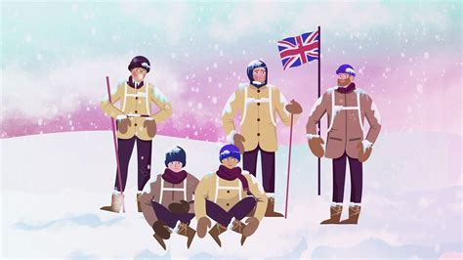  Using a map identify where Antarctica is describe the weather and label the map. | Scott led the National Antarctic Expedition in 1901. Although the team did not reach the South Pole, they made it further south than anyone before them.  Scott’s second Antarctic expedition took place in 1910. Soon after landing, the dogs and ponies had to be left behind because of the cold, and only Scott and four other team members continued.  Captain Scott reached the South Pole in January, 1911 only to discover a Norwegian explorer, Roald Amundsen had reached there a month earlier.  Captain Scott died on 29th March 1912 from the extreme cold on the return journey, within 20 km of supplies.
Week 8 | Discuss the lives of significant individuals in  the past who have contributed to national and international achievements. Some should be used to compare aspects of life in different period | Why is Charlies Dickens an important person from history?  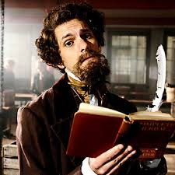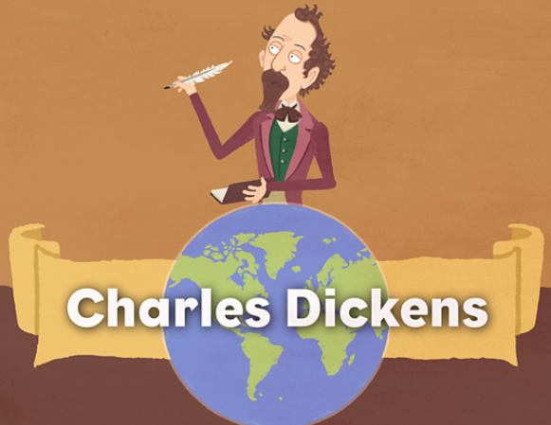  Watch the videos about Charles Dickens and his life. Create a fact sheet about his life. | Charles Dickens was a famous English writer. He wrote many books, including Oliver Twist and Scrooge.  When Dickens was a child his family were very poor.  When he became famous, only rich people could afford to buy books. Dickens published his stories in sections in (cheaper) magazines so poorer people could read them.
Week 9 | Discuss the lives of significant individuals in  the past who have contributed to national and international achievements. Some should be used to compare aspects of life in different period | Why is George Stephenson a significant individual in history?  Share an image of an old fiver pound note with George Stephenson on. Ask the children who they think this might be. Look at the note and see if there are any clues about what the man was called, what he did and why he is important.  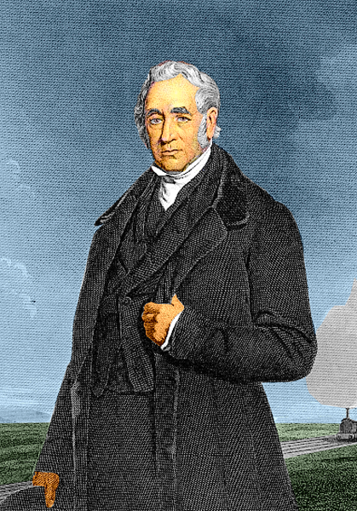  Share the PowerPoint about George Stephenson then use an iPad to research him further to complete the fact file template about George Stephenson.  The story of the steam engine - KS2 History - BBC Bitesize | George Stephenson was born in 1781 near Newcastle-upon-Tyne.  In 1814, George designed his first steam locomotive for the railways  In 1829 a new railway was built. George and his son Robert entered a competition to design the best locomotive to pull heavy loads over long distances.  They won the competition and the prize was £500.  This was a huge turning point in rail history.
Week 10 | Discuss the lives of significant individuals in  the past who have contributed to national and international achievements. Some should be used to compare aspects of life in different period | 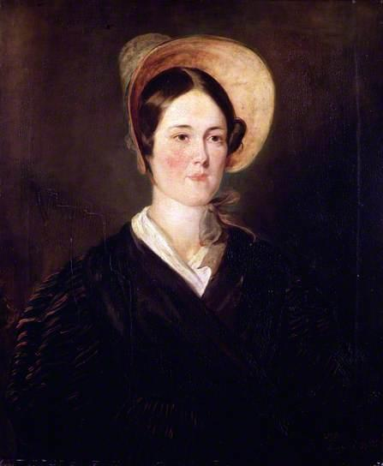  Who is Grace Darling?  Share an image of Grace Darling. Slowly reveal different aspects of her. Discuss what can be seen and if there are any clues as to who Grace Darling is.  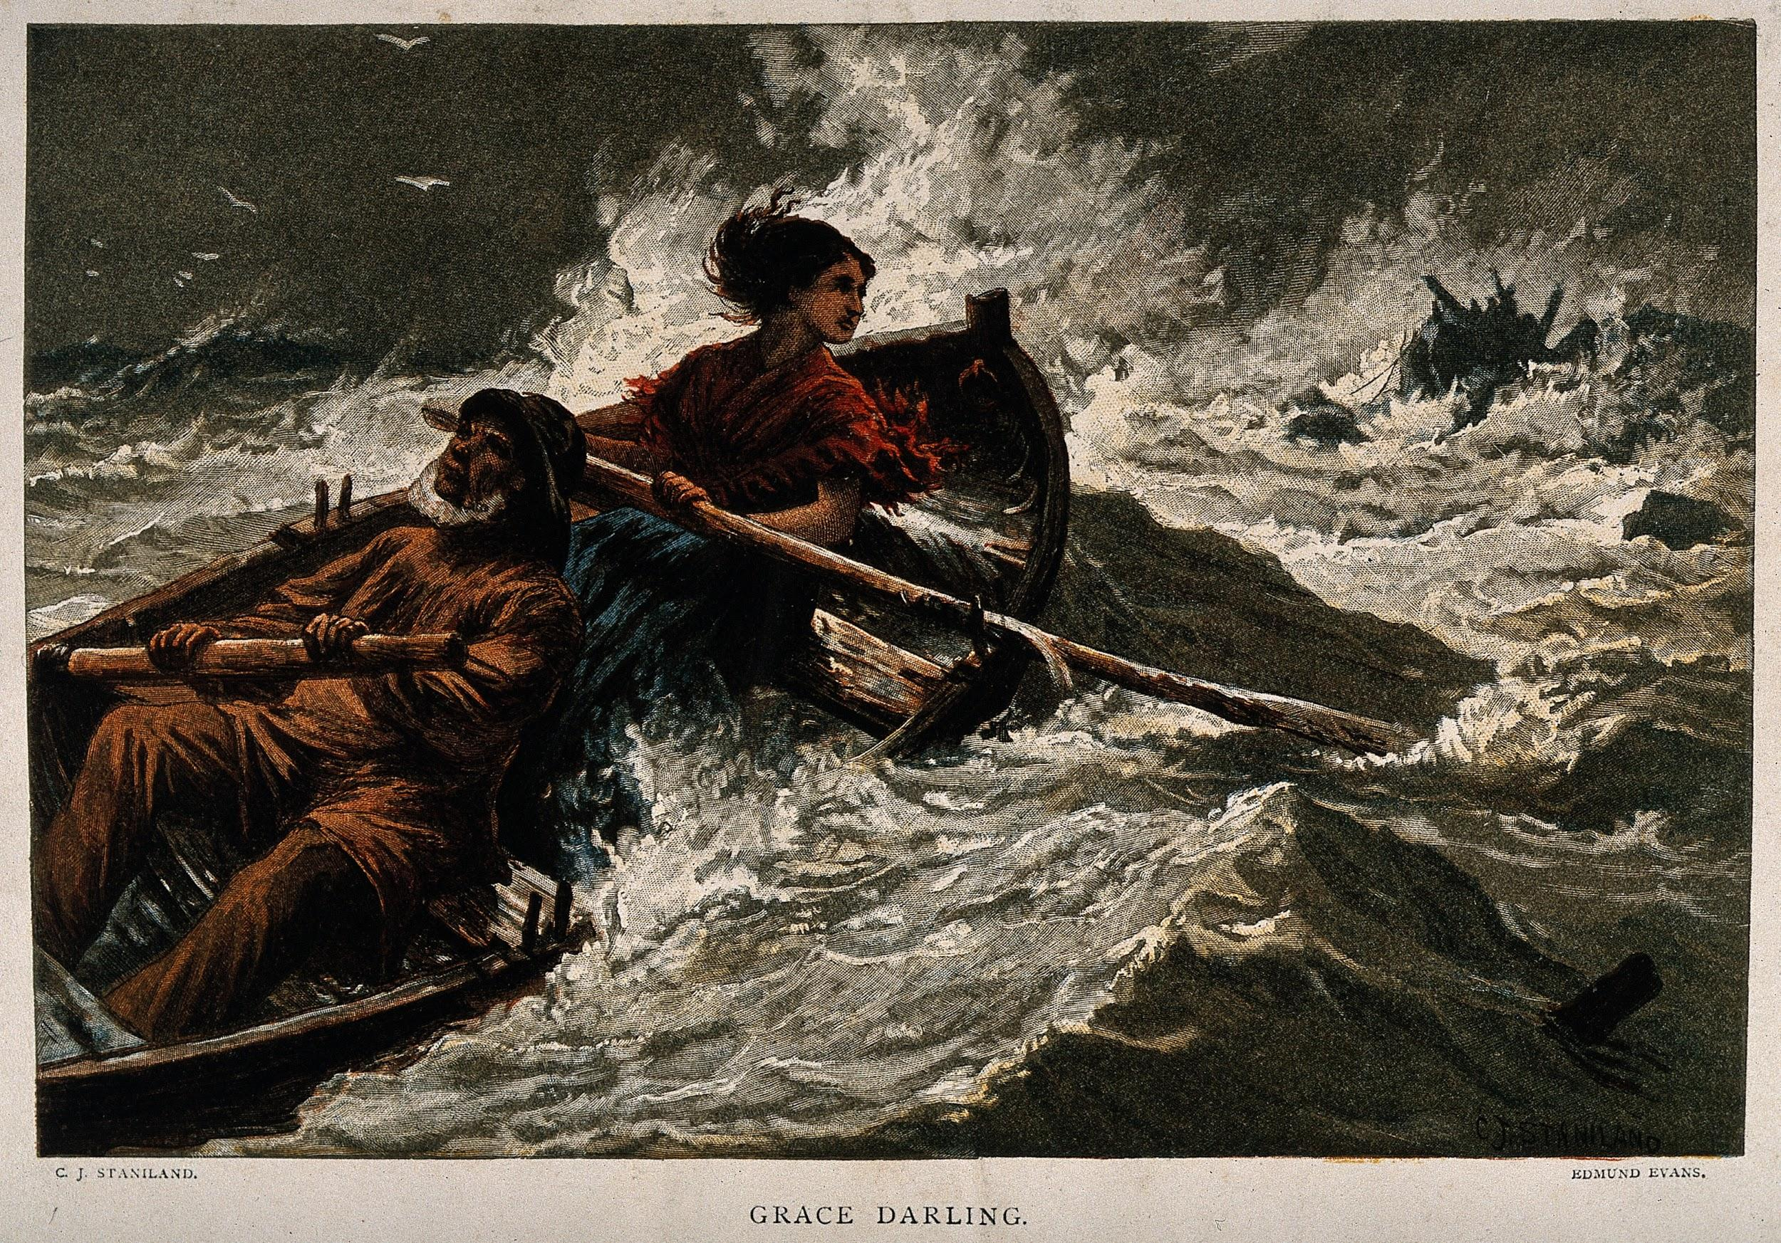  Explain that Grace was a Victorian heroine. Grace would not have had electricity and the clip shows how different her home was. Share her story via the link:  Retell the story of Grace Darling on the frame provided. | Grace Darling was a Victorian heroine.  She lived in a lighthouse with her family.  On the night of 7th September 1838, Grace Darling set out to see in a storm after seeing another ship crash.  Grace and her father saved 9 people on their tiny boat.  She became a national heroine for her brave act.  Grace Darling died at the age of 26, only 4 years later.

Art/DT
 | Key works of art to recognise/ Artists to know: | Vocabulary/ Knowledge (see BIG Questions) | Skills (ART) | Skills (DT)
Art –  DT – |  | What was Victorian artwork like?  Who was William Morris?  What is he best known for?  Who was Henri Matisse? Can you name any of his artwork?  What is a silhouette portrait?  What does ‘wax resist’ mean? | Become proficient in drawing, painting, sculpture and other art, craft and design techniques.  Children know how to use different grades of pencil in my drawing for a specific purpose.  Children know how to use charcoal, pencil, pens and pastels.  Children know how to create different tones using light and dark.  Children know how to show patterns and texture in drawings. | Technical  - design purposeful, functional, appealing products for himself/herself and other users based on design criteria  - generate, develop, model and communicate his/her ideas through talking, drawing, templates, mock-ups and, where appropriate, information and communication technology  - select from and use a wide range of materials and components, including construction materials, textiles and ingredients, according to their characteristics  - choose materials and explain why they are being used depending on their characteristics  - evaluate his/her ideas and products against design criteria  - join materials together as part of a moving structure  - explore and use mechanisms e.g. levers, sliders, wheels and axles, in his/her products

Why do we have different grade pencils?
How can we create a wax resist?
What is a repeating pattern?
What are the primary colours?
Who was Henri Matisse/William Morris?
What is a collage?

Books to be  Read | 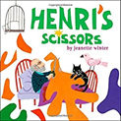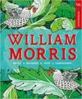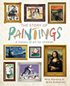

 | National Curriculum PoS | Learning | Lesson Knowledge
Week 1 – Art | To develop a wide range of art and design techniques in using colour, pattern, texture, line, shape, form and space | Key Question: What is a silhouette portrait?  LI: to create a silhouette portrait.  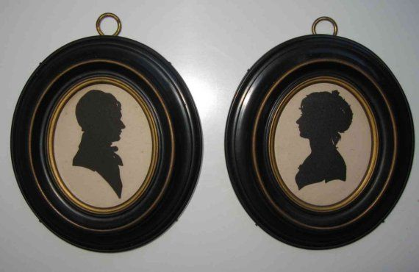  Share examples of portraits and silhouette portraits. Explain that in the Victorian era, silhouette portraits were popular. They were used as artwork and brooches and other jewellery.  Activity: Children to work in pairs and draw an outline of the side profile of their partner and fill it in using charcoal. | Children know how to use charcoal, pencil, pens and pastels.
Week 2 - Art | To learn about the work of a range of artists, craft makers and designers, describing the differences and similarities between different practices and disciplines, and making links to their own work. | Key Question: Who is William Morris?  LI: to understand who William Morris was.  Share information about William Morris.  Discuss the information and compare to the children’s own printing from the previous half term. How did they compare? Allow children to analyse artwork and discuss. 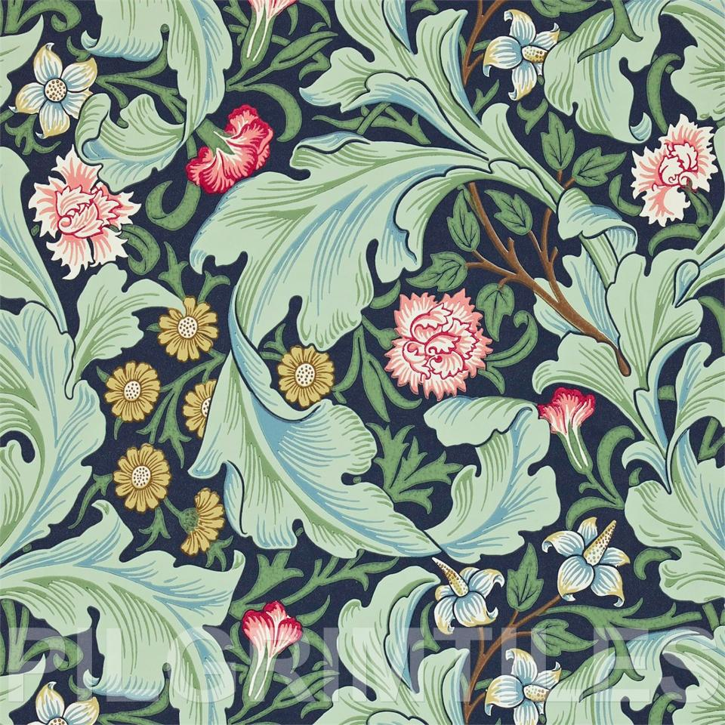  Discuss the repetition in the patterns.  Activity: Children to record one fact about Willaim Morris. | Children know how to suggest how artists have used colour, pattern and shape.
Week 3 – Art | To develop a wide range of art and design techniques in using colour, pattern, texture, line, shape, form and space | Key Question: What is a repeating pattern?  LI: to create repeating patterns.  Recap: Who was William Morris? What was his artwork like?  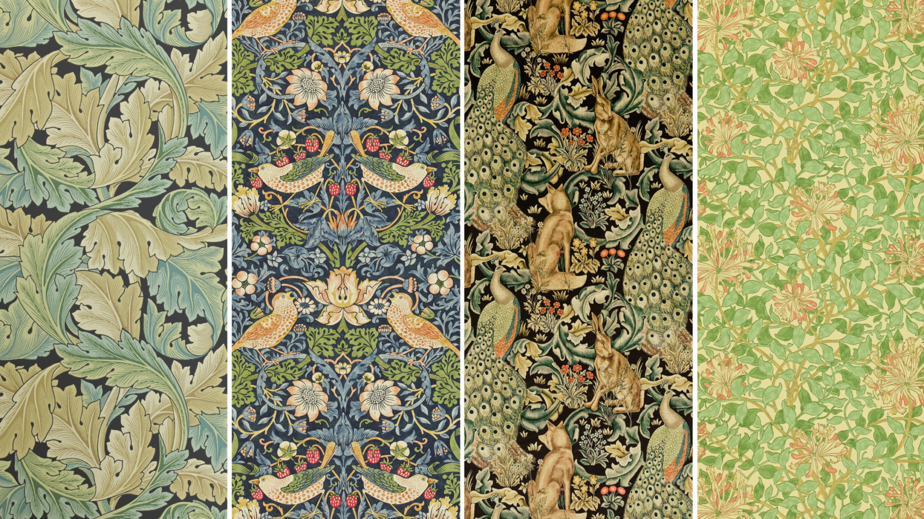  Show examples of William Morris’s art (wallpapers) and discuss the repeating patterns. William Morris famously created wallpaper which consisted of repeating patterns.  Children will go outside and observe plant/leaf shapes. Photos to be taken of the shapes found.  Activity: Practise sketching leaf/plant shapes in sketchbooks and create a repeating pattern using 3 or 4 shapes to create a draft for the next lesson. | Children know how to design patterns of increasing complexity and repetition.  Children know how to create a piece of work in response to another artist’s work.
Week 4 - Art | To develop a wide range of art and design techniques in using colour, pattern, texture, line, shape, form and space  Children know how to use a variety of techniques, inc. monoprint, block, relief and resist printing. | LI: to create repeating patterns.  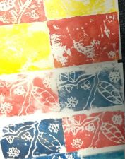  Remind the children of William Morris’s repeating pattern art. Allow the children time to review their sketching from the previous week - What worked well? What may need improving?  Discuss the colours used in Morris’s art.  The children will create a repeating pattern onto a whiteboard and use this for monoprinting. | Children know how to design patterns of increasing complexity and repetition.  Children know how to create a piece of work in response to another artist’s work.  Children know how to print using a variety of materials, objects and techniques
Week 5 - Art | To learn about the work of a range of artists, craft makers and designers, describing the differences and similarities between different practices and disciplines, and making links to their own work. | Key Question: Who was Henri Matisse  Look at the picture. What do you think it could be? What do you notice about the picture? How is this similar to artwork we have studied before? (Firework collage Autumn term)  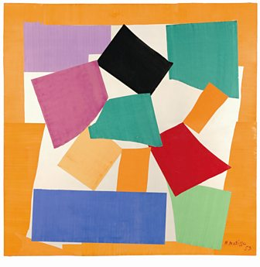  Look at a variety of Matisse’s work and create our own collages to display in school | Children know how to create a piece of work in response to another artist’s work.
Week 6 - Art | To learn about the work of a range of artists, craft makers and designers, describing the differences and similarities between different practices and disciplines, and making links to their own work. | Key question: Who was LS Lowry?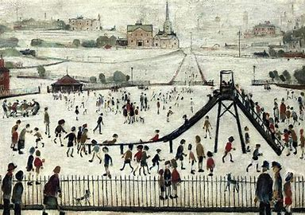Laurence Stephen Lowry RBA RA was an English artist. His drawings and paintings depict Pendlebury, Lancashire, where he lived and worked for more than 40 years, Salford and its vicinity.  Using our school as a stimulus, create a portrait in the style of L.S Lowry. | Children know how to create a piece of work in response to another artist’s work.
DT Week 1 | Design purposeful, functional, appealing products for themselves and other users based on design criteria generate, develop,  Model and communicate their ideas through talking, drawing, templates, mock-ups and, where appropriate, information and communication technology | How could we keep boats safe at sea?  https://www.bbc.co.uk/programmes/p015gmjd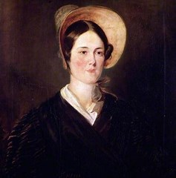  Listen to the story of Grace Darling. How do we keep sailors safe at sea today?  Design a building that you think would meet this criteria::  Keep sailors safe  Be seen from far away | Technical  design purposeful, functional, appealing products for himself/herself and other users based on design criteria
DT Week 2 | Generate, develop, model and communicate their ideas through talking, drawing, templates, mock-ups and, where appropriate, information and communication technology | Testing lesson:  Using a range of junk materials pupils create a mockup of their final design. Ask the question:  How can we make this bulb light up?  Pupils try using the equipment to make the bulb light up. | select from and use a wide range of materials and components, including construction materials, textiles and ingredients, according to their characteristics  choose materials and explain why they are being used depending on their characteristics
DT Week 3 | Make select from and use a range of tools and equipment to perform practical tasks [for example, cutting, shaping, joining and finishing  select from and use a wide range of materials and components, including construction materials, textiles and ingredients, according to their characteristics | Which materials would be best to use and why?  Reflect on the previous week learning and evaluate the mock ups. How could we improve our work?  What would be the ‘even better ifs’?  How can we make the light appear to move around?  Test out a range of options cup moving around, bottom moving around  How can we join the parts together?  Test out a range of different ways of joining parts of the model together.  Complete the lighthouses, hold a great exhibition and ‘advertise’ inventions- Link to English | select from and use a wide range of materials and components, including construction materials, textiles and ingredients, according to their characteristics  choose materials and explain why they are being used depending on their characteristics
DT Week 4 | Evaluate his/her ideas and products against design criteria | What could I do to improve my model?  In pairs pupils evaluate their finished lighthouses using the two tickled pinks and the green for growths to evaluate. | Evaluate his/her ideas and products against design criteria  Join materials together as part of a moving structure  Explore and use mechanisms e.g. levers, sliders, wheels and axles, in his/her products

Computing
Finger tip knowledge | Vocabulary | Skills
Algorithms are a set of instructions  that make something happen.  Algorithms are used in all different kinds of robots including traffic lights and washing machines. | Algorithm  Programme  Bug/ de bug  Accurate  Left, Right, Forwards, Backwards | Children know how to use of a wide range of technology and can describe how it works in a variety of different contexts.  Children know how to select the appropriate piece of technology for a particular purpose and communicate this.  Children know how to save their work to a folder and retrieve it when needed.  Children know how to understand how to edit and copy information using a variety of media.  Children know how to capture a digital image, retrieve and manipulate it.  Children know how to save their work to a folder and retrieve it when needed.  Children know how to begin to understand how to edit and copy information using a variety of media.

What is an algorithm?
How are algorithms used?
What is directional language?

 | National Curriculum PoS | Learning | Lesson Knowledge
Week 1  Computing | understand what algorithms are; how they are implemented as programs on digital devices; and that programs execute by following precise and unambiguous instructions | Key question: What is an algorithm?  Watch the clip- click on the picture.  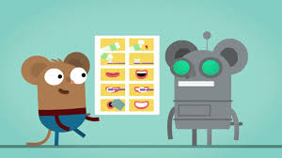  An algorithm is a set of instructions to make something happen. The teacher is a robot- how could we give the teacher the right instructions to make a jam sandwich? Children give the teacher the instructions- have we made any mistakes? How could we correct them? | An algorithm is a set of instructions to make something happen.  We can edit and improve an algorithm to make it even more exact.  Directional language including left, right, forwards, backwards.
Week 2  Computing | understand what algorithms are; how they are implemented as programs on digital devices; and that programs execute by following precise and unambiguous instructions  use logical reasoning to predict the behaviour of simple programs | Key question: How do you programme a robot?  Watch the clip- click on the picture.  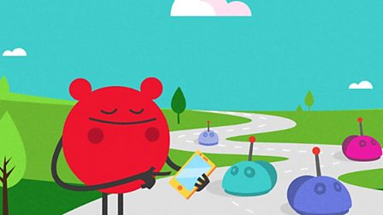  Recap what an algorithm is. Explain that this week we are going to use the Bee Bots and the Bee Bot app to create an algorithm. Explain that the Bee Bots are robots.  Teach the pupils directional language and leave as a prompt. Using a map, ask how could we get the Bee Bot from point a to point b?  Children use the Bee Bots and the Bee Bot app to create algorithms and solve problems. | An algorithm is a set of instructions to make something happen.  We can edit and improve an algorithm to make it even more exact.  Directional language including left, right, forwards, backwards.
Week 3  Computing | understand what algorithms are; how they are implemented as programs on digital devices; and that programs execute by following precise and unambiguous instructions | Key question: How can we use algorithms?  Demonstrate Scratch junior to the pupils. Explain that at the bottom of the screen we can see the algorithm or set of instructions that we are creating.  The first session needs to be an experimental session where they have the opportunity to test out Scratch. | An algorithm is a set of instructions to make something happen.  We can edit and improve an algorithm to make it even more exact.  Directional language including left, right, forwards, backwards.
Week 4  Computing | understand what algorithms are; how they are implemented as programs on digital devices; and that programs execute by following precise and unambiguous instructions | Key question: How can we create algorithms?  At the start of the session play the game ‘Simon Says’. Explain that Simon Says id just like the start command in an algorithm, nothing will happen unless it is at the start of the set of instructions.  Recap using Scratch junior. This week we are going to complete the following challenges  - Add a beach background  - Add two characters- one bigger than the other  - Add a set of instructions to make Scratch move from left to right and jump up and down. | An algorithm is a set of instructions to make something happen.  We can edit and improve an algorithm to make it even more exact.  Directional language including left, right, forwards, backwards.
Week 5  Computing | understand what algorithms are; how they are implemented as programs on digital devices; and that programs execute by following precise and unambiguous instructions  create and debug simple programs  recognise common uses of information technology beyond school | Key question: What does’ de bug’ mean?  Explain that sometimes when we use a set of instructions if there is some information missing or a missing step in the instructions can mean that the instructions do not create the correct outcome. Give the examples of what could happen if for example traffic lights weren’t using the correct algorithm and demonstrate brushing teeth in the wrong order.  As a class demo the game then let the children solve the problems independently. | We can debug an algorithm by checking that our instructions are accurate and fixing it.  Algorithms are used to programme different pieces of equipment in everyday life.
Week  6  Computing | Safer Internet Day  Use technology safely and respectfully, keeping personal information private; identify where to go for help and support when they have concerns about content or contact on the internet or other online technologies. | Key question: How can we stay safe online?  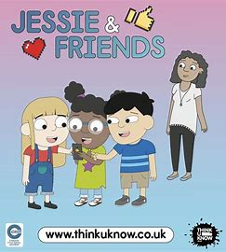  Watch the video and discuss the following questions.  What videos have you watched online recently? Do you have a favourite? Why is it your favourite? Lots of people watch videos online – is this true for your friends?  Draw around your hand and recap who is on your helping hand. Which adults do you trust to help you if you have a problem online? | Children know how to use technology respectfully and safely.
Week 6  Computing | use technology purposefully to create, organise, store, manipulate and retrieve digital content  use technology safely and respectfully, keeping personal information private; identify where to go for help and support when they have concerns about content or contact on the internet or other online technologies. | Key question: How can we use technology to organise information?  Recap e-safety rules about keeping passwords safe and not sharing information.  Using what we have learnt about Victorian schools create a fact file using purple mash. | Children know how to capture a digital image, retrieve and manipulate it.  Children know how to save their work to a folder and retrieve it when needed.  Children know how to begin to understand how to edit and copy information using a variety of media.

RE
 | Finger Tip Knowledge | Vocabulary
RE | Celebrations are times when people remember key events and are often linked to seasonal changes. They can be religious or non-religious.  Positive role models are people who behave in a respectful and responsible way around us. | Role model  Celebration  Easter  Miracle

What makes a good role model?
Why do we celebrate different events?
Why do Christians celebrate Easter?

 | MK Local Syllabus Skills | Learning | Lesson Knowledge
Week  1 | See MK Local Syllabus  Behaving | What can we learn from teachers, leaders and religious leaders about behaving? | What is the meaning of the words ‘ role model’  Who is a good role model to us? Create a class mind map of all the people that we know that are good role models.  Listen to the story of Zaccheus meets Jesus. Why did the tax collector decide to follow Jesus?  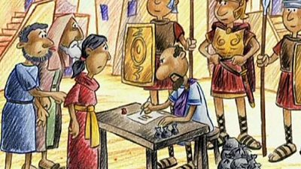
Week  2 | See MK Local Syllabus | How can we become good role models? | To discuss what a role model is and how someone can become a role model through their actions and behaviour.  Identify and label the attributes of a positive role model.  Reflect on how spiritual qualities and moral values relate to their own behaviour  Recognise that religious teachings and ideas make a difference to individuals, families and the local community.
Week  3 | See MK Local Syllabus  Believing | What do Christians believe about God, people and the natural world? | What made Jesus a role model to Christian people? Discuss how his actions affected others. Listen to the miracle of how Jesus healed a paralysed man.  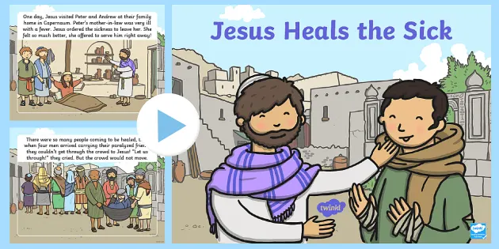  Describe the attributes that Jesus had which made him a positive role model.  Reflect on how spiritual qualities and moral values relate to their own behaviour  Recognise that religious teachings and ideas make a difference to individuals, families and the local community.
Week  4 | See MK Local Syllabus  Behaving | Why is the story of Jesus feeding the 5000 important to Christians? | Listen carefully to the story of Jesus feeding the 5000, discussing what the story was trying to teach us and why.  Think carefully – what is the story about?  Retell the story using the power point to support- create a story map.  Recognise the importance for some people of belonging to a religion or holding special beliefs, in diverse ways, exploring the difference this makes to their lives.
Week  5 | See MK Local Syllabus  Reflecting, responding and making links | What do people believe about God, people and the natural world?  Comparing and contrasting, evaluating and appraising and making connections to their own and others’ lives | What is a Humanist?  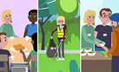  Create a mind map of different things that Humanists believe using key words – discuss and explain ideas.  Recognise the importance for some people of belonging to a religion or holding special beliefs, in diverse ways, exploring the difference this makes to their lives.
Week  6 | See MK Local Syllabus  Believing | What do people believe about God, people and the natural world? | To discuss how Humanists behave and what they do to be good people.  Recognise the importance for some people of belonging to a religion or holding special beliefs, in diverse ways, exploring the difference this makes to their lives
Week  7 | See MK Local Syllabus  Believing | How and why are celebrations, including religious celebrations, important to people? | What is a celebration? Which celebrations do you know?  Create a list of all of the celebrations that we know.  Why are celebrations important?  Celebrations are connected with nature and key events over time for example birthdays, Christmas, baptisms.
Week 8 | See MK local syllabus  Behaving | Why is the story of the good samaritan important to Christians?  What does it teach us about being a good friend? | What does the story teach us about friendship?  What makes a good friend?  Click on the picture to listen to the story.  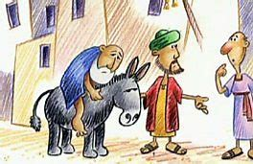
Week 9 | See MK Local Syllabus  Belonging | What does it mean to belong?  Which groups do you belong to? | 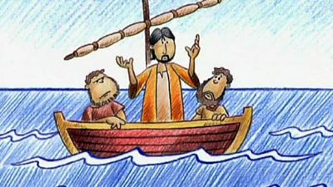  Click on the picture and listen to the story of Jesus and his disciples.  Why did Jesus need the disciples? Why do you think he chose fishermen and not people with ‘more important’ jobs?  We all need friends. Create a picture of a group that you belong to, it can be your school, your family, your class, brownies, a football team.
Week 10 | See MK Local Syllabus  Believing | Why is aPalm Sunday important to Christians?  How and why are some stories and books sacred and important in religion? | 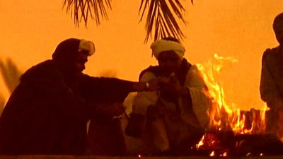  Listen to the story of Palm Sunday. Why is it important to Christians? Did it put Jesus in danger?  Who is your hero and how would you welcome them to your town?
Week 11 | See MK Local Syllabus  Belonging | Why is the last supper an important story for Chritians?  How and why do symbols express meaning including religious meaning? | 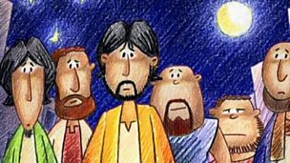  Listen to the story of the last supper. Jesus knew that he was going to be betrayed but he forgave Judas. The bread and wine symbolise the blood of Christ and the body of Christ.  Complete the sentences about the last supper.
Week 10 | See MK Local Syllabus  Believing | How and why are some stories and books sacred and important in religion? | Which stories do we know are important to religions? Recap the Good Samaritan, Christmas, Zacchaeus meets Jesus.  What do we already know about Easter? Why is it an important story to Christians?  