Reception - Autumn 1- Theme:Magical Me

Literacy  We will be listening to a range of stories including: Brown Bear, Brown Bear, Giraffes Cant Dance and My five Senses. We will be exploring our likes and dislikes and talking about our families. We will start learning our phonics sounds using Read Write Inc scheme to help us with our reading and writing. |  | Mathematics  We will be focusing on counting, including 1:1 counting where one number name is assigned to each object being counted. The children will be able to physically move the objects to count carefully. We will be looking closely at the numbers 1-5, looking at how each number can be represented. We will be sorting objects into two groups based on attributes for example colour, getting the children to look at similarities and differences and grouping them. |  |  |  | Physical Development  We will be learning to dress and undress independently for P.E. lessons. We will be experiment with how our bodies move. We will develop our fine motor skills through a range of activities including: threading, playdough, cutting and exploring anticlockwise movements.
Communication and Language  During lessons children will learn to listen and follow instructions. They will build their vocabulary knowledge around the topic and will build their confidence to talk to their learning partner. |  | 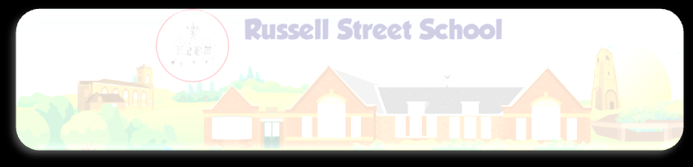  Magical Me |  |  |  | Personal, Social and Emotional Development  We will be learning the rules and routines of school. We will be learning about making friendships, dealing with disputes and conflict in positives ways. We will look closely at our value of cooperation.
Expressive Arts and Design  Exploring media and materials: We will learn topic related songs. Throughout the term we will have access to both construction and creative materials.  Being imaginative: We will experiment with different tools to draw or paint pictures of ourselves and also our families. Using different techniques the children will be taught how to make a photo frame for these drawings. We will use role play areas and small world toys to create friendships and explore our families. |  |  |  | Understanding the World  The world: This half term we will be exploring our bodies and what they can do. We will look at our senses and body parts linked to the senses.  People and communities: We will learn about the different types of homes around the world and compare them to our local area of Stony Stratford, looking at similarities and differences.  Technology: We will have regular access to tablets and the Interactive whiteboard to access age appropriate software.
Phonics  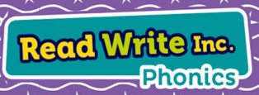 | Read Write Inc  Set 1 & 2 | Read Write Inc  Set 1 & 2 | Read Write Inc  Set 1 & 2 | Read Write Inc  Set 1 & 2 | Read Write Inc  Set 1 & 2 | Read Write Inc  Assessment Week
English | Week 2 | Week 3 | Week 4 | Week 5 | Week 6 | Week 7
 | Reading Focus | Writing Focus (oral sentences) | Reading Focus | Reading Focus | Reading Focus | Writing Focus
Contexts | Magical Me  Brown Bear, Brown Bear  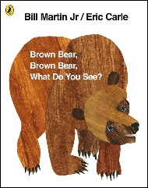 | Magical Me  Ruby’s Worry  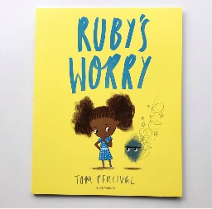 | Magical Me  Giraffes Can’t Dance  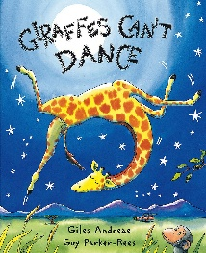 | Magical Me  Little Red Hen (Harvest)  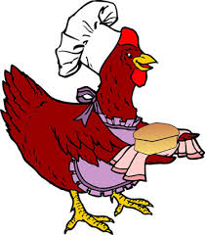 | Magical Me  The Five Senses  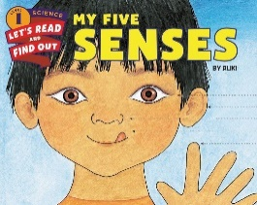 | Magical Me  The Family Book  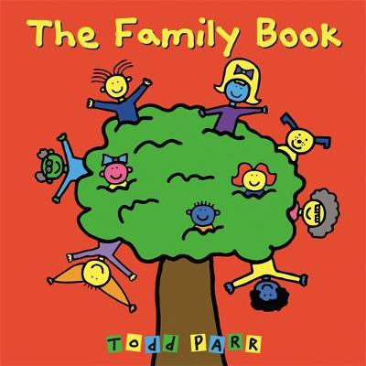
Learning Intention and Success Criteria | WALT Join in with repetitive phrases.  Remember:  Listen carefully.  Repeat what you have heard. | WALT talk about emotions.  Remember:  Listen carefully  Talk clearly | WALT rhyme.  Remember:  We need to listen to the end of the word. | WALT know and tell a story.  Remember:  To say what happens at the beginning, the middle and the end.  To listen carefully.  Remember the actions. | WALT Hears and sounds the initial sounds in words.  Remember:  To say what happens at the beginning of the story. To say what happens in the middle of the story. To say what happens at the end of the story. | WALT Know how to write a sentence.  Remember:  Say your sentence.  Use Fred Fingers and red words to help you.  Leave spaces between words.  Capital letter at the start.  Full stop at the end.
New Vocabulary (Grandma Fantastic)  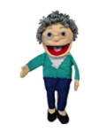 | Interesting colours/animals  Violet  Scarlett  Indigo  Turqoise  Magenta  Emerald  Jade | Emotion words  Anxious  Niggly  Jittery  On edge  Emotions | Action words  Swaying  Swirling  Twirling  Prancing | Bread making vocabulary  Wheat  Grind  Dough  Yeast | Describing story settings:  Meadow  Woodland  Palace  Fjord  Lair | Genre vocabulary:  Traditional tale  Fairy tale  Fantasy  Fiction
Starters | Body percussion/ Hickety Tickety Bumble Bee | Act out emotions/Have you brought your singing voice | Nursery Rhymes | Circle – my favourite character in the little red hen is…because… | Tell the story in the wrong order. What do you notice? | Circle Time – say a sentence to match a picture from Each Peach Pear Plum.
Main Lesson | Language:  Assessment | Language:  Worried, scared, upset, nervous, feeling, emotions. | Language:  Rhyme, ending, same, sound. | Language:  Character, beginning, middle and end | Language:  Know, tell, re-tell, story, beginning, middle, end | Language:  Sentence, finger space, full stop, Kung Fu punctuation.
Task | Reading in small groups, handling books, joining in with repetitive phrases. | Say a sentence about how Ruby is feeling.  Introduce the worry monster – make cards or pictures to send to the worry monster. | Rhyming pairs/puzzles. | Listen to and participate in an aural retelling of the little red hen. | Re-tell and act out the story in small groups.  Hot seating – asking questions of a character.  Independent writing – zig-zag or stapled books to write stories. | Write a sentence about a picture from Each Peach Pear Plum.  Assessment opportunity – phonics application, handwriting, punctuation.
Phonics:
Set 1
m - a - s - d - t - i - n - p - g - o - c - k - u - b - f - e - l - h - sh - r - j - v - y - w - th - z - ch - qu - x - ng – nk

Set 2
ay – ee – igh – ow – oo – oo – ar – or – air – ir – ou – oy

Set 3
a-e – ea – i-e – o-e – u-e – aw – are – ur – er – ow – ai – oa – ew – ire – ear – ure – tious – tion

Week | Expressive Art & Design (Art) | Learning Intention/  Success Criteria | Key Vocabulary | Key Skills  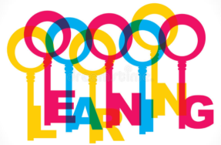 | Key Knowledge
1 | They safely use and explore a variety of materials, tools and techniques, experimenting with colour.  Self portraits | Identify features  Look carefully  Draw/paint what you see | Observe  Features | Brush and paint skills  Pastel skills | Know what a self-portrait is and how to draw from observation.
2 | They safely use and explore a variety of materials, tools and techniques, experimenting with colour.  Self portraits | Identify features  Look carefully  Draw/paint what you see | Observe  Features | Brush and paint skills  Pastel skills | Know what a self-portrait is and how to draw from observation.
3 | They safely use and explore a variety of materials, tools and techniques, experimenting with texture.  Collage | Combine materials  Select materials  Carefully place materials  Attach with glue | Cut  Stick  Combine  Attach | Combining materials | Know what a collage is and how to attach materials using glue.
4 | They safely use and explore a variety of materials, tools and techniques, experimenting with texture.  Collage – photo frames | Combine materials  Select materials  Carefully place materials  Attach with glue | Cut  Stick  Combine  Attach | Combining materials | Know what a collage is and how to attach materials using glue.
5 | They safely use and explore a variety of materials, tools and techniques, experimenting with form.  Family portraits. | Look carefully  Draw/paint what you see | Observe  Features  Portrait | Drawing skills  Pen skills | Know how to draw from observation.
6 | They safely use and explore a variety of materials, tools and techniques.  Cutting skills - paper bag houses | Use scissors  Hold scissors correctly  Move the paper/card  Carry scissors safely | Snip  Cut  Safety | Cutting skills | Undertand how to hold scissors properly and use them to cut effectively.
 | They safely use and explore a variety of materials, tools and techniques, experimenting with texture.  Cutting and Collage – Little Red Hen collage pictures | Combine materials  Select materials  Carefully place materials  Attach with glue | Cut  Stick  Combine  Attach | Combining materials | Know what a collage is and how to attach materials using glue to create a planned outcome.

Week | Understanding the world: The World and People and Communities | Learning Intention/  Success Criteria | Key Vocabulary | Key Skills | Key Knowledge
1 | Transition/settling in
2 | Making observations of animals and plants.  What can I do now I am 4/5.  Explore what our bodies can do.... | - WALT make observations/ Look carefully  - say what you see  Compare | Similar  Different  Same  Grow  Body  Change | Identifying | Vocabulary of body parts and how their bodies have changed as they have grown.
3 | Making observations of animals and plants.  Senses – labelling body parts | - WALT make observations/ Look carefully  - say what you see  Compare | Unknown vocab –  Shoulders  Elbows  Knees  Ankles  Torso | Identifying | Vocabulary – names of senses and body parts.  Understand what a label is.
4 | Making observations of animals and plants.  Senses – exploring senses with a carousel of sensory activities. | - WALT make observations/ Look carefully  - say what you see  Compare | Smell  Taste  Touch  Hear  Sight | Identifyng | Know which body part they are using for each sense.  Knows the vocabulary of different materials.
5 | Make observations and talk about changes.  know about similarities and differences in relation to places, objects, materials and living things  Exploring different tyoes of homes | WALT: Identify/  Look closely  Use the correct vocabularly  What is the same  What is different | Flat  House  Terraced  Semi-detached  Detached  Bungalow | Identifying | Know that there are different types of homes.  Vocabulary related to different types of homes.
6 | They know about similarities and differences about themselves and others and among families, communities and traditions.  Exploring different types of homes – walk around Stony. | Compare / How is it the same ?  How is it different? | Flat  House  Terraced  Semi-detached  Detached  Bungalow | Identifying and comparing | Know that there are different types of homes.  Vocabulary related to different types of homes.
7 | Talk about features of their own environment and how environments might vary from each other.  Comparing places across the world with Stony. | WALT: Identify/  Look closely  Use the correct vocabularly  What is the same  What is different | Flat  House  Terraced  Semi-detached  Detached  Bungalow  Igloo  Mud hut  Teepee  Castle  Tree house  River boat  Canal boat | Identifying and comparing | Know that there are different types of homes.  Vocabulary related to different types of homes.

Week | Physical Development  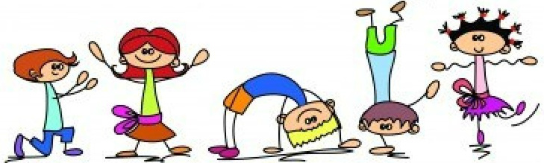 | Learning Intention/ Success Criteria | Key Vocabulary | Key Skills | Key Knowledge
1 | Safely negotiating space Children show good control and coordination in large and small movements.  Learning the rules  Using the hall safely  Taking off shoes and socks | WALT: Travel in different ways.  Listen to the instructions  Look for spaces  Change directions | Moving, safety, control, coordination.  Running, Side-stepping, Skipping, Jumping, Hopping | Running, Side-stepping, Skipping, Jumping, Hopping | Vocabulary for different ways of travelling.
2 | Safely negotiating space Children show good control and coordination in large and small movements.  Learning the rules  Using the hall safely  Taking off shoes and socks | WALT: Travel in different ways.  Listen to the instructions  Look for spaces  Change directions | Moving, safety, control, coordination.  Running, Side-stepping, Skipping, Jumping, Hopping | Running, Side-stepping, Skipping, Jumping, Hopping | Vocabulary for different ways of travelling.
3 | Safely negotiating space Children show good control and coordination in large and small movements.  Undressing and dressing independently | WALT: Travel in different ways.  Listen to the instructions  Look for spaces  Change directions | Moving, safety, control, coordination.  Running, Side-stepping, Skipping, Jumping, Hopping | Running, Side-stepping, Skipping, Jumping, Hopping | Vocabulary for different ways of travelling.
4 | Safely negotiating space Children show good control and coordination in large and small movements.  Moving with control | WALT: Travel in different ways.  Listen to the instructions  Look for spaces  Change directions | Moving, safety, control, coordination.  Running, Side-stepping, Skipping, Jumping, Hopping | Running, Side-stepping, Skipping, Jumping, Hopping | Understand the rules of different games and know associated vocabulary.
5 | Safely negotiating space Children show good control and coordination in large and small movements.  Moving with control | Listen to the instructions  Take turns  Move in different ways | Communicating, collaborating and competing | Communicating, collaborating and competing, turn taking. | Understand the rules of different games and know associated vocabulary.
6 | Safely negotiating space Children show good control and coordination in large and small movements.  Moving with control | Listen to the instructions  Take turns  Move in different ways | Communicating, collaborating and competing | Communicating, collaborating and competing, turn taking. | Understand the rules of different games and know associated vocabulary.
7 | Safely negotiating space Children show good control and coordination in large and small movements.  Moving with control | Listen to the instructions  Take turns  Move in different ways | Communicating, collaborating and competing | Communicating, collaborating and competing, turn taking. | Understand the rules of different games and know associated vocabulary.

NB. In addition, fine motor skills are taught and practised in EAD, English, Handwriting and specific activities available in continuous provision (inside & outside). Gross motor skills also developed daily, through use of the large outdoor equipment .
Health and Self-care taught and supported daily through circle times, meal times and books. Parents encouraged to help children to develop self-care skills at home, as communicated through weekly parent updates.

Week | PSED  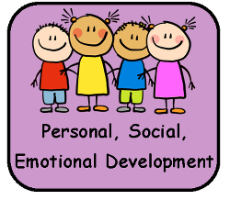 |  |  | Learning Intention/Success Criteria | Key Vocabulary |  | Key Skills |  | Key Knowledge
1 | Aware of the boundaries set, and of behavioural expectations in the setting  Why do we do Calm Me time? |  |  | Understand why Calm Me time is important/  Listen to the story  Listen to the chime  Reflect | Reflecting  Anxious  Peaceful |  | Listening  Reflecting  Following instructions |  | Why should we reflect?
2 | Children talk about how they and others show feelings  Recognising emotions and deciding what we can do to change them. |  |  | Recognising and managing own feelings /  Share your feelings  Listen to others  Reflect | Recognising  Strategies  Application |  | Listening  Speaking clearly  Sharing ideas |  | Can I talk in context about how I feel?
3 | Children talk about how they and others show feelings  Recognising how their own actions can affect other people. |  |  | Considering other people’s feeligs/  Listen to the situation  Think of a solution  Share ideas | Solution  Resolution  Reflecting |  | Listening  Sharing ideas  Discussing the problem |  | How can I consider people’s feelings?
4 | Beginning to be able to negotiate and solve problems without aggression  Using kind words and gentle hands when we play. |  |  | Understand why it is good to be kind and use gentle hands/  Listen to the story  Use gentle hands | Gentle  Caring  Immediately |  | Listening  Speaking clearly  Discussing |  | How we can think about how our actions can affect other people.
5 | Aware of the boundaries set, and of behavioural expectations in the setting  Understand rules and why it is important to follow them. |  |  | Understanding right to learn and play / Listen to the ideas  Discuss with your partner  Reflect | Rights  Boundaries  Importance |  | Listening  Speaking clearly  Discussing |  | Why it is important to follow rules in the setting.
6 | Children are confident to speak in a familiar group.  Realising that we need to be responsible. |  |  | Understanding how to be responsible/  Listen  Share ideas  Ask questions | Responsibility  Relationship |  | Listen  Speak clearly  Discuss |  | Reflecting on how we have improved.
Week |  | Understanding the World - Technology | Learning Intention/  Success Criteria |  |  | Key Vocabulary |  | Key Skills |  | Key Knowledge
1 |  | Select and use technology for a particular purpose. | Transition/ settling in
2 |  | Select and use technology for a particular purpose. | Transition / settling in
3 |  | Select and use technology for a particular purpose. | Stay safe online  Remember the rules  Ask for help |  |  | Online  Safety  Help  Danger  Adult |  | Identifying dangers online |  | Understand the rules of how to stay safe  Know when to ask for help
4 |  | Select and use technology for a particular purpose. | Stay safe online  Remember the rules  Ask for help |  |  | Online  Safety  Help  Danger  Adult |  | Identifying dangers online |  | Understand the rules of how to stay safe  Know when to ask for help
5 |  | Select and use technology for a particular purpose.  Using IWB | Select and use technology  Select the correct programme  Use the programme commands to complete the programme. |  |  | Technology  Programme  Command  Select  Choose  Drag  Drop |  | Use technology to draw a picture. |  | Know which tools to use to draw on IWB
6 |  | Select and use technology for a particular purpose.  Using IWB | Select and use technology  Select the correct programme  Use the programme commands to complete the programme. |  |  | Technology  Programme  Command  Select  Choose  Drag  Drop |  | Use technology to draw a picture. |  | Know which tools to use to draw on IWB
7 |  | Select and use technology for a particular purpose.  Using IWB | Select and use technology  Select the correct programme  Use the programme commands to complete the programme. |  |  | Technology  Programme  Command  Select  Choose  Drag  Drop |  | Use technology to draw a picture. |  | Know which tools to use to draw on IWB
NB. Technology also planned in across all areas of learning and in continuous provision.

