Spring Quiz
Read the statement and circle if it is true or false.
- In spring the leaves turn brown and orange
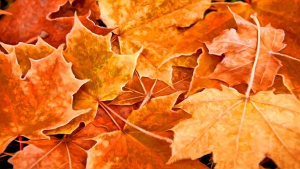 True or False

- Spring is the season after Winter
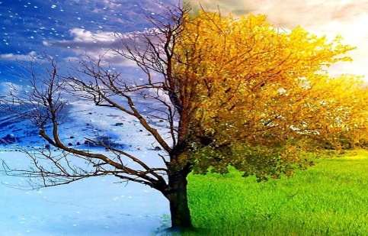 True or False

- Spring falls in different months of the year, depending on where you are in the world.
True or False

- Spring is the season well known for when chicks hatch.
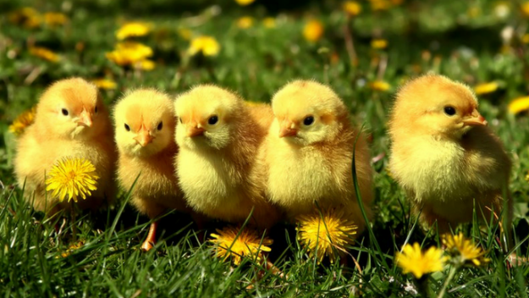 True or False

