**My Questions about Mae Jemison**

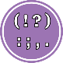 Punctuation: Use capital letters and question marks

 Basics: Use question words.

When

How

What

Who